POP PRODIGY JENNA RAINE RELEASES INFECTIOUS NEW SINGLE “IT IS WHAT IT IS”
LISTEN HERE

BIG DUMB HEART, CHAPTER 2 EP SET FOR RELEASE ON AUGUST 18
PRE-ORDER HERE

JENNA GRACES THE COVER OF GIRLS’ LIFE MAGAZINE
ON STANDS NOW

Download hi-res artwork HERE

July 21, 2023 (Los Angeles, CA) – Rising pop star Jenna Raine serves up an energetic new single entitled “It Is What It Is” today via Warner Records. Listen HERE.

Heralded by Variety who proclaimed, “Raine’s future looks bright,” Jenna has been teasing the track to her 1.7M TikTok followers, tallying up millions of views ahead of its release. It notably sets the stage for her forthcoming new EP, Big Dumb Heart, Chapter 2, arriving August 18. Pre-order HERE.

On the track, breezy acoustic guitar and bright piano uplift a sunny refrain where she accepts, “Growing up is a pain, and it is what it is.” Carried by her upbeat delivery, the hook doubles as a relatable reminder to roll with the punches and go with the flow no matter how crazy life gets.

It lands in the wake of her recent EP, Big Dumb Heart, Chapter 1. Beyond generating millions of streams to date, it earned widespread acclaim. Her Campus christened her “a rising superstar,” and Celeb Secrets hailed the EP as “her phenomenal 5-track project.” Meanwhile, The Honey Pop raved, “We literally see ourselves in her shoes through her new EP, Big Dumb Heart, Chapter 1.”

Jenna graces the current cover of Girls’ Life Magazine. View online and order HERE.

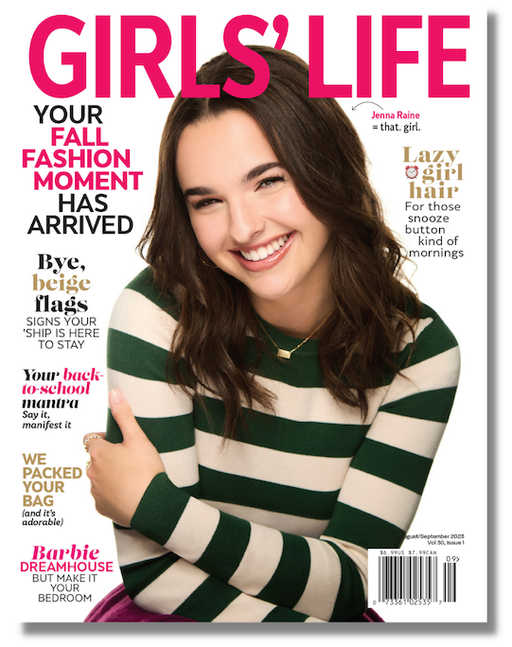

ABOUT JENNA RAINE:
Jenna Raine’s songs brim with hope and wide-eyed wonder. “My goal is to be a light in a troubled world,” the 19-year-old says. “I want my music to make people feel less alone.” By documenting her hopes and dreams in diary-like detail on her major-label debut EP, see you later, she reminds listeners that the growing pains of adolescence are universal and best approached with positivity. Even the teen’s sad songs look on the bright side. Take her breakout hit, “see you later (ten years),” which exploded on TikTok in 2021. “It’s heartbreaking when the timing is all wrong,” the Dallas, Texas native says of dating the right person at the wrong time. However, instead of giving up, she manifested a happy ending. “It doesn’t have to mean goodbye, simply see you later.” The song went on to amass more than 76 million global streams and resulted in a deal with Warner Records. It’s a goal she has been working towards since entering her first talent show at age 8. A four-year stint in girl group L2M followed as well as world tours and a pair of independently released EPs. With her see you later EP and new Big Dumb Heart EPs, Raine touches hearts and lifts spirits — one loved-up ballad at a time.

###

FOLLOW JENNA RAINE:
Official | TikTok | Instagram | Twitter | Facebook | YouTube | Press Materials

For more information on Jenna Raine, please contact:
Darren Baber | Warner Records
Darren.Baber@warnerrecords.com

Patrice Compere | Warner Records
Patrice.Compere@warnerrecords.com

