RICKY MONTGOMERY GRAPPLES WITH HIS FATHER’S SUICIDE
15 YEARS LATER ON RAW & POWERFUL NEW SINGLE
“BLACK FINS”

LISTEN HERE | WATCH HERE

BITTERSWEET DAZE TOUR FEATURING
CAVETOWN, MXMTOON + GRENTPEREZ KICKS OFF JULY 20

Credit Haley Appell, download hi-res here

“The listener can’t help but pay attention to Montgomery”
Billboard

“Vibey bedroom pop-esque vulnerab[ility]… with the musician stepping into a more comfortable and mature sound”
V Magazine

July 14, 2023 (Los Angeles, CA) – Earmarking a moment 14 years in the making, breakout alt-pop artist Ricky Montgomery tells the story he always wanted to tell on his touching new single and music video “Black Fins” out now via Warner Records. Listen HERE and watch HERE.

“Black Fins” recounts one of the most pivotal moments of Ricky’s life: his father’s 2009 suicide in Mexico, initially thought to be a scuba-diving accident until Ricky found hand-written letters. Culled from a 2009 poem penned by a 15-year-old Ricky, he molded those initial teenage words into a timeless anthem of acceptance. For as much as it boldly faces tragedy head-on, the track also illuminates its creator’s growth to finally speak on both the loss itself and the estranged relationship with his father. What results is a starkly honest, strangely soothing, and softly triumphant catharsis of a song.

Ricky filmed the accompanying Madeline Leshner-directed visual in Mexico, coming full circle in this captivating vignette co-starring his sister, Mary Montgomery.

Ricky further elaborates, “‘Black Fins’ is about the long road toward forgiving [my father]. I’ve come to understand more about his situation: he was bipolar and manic, and money was slowly killing him. He lost his job during the recession, and they foreclosed on his house the same month he died. I’ve come close to poverty as an adult too, and know how it infects your mind. I can’t imagine what was happening inside of him.”

He continues, “As a young kid, music was my only healthy outlet. Songs about deadbeat dads and abusive households made me feel more normal. Like I wasn’t so alone. But nobody had the same story I did. With this song, it is my hope that I can carry forth that tradition of helping other people feel seen. If even one kid out there feels some kind of kinship from this song, that’s a good enough reason to put it out there into the world.”

To continue that sentiment, Ricky has created a resources page for fans, further detailing his own experiences and information about the 988 Suicide & Crisis Lifeline. As he states, “There are no easy answers to suicide or grief, but hopefully the resources above will help you find a good place to start.” Visit the page here.

On the heels of the release, Ricky will embark on the Bittersweet Daze tour next week, joining his close collaborators and friends Cavetown, mxmtoon, and grentperez – see a full list of dates below. The special 12-date tour kicks off with a sold-out show at the Greek Theater on July 20, with $1 from every ticket sold benefiting Cavetown’s This Is Home Project. At each show, a This Is Home tent will welcome local LGBTQ+ youth organizations to connect with fans.

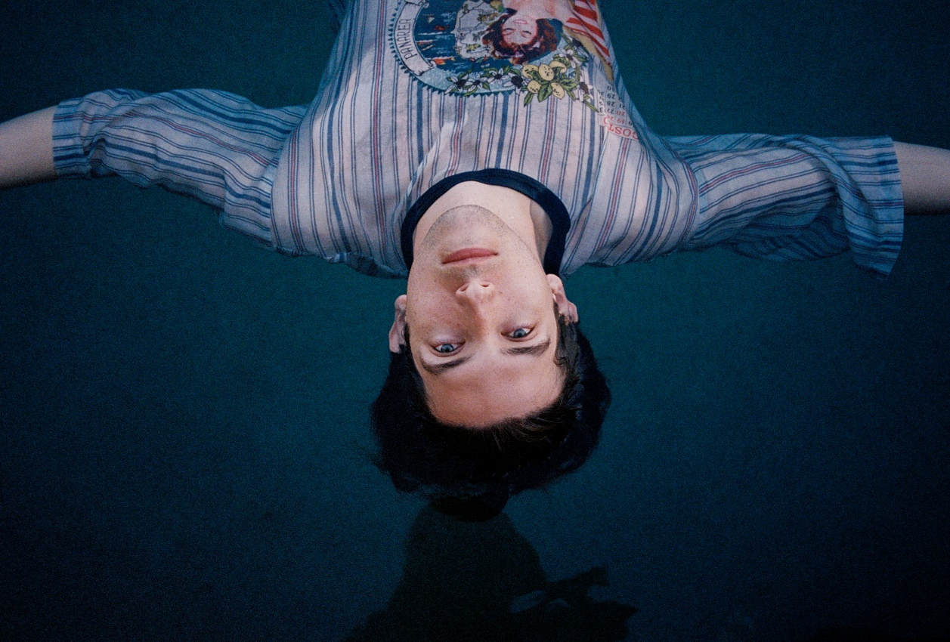
Credit Haley Appell, download hi-res here

UPCOMING TOUR DATES
7/18 – The Observatory – Santa Ana, CA ^
7/20 – Greek Theatre – Los Angeles, CA* (SOLD OUT!)
7/21 – Cal Coast Credit Union Open – San Diego, CA*
7/23 – Frost Amphitheater – Stanford, CA*
7/25 – Saltair – Magna, UT*
7/26 – Levitt Pavilion – Denver, CO*
7/28 – St. Louis Music Park – Maryland Heights, MO*
7/29 – The Salt Shed – Chicago, IL*
7/30 – Rock The Ruins – Indianapolis, IL*
8/1 – Jacobs Pavilion – Cleveland, OH*
8/3 – SummerStage – New York, NY*
8/4 – Skyline Stage at the Mann – Philadelphia, PA*
8/5 – The Palladium Outdoors – Worcester, MA*

^ = with mxmtoon only
* = Bittersweet Daze tour feat. Cavetown, mxmtoon + grentperez

ABOUT RICKY MONTGOMERY:
Music always lures Ricky Montgomery back. He blames the internet. First a devotee of the Vine underground, and now—nearly a decade and several jobs later—an unexpected hitmaker, the Los Angeles native has spent the last few years trying to reconcile with his artist self. He recently surpassed 1 billion global streams thanks to Platinum indie-pop hits “Mr. Loverman” and “Line Without a Hook.” But those songs, written when he was a teen, have come to feel like they were by a whole other person—at least to Ricky. In 2023, we get to meet Ricky’s new chapter, a sophomore set that comes seven years later, rich with electro-laced, emo-tinged alt-pop that spins stories about life in all its messy and mundane glory. Ricky's journey fits the bill: a childhood in L.A. interrupted by divorce, an adolescence playing in the basement bands of suburban Missouri, a viral explosion on a soon-to-implode platform, and a brief music career back on the West Coast that sent his songs up the Rock and Alternative charts. That was in 2014, before life intervened and he quit music for good… until the world discovered his sunny, sardonic songs. With millions of socials followers and a string of sold-out tours under his belt, Ricky now sets out to document "my long, awkward path toward remembering myself as an artist," he says. "It’s been embarrassing and difficult, but also thrilling. It’s everything I’ve ever wanted to do but was too scared to try.”

###

For more information, contact:
Ceri Roberts, Ceri.Roberts@warnerrecords.com
Patrice Compere, Patrice.Compere@warnerrecords.com

Press Materials:
press.warnerrecords.com/rickymontgomery

Follow Ricky Montgomery:
INSTAGRAM | TWITTER | YOUTUBE | TIKTOK

