RETT MADISON MAKES WARNER RECORDS/WAR BUDDHA DEBUT WITH “PIN-UP DADDY” FEATURING KATIE PRUITT

TO TOUR THE U.S. AND PLAY FIRST HEADLINE LONDON SHOW
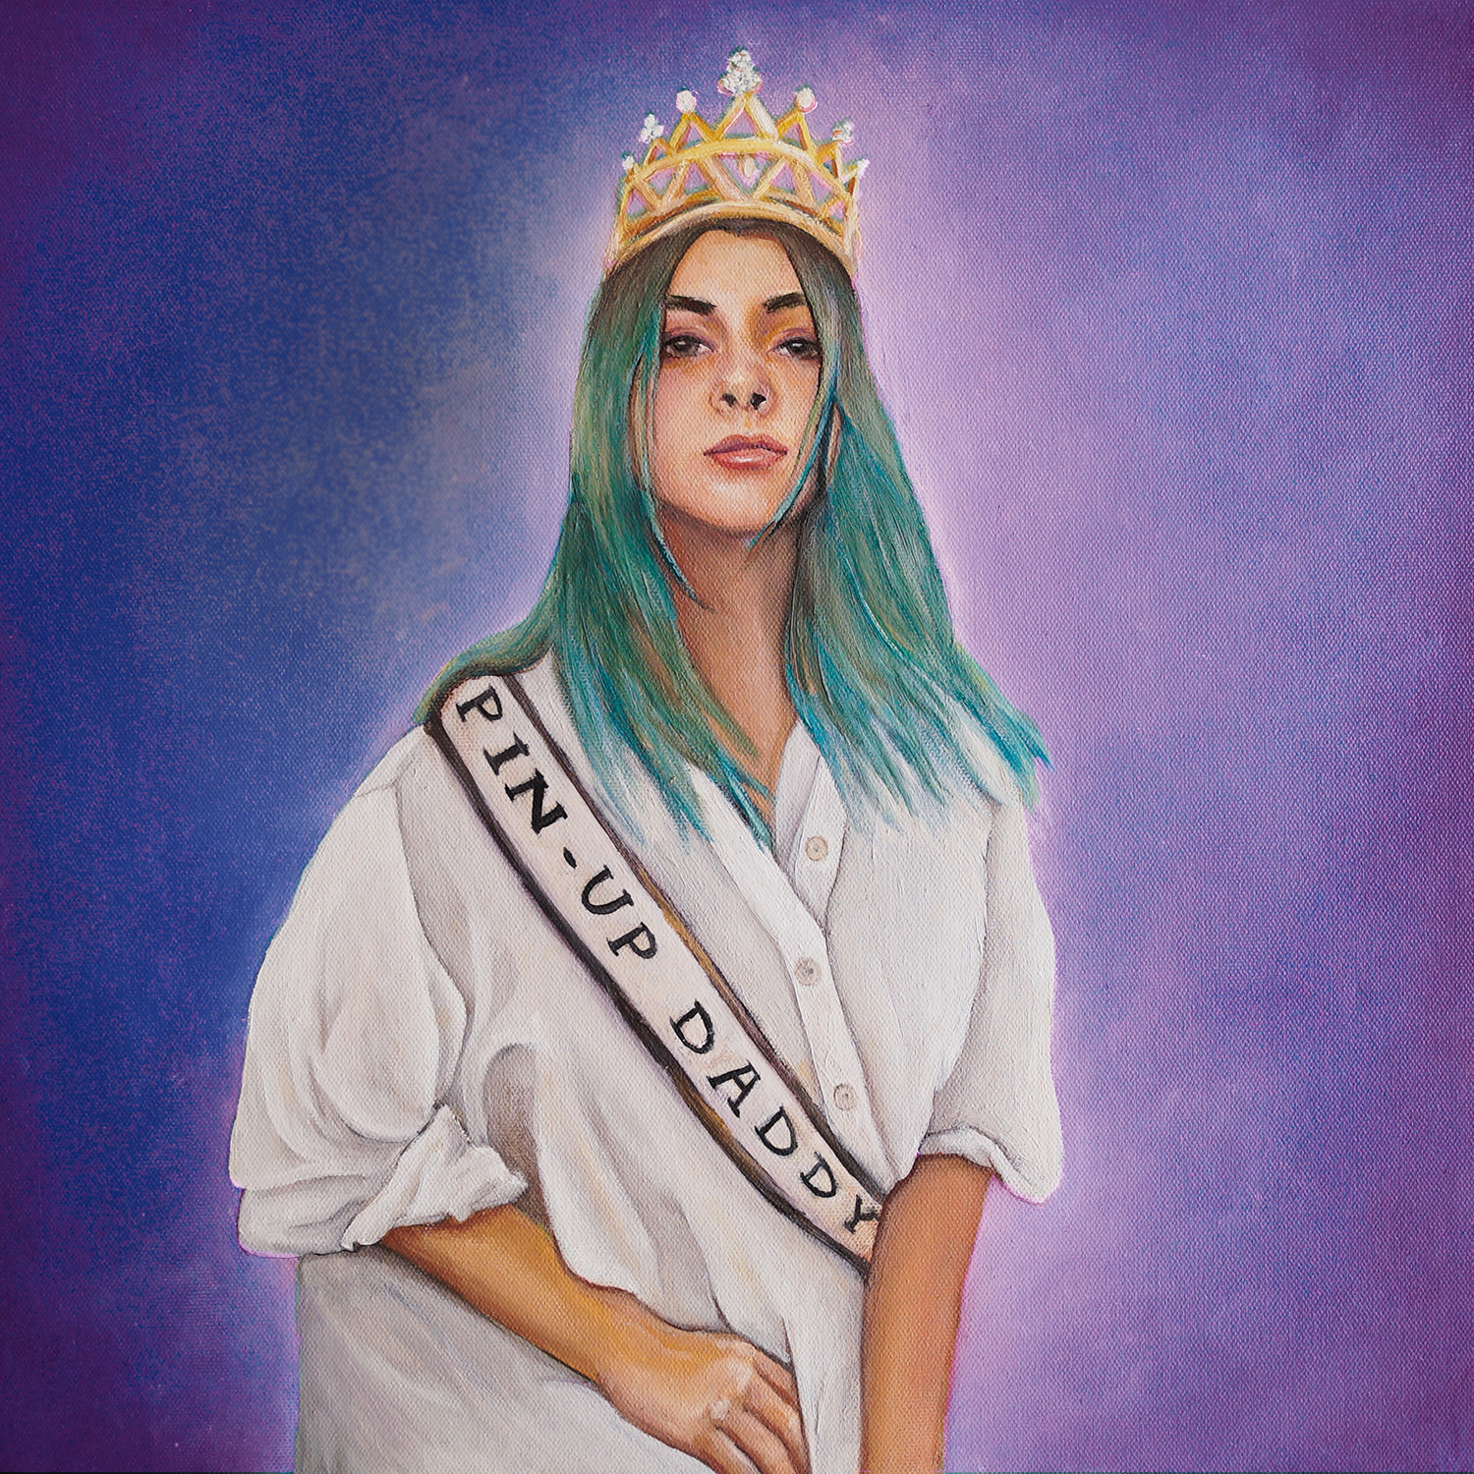
Download hi-res artwork HERE
June 23, 2023 (Los Angeles, CA) —Today, Los Angeles-based vocalist, songwriter and multi-instrumentalist Rett Madison makes her Warner Records/War Buddha debut with a new version of her previously released track, “Pin-Up Daddy,” featuring acclaimed vocalist and songwriter Katie Pruitt—listen here and watch the lyric video here. The new collaboration marks the first release from a new joint venture between Warner Records and Nashville’s War Buddha Records.
“I wrote ‘Pin-Up Daddy’ reflecting on my own fluidity in expression of gender as a queer woman,” Madison says. “Some days I feel quite masculine and other days I show up to the world embracing my femininity. My fluidity is beautiful, and I hope this song can be affirming and empowering to folks that relate to its message. Katie Pruitt is such an incredible storyteller and artist that I’ve admired for years,” she continues. “I relate to many of the themes in her own music, so I was thrilled when she agreed to join this reimagined version of ‘Pin-Up Daddy. Her vocal interpretation of this song felt so honest and powerful that I was nearly in tears when I first heard our voices together.”
“When Rett asked me to sing on her song ‘Pin Up Daddy,’ I was stoked,” Pruitt says. “Not only did I already love the song, but I’ve been grappling with my gender identity and this song felt like such a positive representation of how it feels to exhibit both feminine and masculine qualities that exist in of all of us. The lyrics in verse two where Rett talks about her Dad ‘looping a tie around her neck’ and buying her a suit that ‘fit just right’ was the childhood experience I wanted but didn’t have. This song helped me heal a little part of my past & reminded me to love myself for all that I am.”
The original version of “Pin-Up Daddy” is taken from Madison’s debut album of the same name, produced by Theo Katzman and released independently in 2021 to critical acclaim. More music from Madison is imminent.
Additionally, Madison will hit the road next week for a run of tour dates through the U.S., including dates with The Head And The Heart, Andy Grammer, Fitz & The Tantrums and Medium Build as well as her first headline show in London—see full routing below and get tickets here.
Originally from West Virginia, Rett Madison is a queer singer-songwriter and multi-instrumentalist based in Los Angeles. She has been featured in publications such as Billboard, American Songwriter and Rolling Stone, where her music was described as “simultaneously brazen and vulnerable,” giving her a place “in the new school of acclaim-worthy troubadours.” She has recorded backing vocals for artists such as Lorde and Kate Nash and opened for artists including Melissa Etheridge, Sheryl Crow, Elle King and more. Having independently released a handful of singles ahead of her 2021 debut album, Pin-Up Daddy, she’s worked with some of the most talented players today, including Theo Katzman, Brian Jones, Lee Pardini and Joe Dart.
Acclaimed singer, songwriter and musician Katie Pruitt is in the midst of a breakout moment following her widely acclaimed, 2020 debut album, Expectations, which finds Pruitt covering topics such as mental illness, toxic relationships and the frustration and difficulties of growing up gay in the Christian South. Originally from the Atlanta suburbs and now based in Nashville, Pruitt has continued to receive widespread attention since her debut, having been featured in Rolling Stone, NPR Music and CBS Saturday Sessions series. Pruitt toured extensively following the release of her debut album, with headline shows in Los Angeles, New York, Dallas, Washington D.C., Nashville and more.
RETT MADISON LIVE
June 28—Boulder, CO—Fox Theatre (SOLD OUT)*
July 18—Morristown NJ—Mayo Performing Arts Center†
July 19—Virginia Beach, VA—Oceanfront Concert Series at 17th Street Stage†
July 21—Indianapolis, IN—Rock The Ruins at Holliday Park†‡
July 22—Cleveland, OH—Rock & Roll Hall Of Fame‡
July 23—Columbus, OH—Hartwood Acres Park‡
Sep 02—London, UK —The Slaughtered Lamb
Sep 21—Louisville, KY—Zanzabar§
Sep 22—Pittsburgh, PA—Club Cafe§
Sep 23—Columbus, OH—The Basement§
Sep 25—Chicago, IL—Schubas Tavern§
Sep 26—Minneapolis, MN—7th Street Entry§
Sept 27—Omaha, NE—Reverb Lounge§
Sep 29—Denver, CO—Globe Hall§
Oct 1—Oklahoma City, OK—Pony Boy§
* with The Head And The Heart
† with Andy Grammer
‡ with Fitz & the Tantrums
§ with Medium Build
For more information, please contact:
Rick Gershon | rick.gershon@warnerrecords.com
Reid Kutrow | reid.kutrow@sacksco.com
Ethan Jacobs | ethan.jacobs@sacksco.com
Carla Sacks | carla@sacksco.com

