PANAMANIAN ARTIST SOFÍA VALDÉS UNVEILS SILVIA EP

STREAM HERE | WATCH "SILVIA" VIDEO HERE

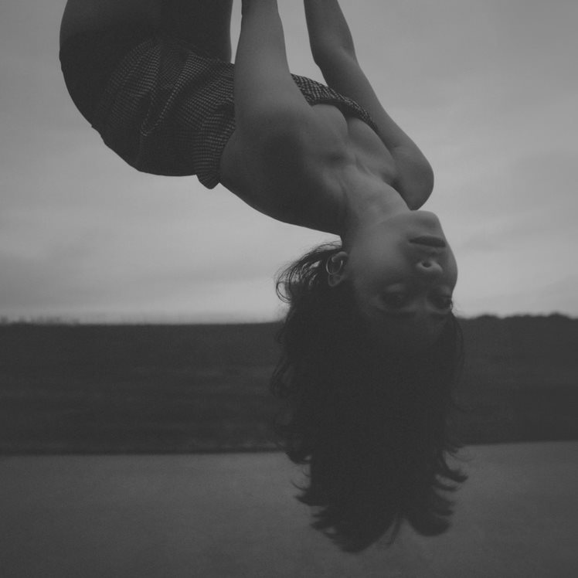

August 11, 2023 (Los Angeles, CA) – Panamanian singer-songwriter Sofía Valdés unveils her latest EP Silvia, the first installment of her forthcoming full-length debut. Produced by Michael Uzowuru (Rosalia’s Motomami, SZA’s Ctrl, and Frank Ocean’s Blonde) and boasting contributions from Carter Lang, John Hill, Ryan Hahn, Arthur Verocai, and Diana Gordon, the 5-song set unfolds in a transportive and thrillingly original sound inspired by her family's deep, multi-generational connection to music. Listen to it HERE.

The EP – named after Sofia’s great-grandmother and an acclaimed singer in her time who toured with the likes of Louis Armstrong – kicks off with a pair of recent singles: “Midnight Freakout,” a dreamy rumination on Sofia’s recent move to the United States, and the transfixing "Easy," which deals with the alienation, culture shock, and isolation that Sofia felt as a young immigrant struggling to find a home during the heat of the pandemic. “Barbed Wire” offers a winsome digression punctuated by piano and gentle guitar, while “Wild” finds the rising star at her most raw and experimental. And then there's “Silvia,” a song that seamlessly shifts between English and her native Spanish, which was co-written with GRAMMY-nominated artist Diana Gordon (Beyoncé’s Lemonade). “Silvia” arrives alongside a stunning new visual, out today – watch it HERE.

“Silvia is a collection of stories of my great grandparents all told through the song. Their story resonated with me at a time I felt like music maybe wasn’t for me after all,” Sofia explains. “My grandfather was a Cuban musician, and on the other side of my family, Silvia was a Panamanian folklore singer married to a Dominican musician (my great grandfather). They traveled the world and dedicated their entire life to music so much so, that my great-grandfather died on stage on his last song. A bit dark but poetic. The stories of Silvia and her persona felt so mystical and powerful. Even though I’m not that religious, I do pray to my ancestors when I feel lost. Silvia was someone I kept asking for help over the past couple of years, so it felt right to name my EP for her.”

The release of Silvia could not be more momentous for Valdés, following last year’s emotional bedroom-pop gems “Heart of Glass” and “Broken” [feat. Pink Sweat$]. The singles — along with 2021’s acclaimed EPs In Bloom and Ventura — have received a long list of critical acclaim from the likes of NPR, W Magazine, Interview Magazine, NYLON, Ones To Watch, and more for her beautifully original blend of bossa nova, folk, and pop.

Now with Silvia, Valdés celebrates her ancestral ties to music and showcases her incredible versatility — crafting one of 2023's most striking and intimate projects.

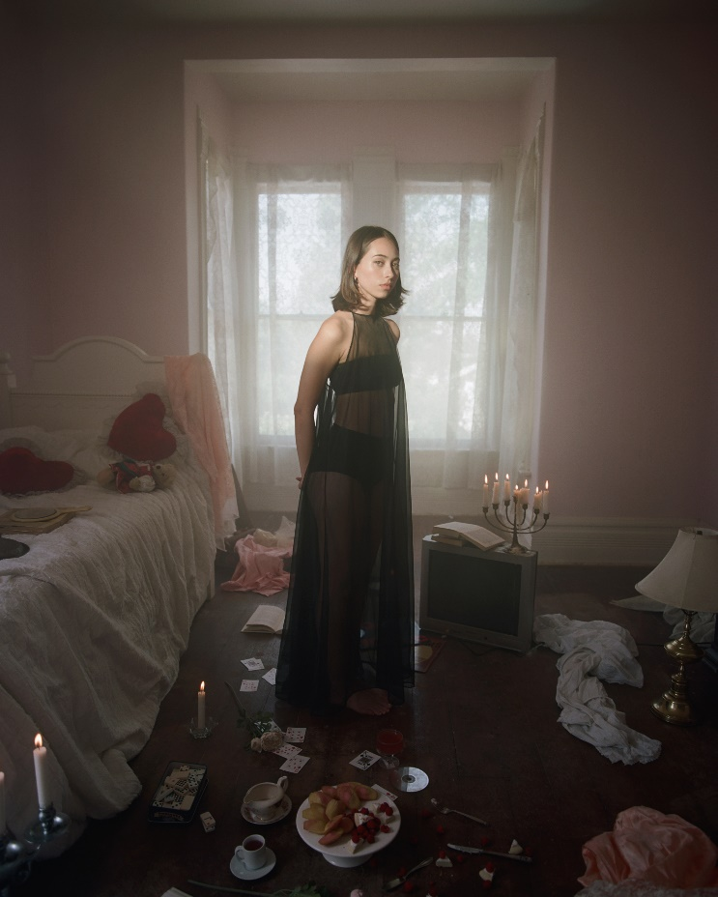

FOLLOW SOFÍA VALDÉS
INSTAGRAM | FACEBOOK | YOUTUBE | TIK TOK | WEBSITE

FOR PRESS INQUIRIES
Patrice Compere / patrice.compere@warnerrecords.com

