BREAKOUT POP STAR NESSA BARRETT ANNOUNCES FALL 2023 NORTH AMERICAN HEADLINE TOUR

PERFORMING AT AUSTIN CITY LIMITS FESTIVAL
OCTOBER 6TH AND 13TH

HELL IS A TEENAGE GIRL EP OUT NOW
LISTEN HERE

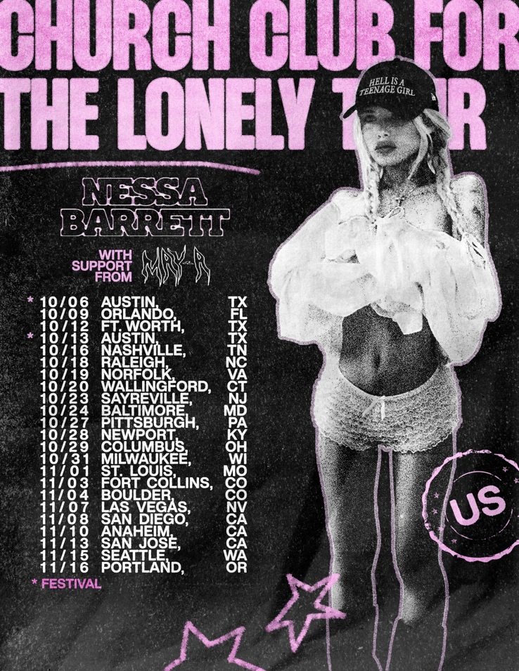

August 21, 2023 (Los Angeles, CA) – This Fall, pop sensation Nessa Barrett returns to the road for her biggest North American headline tour to date, with support from MAY-A. It kicks off on October 6 in Austin,TX at Austin City Limits Festival, visits major markets coast-to-coast including a two-night stand in Anaheim, CA at House of Blues, and concludes on November 16 in Portland, OR at Crystal Ballroom. It will be her first tour in support of her acclaimed new EP hell is teenage girl. Listen HERE via Warner Records.

For the next 24 hours, fans can pre-order a limited-edition tour shirt on Nessa’s website that will grant them access to an exclusive ticket presale on Wednesday, August 23 at 12pm local time. Purchase the shirt HERE. General on-sale commences on Friday, August 25 at 12pm local time. Tickets can be purchased HERE.

Beyond piling up tens of millions of streams, hell is a teenage girl has garnered widespread critical praise. American Songwriter proclaimed, “the song, album, and artist, as one, pushes you and pushes you with a bouncy, driving tune. So much so that you want more,” and OnesToWatch hailed it as “the 20-year-old songstress's most emotional and personal release to date.” She also graced the cover of KERRANG! in May.

The project picks up where Barrett left off in 2022, by demonstrating incredible songwriting prowess and versatility with her critically acclaimed debut album young forever. With her upcoming tour, Barrett will take the irreverent, sultry pop of hell is a teenage girl to stages across America.

About Nessa Barrett:
After being named as one of Billboard’s “21 Under 21” twice — as well as being featured on Ones to Watch’s list of “25 Artists to Watch in 2022,” Uproxx’s “Next Hitmakers List,” and People Magazine’s “Emerging Artist List” — Nessa Barrett has gone on to accumulate more than 1.5 billion global streams to date. She was also nominated for Push Performance of the Year at the 2022 MTV VMAs, performed at When We Were Young Festival, and took her show on the road for her sold out North American and European young forever tours. This Fall, she will hit the road once again, including performances at Austin City Limits Festival in October.

Credit: Andrew Donoho
Download hi-res image HERE

TOUR DATES
10/6 Austin, TX Austin City Limits Festival
10/9 Orlando, FL House of Blues
10/12 Fort Worth, TX Tannahill’s Tavern & Music Hall
10/13 Austin, TX Austin City Limits Festival
10/14 Austin, TX Emo’s
10/16 Nashville, TN Marathon Music Works
10/18 Raleigh, NC The Ritz
10/19 Norfolk, VA The NorVA
10/20 Wallingford, CT The Dome
10/23 Sayreville, NJ Starland Ballroom
10/24 Baltimore, MD Rams Head Live
10/27 Pittsburgh, PA Stage AE
10/28 Newport, KY MegaCorp Pavilion
10/29 Columbus, OH Kemba Live
10/31 Milwaukee, WI The Rave
11/1 St. Louis, MO The Pageant
11/3 Fort Collins, CO The Aggie
11/4 Boulder, CO Boulder Theatre
11/7 Las Vegas, NV House of Blues
11/8 San Diego, CA Observatory North Park
11/10 Anaheim, CA House of Blues Anaheim
11/11 Anaheim, CA House of Blues Anaheim
11/13 San Jose, CA San Jose Civic
11/15 Seattle WA Showbox SODO
11/16 Portland, OR Crystal Ballroom

Follow Nessa Barrett:
Official | TikTok | Instagram | Twitter | Facebook | YouTube | Press Materials | Store

Nessa Barrett contact:
Darren Baber | Warner Records
Darren.Baber@warnerrecords.com

