GREEN DAY RELEASE
"THE AMERICAN DREAM IS KILLING ME”
OUT NOW - LISTEN HERE

FIRST SINGLE AND OPENING TRACK FROM THE ICONIC ROCK BAND’S NEW ALBUM ‘SAVIORS’ OUT JANUARY 19, 2024

NEW ALBUM CO-PRODUCED BY ‘DOOKIE’ AND ‘AMERICAN IDIOT’ PRODUCER ROB CAVALLO

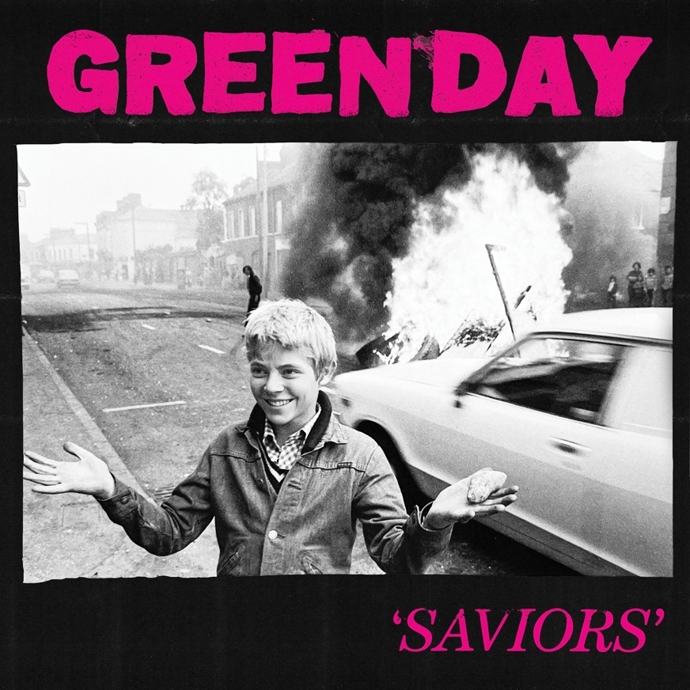
Saviors Artwork

October 24, 2023 (Los Angeles, CA) - Global rock superstars Green Day – Billie Joe Armstrong, Mike Dirnt and Tré Cool – have returned with a fiery call to action on “The American Dream Is Killing Me,” the first single and opening track from the group’s 14th studio album Saviors, releasing January 19th, 2024 via Reprise/Warner Records - pre-order HERE. The band debuted “The American Dream Is Killing Me” and “Look Ma, No Brains!” off the new album live last weekend during their triumphant and electrifying Las Vegas, NV, takeover, consisting of a sold-out surprise show at the 800 capacity Fremont and back-to-back headlining performances at When We Were Young Festival. Listen to “The American Dream is Killing Me” and watch the accompanying music video, directed by Brendan Walter and Ryan Baxley, HERE. There will also be several exclusive vinyl versions of Saviors available including neon pink with neon green splatter, and black ice with hot pink splatter, with most in very limited supply and pressed only once.

“The American Dream Is Killing Me” was one of the last tracks written and recorded by Green Day for Saviors. “As soon we cut it, we said, `Okay, that’s going first,’” says Billie Joe Armstrong who describes the new song as “a look at the way the traditional American Dream doesn’t work for a lot of people -- in fact, it’s hurting a lot of people.”

Recorded in London and Los Angeles, Saviors is the latest powerful collaboration between Green Day and Grammy-winning producer Rob Cavallo, whose notable previous work with Green Day includes two of the band’s most iconic albums, 1994’s Dookie and 2004’s American Idiot. The record comes just ahead of Dookie’s 30th anniversary - celebrations have already begun with the release of a massive deluxe edition of the album and a surprise show in Las Vegas where the band performed Dookie from front to back to a sold-out crowd of superfans.

Alongside the track the band has unveiled a film noir inspired black and white music video featuring Green Day in the midst of a zombie apocalypse. The killer video was directed by Brendan Walter and Ryan Baxley and shot in Los Angeles.

Green Day will also be performing this Thursday, October 26 as part of Amazon Music Live’s concert series, and on November 19, the band is heading up north to headline the Twisted Tea Grey Cup Halftime Show for the 110th Grey Cup at Tim Hortons Field in Hamilton, Ontario.

Stay tuned for so much more!

ABOUT GREEN DAY:
Formed in 1986 in Berkeley, CA, Green Day is one of the world’s best-selling bands of all time, with more than 75 million records sold worldwide and 10 billion cumulative audio/visual streams. The five-time Grammy Award-winning Rock and Roll Hall of Fame inductees released their breakout album Dookie in 1994, which sold over 10 million and achieved 10x Platinum Diamond status, is widely credited with popularizing and reviving mainstream interest in punk rock, catapulting a career-long run of #1 hit singles. Entertainment Weekly calls Green Day, “The most influential band of their generation,” while Rolling Stone attests, “Green Day have inspired more young bands to start than any act this side of Kiss, and that doesn't seem to be changing.” In 2004, Green Day released the rock opera American Idiot which captured the nation’s attention, selling more than 8 million copies in the U.S. alone and taking home the Grammy Award for Best Rock Album. Mojo declared “It's exhilarating stuff, the kind of record that sets new parameters as to what is possible from a punk rock'n'roll band in the 21st century.” In 2010, a stage adaptation of American Idiot debuted on Broadway to critical and commercial acclaim. Released in 2020, Green Day’s thirteenth studio album Father Of All... debuted at #1 on Billboard’s Album Sales Chart and #1 in both the U.K. and Australia. Pitchfork declared, “Green Day’s most fetching and youthful songs in ages. The trio sounds reinvigorated, more like hungry newcomers staking their claim.” In July 2021, Green Day embarked on The Hella Mega Tour (w/ Fall Out Boy & Weezer). The global tour included 29 sold-out stadium gigs – including renowned venues like London Stadium and Los Angeles’ Dodger Stadium. Watch out for more exciting music news coming soon.

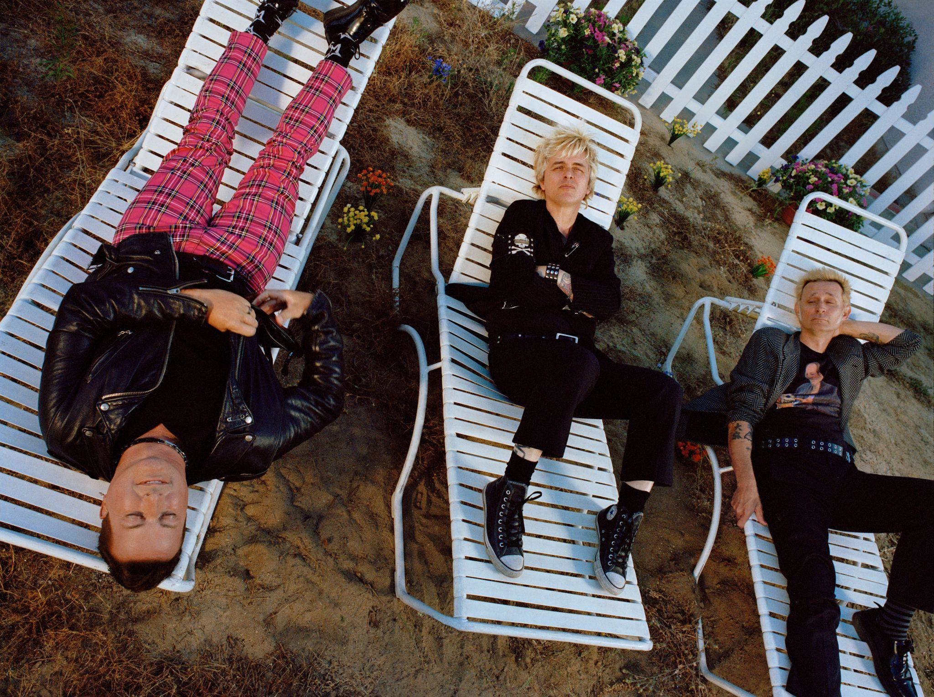
Photo credit: Emmie America

FOLLOW GREEN DAY
Facebook | Twitter | TikTok | Instagram | YouTube | Press Site | Website

For more information, contact:
Luke Burland | 2b Entertainment
luke@2bentertainment.net

Jenny Huynh | 2b Entertainment
jenny@2bentertainment.net

Laura Swanson | Warner Records
laura.swanson@warnerrecords.com

