MOTHER MOTHER TAKE FANS ON A JOURNEY “TO MY HEART”
NEW SINGLE TO BE RELEASED SEPTEMBER 15 VIA WARNER RECORDS
30-DATE EUROPEAN TOUR ANNOUNCED
LISTEN HERE / WATCH HERE
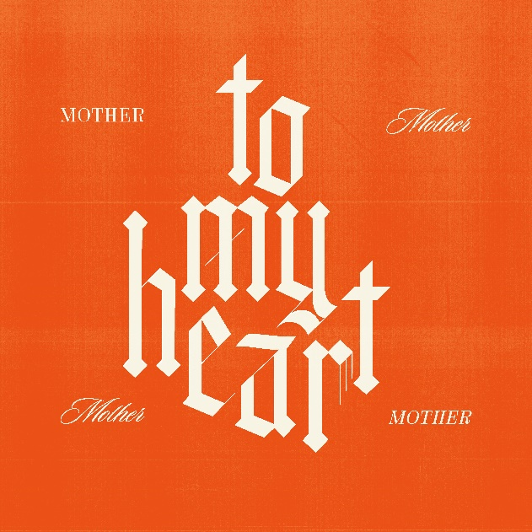
(Click HERE for single artwork)
September 15, 2023 – Platinum certified alt-pop rockers Mother Mother announce the release of their new single “To My Heart,” an uplifting track that takes listeners on an introspective journey that hearkens back to their early catalogue. Also announced today is an extensive 30-date tour of Europe including an appearance at London’s prestigious Wembley Arena. The tour and song launch comes in the wake of the band’s recent triumphant festival performances to tens of thousands of fans, with stops at some of the world’s most influential events; Reading and Leeds; Lollapalooza Chile, Argentina, and Brazil; Corona Capital in Mexico; Pukkelpop Belgium; Frequency Festival in Austria; and Lowlands in The Netherlands. Click HERE to stream “To My Heart,” and HERE to watch the lyric video.
Of the new song, Ryan Guldemond, lead vocalist-guitarist-songwriter, says "‘To My Heart’ is a song about trekking through the treacherous internal landscape of one's stored bodily trauma to arrive home safely in the space of the heart. It's a theme that mirrors the old adage, ‘The only way out is through.’ We hold this concept dear and find ourselves returning to it often, as a means to become more whole ourselves and ideally to provide the listener with some support, should they find themselves on a similar, often rocky path back to an open heart. Musically, this feels very classic Mother Mother, with the acoustic guitar and trio harmonies guiding the way - a recurring aesthetic on the new album."
“To My Heart” follows fan favorite “Normalize,” the first single from Mother Mother since 2022’s universally acclaimed album INSIDE. “Normalize” arrived with an intense video directed by acclaimed horror director Colin Minihan (Grave Encounters, What Keeps You Alive). Last week the band released an alternate fan video of the track that collected clips from the band’s global community of fanatics. Click HERE to watch the “Normalize (Alternate Fan Video).”
The slate of European headlining dates for winter of 2024 includes stops in the UK, Ireland, Belgium, France, Spain, Germany and more, and will see the band headlining to some of the largest European audiences in their career across the eight-week tour. A full list of dates is below, with more dates to be finalized soon. For tickets, go to the band’s website HERE.
2022 catapulted Mother Mother into a new stratosphere of universal success following the release of their most recent studio album INSIDE. Their explosive follow-up to “Hayloft,” “Hayloft II” connected with fans around the world. The song debuted inside the Top 10 on Spotify’s Global Top Songs chart, is now certified Gold in the US and approaching Platinum in Canada and has garnered over 725 million global streams including 540 million views across YouTube to date. In addition to their Stateside RIAA Gold & Platinum tracks, the band have earned multi-Platinum certifications in their home country of Canada for the album O My Heart as well as several of their other hit songs.
Comprised of Ryan Guldemond (vocals, guitar), Molly Guldemond (vocals, keys), Jasmin Parkin (vocals, keys), Ali Siadat (drums) and Mike Young (bass), Mother Mother have seen truly remarkable growth over the past three years, with enormous global success since 2021: Over 6.6 billion global streams, more than 57.5 million monthly listeners on digital platforms, 6.3 million Shazam searches and nearly 3 million TikTok followers. More to come from Mother Mother soon.

MOTHER MOTHER 2024 European Tour:
Sat Feb 17 Sheffield, UK O2 Academy
Sun Feb 18 Manchester, UK O2 Victoria Warehouse
Tue Feb 20 Glasgow, UK Barrowland Ballroom
Fri Feb 23 Dublin, IRE 3Olympia Theatre
Sun Feb 25 Newcastle, UK O2 City Hall
Wed Feb 28 Leeds, UK O2 Academy Leeds
Thur Feb 29 London, UK OVO, Wembley Arena
Sun Mar 03 Nottingham, UK Rock City
Mon Mar 04 Cardiff, UK Cardiff Students Union Great Hall
Tue Mar 05 Brighton, UK Brighton Dome
Thur Mar 07 Birmingham, UK O2 Institute
Sun Mar 10 Belgium, Brussels Ancienne Belgique
Tue Mar 12 Amsterdam, Netherlands Paradiso
Thur Mar 14 Paris, France L’ Olympia
Sat Mar 16 Madrid, Spain Palacio Vistalegre
Sun Mar 17 Barcelona, Spain Sant Jordi Club
Tue Mar 19 Milan, Italy Fabrique
Wed Mar 20 Zurich, Switzerland Komplex
Fri Mar 22 Luxembourg Den Atelier
Sat Mar 23 Munich, Germany Tonhalle
Sun Mar 24 Prague, Czech Republic Forum Karlin
Tue Mar 26 Warsaw, Poland Stodola
Wed Mar 27 Berlin, Germany Columbiahalle
Thur Mar 28 Hamburg, Germany Edel-optics.de Arena
Sat Mar 30 Cologne, Germany Palladium
Tue Apr 02 Copenhagen, Denmark Vega
Wed Apr 03 Oslo, Norway Sentrum Scene
Thur Apr 04 Stockholm, Sweden Fryhuset Arenan
Sat Apr 06 Helsinki, Finland House of Culture

# # #
(Mother Mother by Mackenzie Walker – Click HERE for Hi-res)

For Further Information, Contact Warner Records:
National: Rick.Gershon@warnerrecords.com
Regional: Delanee.Wilson@warnerrecords.com

Follow MOTHER MOTHER:
Official Site | Facebook | X-Twitter | Instagram | YouTube | Spotify | Press Materials

