GRAMMY-NOMINATED DJ/PRODUCER ILLENIUM RELEASES COVER OF ‘90S CLASSIC “ZOMBIE” WITH EXCISION, WOOLI & VALERIE BROUSSARD

LISTEN HERE

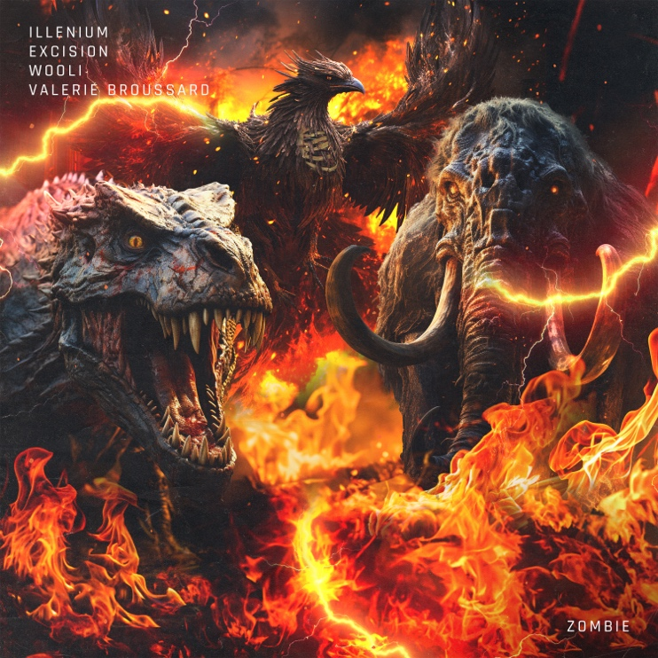
Download hi-res artwork HERE

October 27, 2023 (Los Angeles, CA) – Today, Grammy-nominated DJ/producer ILLENIUM joins forces with Excision and Wooli to deliver a stirring cover of The Cranberries’ classic “Zombie,” featuring Valerie Broussard. Listen HERE via Warner Records.

ILLENIUM has previously logged notable collaborations alongside Excision (“Feel Something” with I Prevail), Wooli (“You Were Right” with Grabbitz), and Broussard (“Sideways” with Nurko). Now, with “Zombie,” ILLENIUM, Excision, Wooli, and Valerie take things to another realm altogether.

Broussard’s stunning and spirited vocal performance serves as a heartfelt homage to the original, while ILLENIUM’s epic production takes the track to a new dimension. Excision and Wooli augment and accent this massive anthem with flourishes of dubstep and progressive house, amplifying the immortal words of the The Cranberries.

“Zombie” lands in the wake of ILLENIUM’s latest offering, ILLENIUM (Remixes). Listen HERE. For the project, he revisited tracks from his self-titled fifth full-length offering, ILLENIUM, which arrived earlier this year as his third consecutive #1 debut on the Billboard Top Dance/Electronic Albums chart. A star-studded collection full of heart, soul, and cinematic beauty, the 16-track set includes the #1 dance hits “All That Really Matters” with Teddy Swims, “Luv Me A Little” with Nina Nesbitt, and “Other Side” with Said The Sky and Vera Blue.

He supported the record with his biggest international headline run to date, ILLENIUM LIVE, selling out gigs across North America—including his biggest show to date, Trilogy: Colorado at Empower Field at Mile High Stadium in Denver—and will touch down in Australia next month after wrapping up the current European leg. He recently shared the details for the third installment of his history-making Trilogy concert series, Trilogy: Los Angeles, which will take place at SoFi Stadium on February 2nd and 3rd, 2024.

In May, he shared his animated short film Starfall, and recently announced the accompanying graphic novel, releasing in November.

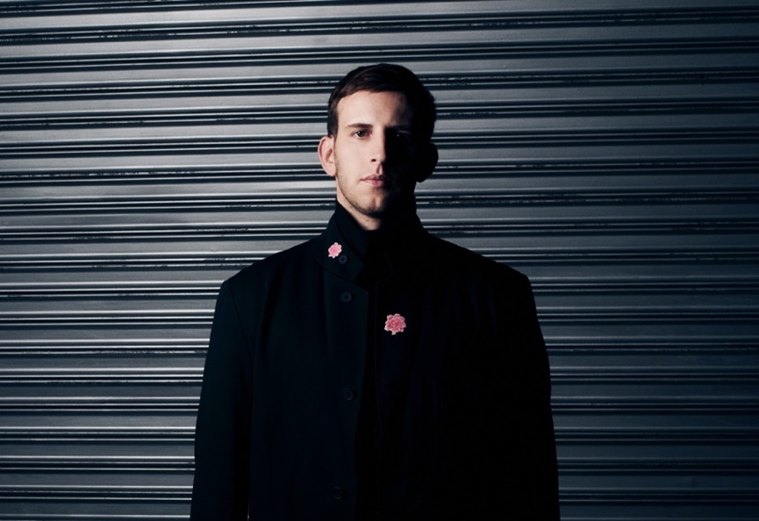
Credit: Lindsey Byrnes | Hi-Res Download HERE

FOLLOW ILLENIUM:
Website | Twitter | Instagram | Facebook | YouTube

For more information, please contact:
Darren Baber | Darren.Baber@warnerrecords.com

