PATRICK DRONEY RETURNS WITH MUCH ANTICIPATED
NEW ALBUM SUBTITLES FOR FEELINGS
LISTEN HERE

THE RUNAWAY TOUR KICKS OFF SEPTEMBER 17

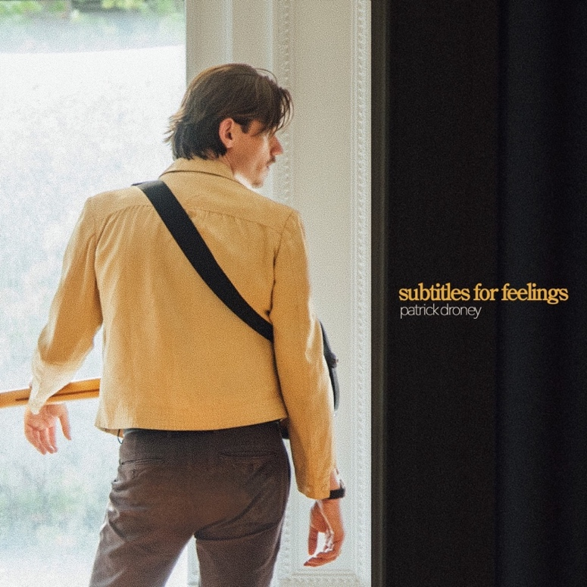
Download hi-res artwork HERE

August 25, 2023 (Los Angeles, CA) — Today, powerhouse singer, songwriter, producer, and guitarist extraordinaire Patrick Droney shares his anxiously awaited second full-length album, Subtitles For Feelings, via Warner Records. Listen HERE. Alongside the album, Droney shares a cinematic, nostalgic video for “Shotgun Rider” featuring Manifest actress Melissa Roxburgh alongside himself and his brother Conor — watch it HERE.

At its core, Subtitles for Feelings represents the idea that each frame of life holds a deeper context—a subtitle meant to be translated in time. Droney’s correspondence with his own timeline, growing up in the era of dedication lines and VHS tapes, finds its way into the very heartbeat of the album. He illustrates the narrative further in the album trailer — watch it HERE.

“Life is the movie. If there’s one subtitle you walk away from this project with, I hope it’s that,” Patrick shares. “‘Subtitles for Feelings’ is an accumulation and a translation of feelings from the film I get to call my own. It helped me process. It makes me laugh, cry, dance and cope with the journey that is understanding why we’re here. I hope you remember to rewind and read the subtitles hiding in your scenes. Make sense of the story, enjoy your movie, and keep the soundtrack close.”

Droney initially teased the raw and enigmatic Subtitles For Feelings with single “Go Getter” in May. Immediately, EUPHORIA. enthusiastically proclaimed, “‘Go Getter’ is a perfect mix of pop, adult contemporary, soul, and blues. The modern pop production is used to enhance the rock roots, while the layered choir section amplifies Droney’s drawling yet hypnotic presence behind the mic.” He then followed up with “Caroline” and “Free,” continuing to build anticipation for the LP.

Droney’s Fall 2023 North American headline run kicks off on September 17 in Boston, taking him through Chicago, Austin and Los Angeles before wrapping up in New York City on October 10. See full list of dates and purchase tickets HERE.

In between writing new music, Droney captivated audiences with performances at a Super Bowl LVII pre-game event, in the UK with The Eagles at Hyde Park and The Vamps at the O2 Arena, plus a string of sold-out headline dates. Earlier this month, Droney graced the stage of Hinterland Music Festival in Saint Charles, IA, and will soon kick off The Runaway Tour, including a performance at Pilgrimage Music & Cultural Festival in Franklin, TN on September 24.

PATRICK DRONEY THE RUNAWAY TOUR 2023 DATES:

Sep 17 Boston, MA Royale
Sep 19 Toronto, ON Axis Club
Sep 20 Cleveland, OH Grog Shop
Sep 22 Detroit, MI Shelter
Sep 23 Chicago, IL Thalia Hall
Sep 24 Franklin, TN Pilgrimage Festival
Sep 26 Fort Worth, TX Tannahil’s Tavern
Sep 27 Austin, TX Scoot Inn
Sep 30 Phoenix, AZ Crescent Ballroom
Oct 01 Los Angeles, CA Teragram Ballroom
Oct 02 San Francisco, CA Great American Music Hall
Oct 04 Tacoma, WA Spanish Ballroom
Oct 05 Vancouver, BC The Commodore Ballroom
Oct 10 New York, NY Webster Hall

SUBTITLES FOR FEELINGS TRACKLISTING:

- Baby, Baby
- Shotgun Rider
- My Grandfather’s Home
- Poems & Apologies
- Caroline
- Little Supernovas
- Limit
- Nobody Loves Me Like You Do
- Go Getter
- Memories
- Free
- Runaway
- 2AM
- Tether
- We Got Old This Year
- Wild Horses Running

About Patrick Droney:
Patrick Droney grew up in the era of dedication lines and VHS tapes. He survives on sentimentality. It hits him every time he hears Delilah on the radio or passes by the Blockbuster sign near the bodega on his corner. The Brooklyn and Nashville based artist/producer/guitar sensation returns with his sophomore album, SUBTITLES FOR FEELINGS, which explores the idea that each frame of life holds a deeper context—a subtitle meant to be translated in time. Written and co-produced by Patrick Droney with collaborators including Foy Vance, Butch Walker, Jon Green, and Lori McKenna, the songs are a deepening of his timeless, cinematic pop sound. Rewind to May 2021, when Droney released his debut album, STATE OF THE HEART. With streams now in the hundreds of millions, the project was his own coming of age film, offering striking snapshots of the human condition in songs like “Glitter” and “The Wire.” Since then, he has toured extensively, selling out shows across the U.S. and making his U.K. debut with the Eagles at London’s Hyde Park. He performed at Super Bowl LVII, claims alumni status at Late Night With Seth Meyers, The Kelly Clarkson Show, and The Late Show with Stephen Colbert, and has shared stages with Sheryl Crow, The Vamps, and more. He also released genre-bending collaborations with Kygo (“Say You Will”) and Billy F. Gibbons (“Rough Boy”). Droney is set to bring the music on the road this fall with THE RUNAWAY TOUR 2023, which ends where his journey began—in New York at Webster Hall.

# # #
Contact Rick Gershon at Warner Records Publicity:
Rick.Gershon@warnerrecords.com

Follow Patrick Droney:
Official | Instagram | Twitter | Facebook | YouTube | Spotify | Press Materials
