BREAKING NEWCOMER RETT MADISON UNVEILS “ONE FOR JACKIE, ONE FOR CRYSTAL” + VIDEO
LISTEN HERE | WATCH HERE

NEW ALBUM ONE FOR JACKIE OUT OCTOBER 27 VIA
WARNER RECORDS/WAR BUDDHA RECORDS
Credit: Mikayla Miller | Hi-res download HERE
October 6, 2023 (Los Angeles, CA) — Los Angeles-based vocalist, songwriter, and multi-instrumentalist Rett Madison unveils a new track today, “One for Jackie, One for Crystal”— listen HERE. The new track arrives alongside a video filmed by Wes O’Connor in-studio at the iconic Sonic Ranch, providing an intimate behind the scenes look at the recording of the song—watch HERE.
The new song is taken from Madison’s forthcoming album, One for Jackie, slated for release on October 27 via Warner Records/War Buddha Records—pre-order/pre-save it HERE.
Additionally, tickets are on sale for Madison’s three headline dates in New York, Nashville and Washington D.C. later this year and a run of dates with Grace Potter—get tickets HERE and see full routing below. She recently wrapped U.S. tours with The Head And The Heart, Andy Grammer, Fitz & The Tantrums and Medium Build and played her first headline show in London.
The new track follows previous offerings “Skydiving” and “Fortune Teller”—which arrived alongside a video directed by Joelle Grace Taylor (Kaytranada, Ariana Greenblatt, Rob Lowe) and choreographed by Carlena Britch (Justin Bieber, Beyonce, Gwen Stefani) and inspired Madison’s recently-launched Fortune Teller Arcana Tarot Card website.
Additionally, Madison shared a new version of “Pin-Up Daddy” in June, featuring acclaimed vocalist and songwriter Katie Pruitt, in celebration of Pride month. The original version of “Pin-Up Daddy” is taken from Madison’s debut album of the same name, produced by Theo Katzman (Kesha, Carly Rae Jepsen, Vulfpeck) and released independently in 2021 to critical acclaim.
One for Jackie is a tribute to Madison’s mom, who struggled with depression, PTSD and alcoholism for Madison’s whole life before she passed by suicide in 2019, leaving her only child with the harrowing responsibility to try and better understand her mother while she mourned her. “Writing this album, I was moving through grief,” Madison says. “It was part of my healing process.”
Recorded in Tornillo, Texas at the storied Sonic Ranch and produced by the Grammy Award-winning Tyler Chester (Madison Cunningham, Sara Bareilles, Watkins Family Hour) and featuring a collaboration with Iron & Wine, One for Jackie simultaneously borrows from legendary storytellers of the past like Bob Dylan and Bruce Springsteen while cementing itself as an American classic for fans of Phoebe Bridgers, Angel Olsen and Brandi Carlile. Between Madison’s gutting lyrics, her singular voice and her exacting creative vision, One for Jackie immerses the listener in Madison’s grief, relying on memory and raw emotion to paint a lasting picture of Jackie. Rather than flattening and sanctifying her mother in the wake of her death, Madison portrays Jackie in all her glory and complexity. The result is an album that brings Jackie to life.
Originally from West Virginia, Rett Madison is a queer singer-songwriter and multi-instrumentalist based in Los Angeles. She has been featured in publications such as Billboard, American Songwriter and Rolling Stone, where her music was described as “simultaneously brazen and vulnerable,” giving her a place “in the new school of acclaim-worthy troubadours.” She has sung backing vocals for artists such as Lorde and Kate Nash and opened for artists including Melissa Etheridge, Sheryl Crow, Elle King and more. Having independently released a handful of singles ahead of her 2021 debut album, Pin-Up Daddy, she’s worked with some of the most talented players today, including Theo Katzman, Brian Jones, Lee Pardini and Joe Dart.
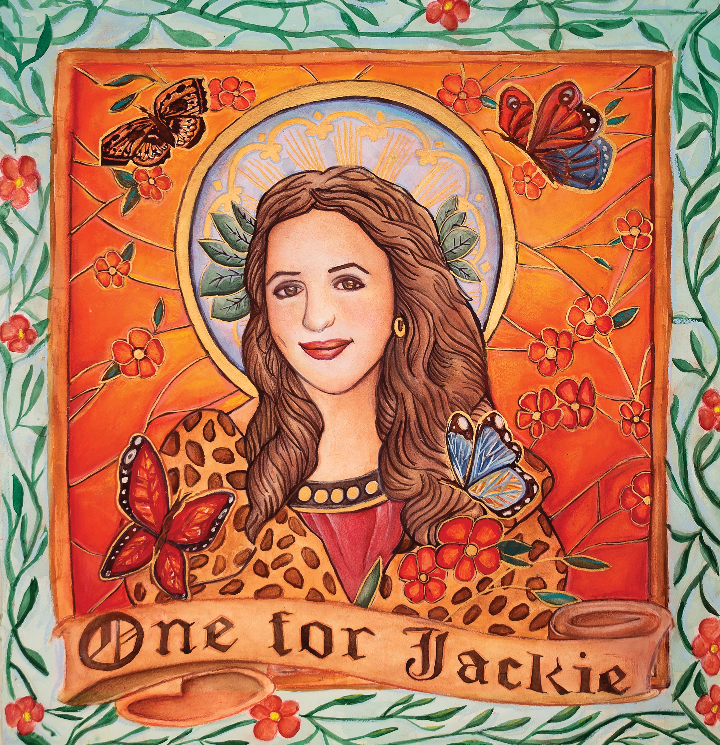
Album artwork, credit: Miriam Cortez-Các | Hi-res download HERE

One For Jackie Tracklisting:
1. Jacqueline
2. How It All Began
3. Flea Market
4. Lipstick
5. St. Luke’s
6. Ballet
7. Death Don’t Make a Bitch an Angel
8. Skydiving
9. Fortune Teller
10. One for Jackie, One for Crystal
11. Mediums, Therapists and Sheriffs
12. Kiki (Feat. Iron & Wine)
Rett Madison Live:
* with Grace Potter
Bold = Rett Madison headlining

Oct 27 Los Angeles, CA Record Safari
Nov 01 Pittsburgh, PA Stage AE *
Nov 02 Detroit, MI St. Andrew’s Hall *
Nov 03 Carmel, IN Palladium *
Nov 04 Cleveland, OH Agora Ballroom *
Nov 06 Washington, D.C. Pie Shop
Nov 08 New York, NY Mercury Lounge
Nov 10 Nashville, TN The Basement

# # #

For more information, please contact:
Rick Gershon | Warner Records Rick.Gershon@warnerrecords.com
Reid Kutrow | Sacks & Co. Reid.Kutrow@sacksco.com
Ethan Jacobs | Sacks & Co. Ethan.Jacobs@sacksco.com
Carla Sacks | Sacks & Co. Carla@sacksco.com
