BREAKING NEWCOMER RETT MADISON’S NEW ALBUM ONE FOR JACKIE OUT NOW VIA
WARNER RECORDS / WAR BUDDHA RECORDS
TOUR STARTS NOVEMBER 1 WITH GRACE POTTER AND HEADLINE SHOWS IN NEW YORK, NASHVILLE AND D.C.
Press photo, credit: Mikayla Miller
October 27, 2023 (Los Angeles, CA) — One for Jackie, the new album from Los Angeles-based vocalist, songwriter and multi-instrumentalist Rett Madison, is out today via Warner Records/War Buddha Records—listen to the album HERE and watch the video for new single “Flea Market” shot by Wes O’Connor at Sonic Ranch HERE.
“I made this album in memory of my mother and to honor my own grief,” Madison says. “I hope these songs will provide a moment of catharsis for anyone that’s lost a loved one, especially those of us that have lost someone to suicide.”
To celebrate the album, Madison will host an in-store performance in L.A. this evening at Record Safari and will also perform at Grandmaster Recorders on October 30, with her sets beginning at 7 p.m. PST both nights. Additionally, she will play three headline shows in New York, Nashville and Washington D.C. next month following a run of dates with Grace Potter—get tickets HERE and see full routing below. Madison recently wrapped U.S. tours with The Head And The Heart, Andy Grammer, Fitz & The Tantrums and Medium Build and played her first headline show in London. She will also be spotlighted in an upcoming Mixtape Moments segment on “CBS Mornings.”
One for Jackie features a collaboration with Iron & Wine and previously shared singles “One for Jackie, One for Crystal,” “Skydiving” and “Fortune Teller,” which arrived alongside a video directed by Joelle Grace Taylor (Kaytranada, Ariana Greenblatt, Rob Lowe) and choreographed by Carlena Britch (Justin Bieber, Beyonce, Gwen Stefani) and inspired Madison’s recently-launched Fortune Teller Arcana Tarot Card website.
One for Jackie is a tribute to Madison’s mom, who struggled with depression, PTSD and alcoholism for Madison’s whole life before she passed by suicide in 2019, leaving her only child with the harrowing responsibility to try and better understand her mother while she mourned her. “Writing this album, I was moving through grief,” Madison says. “It was part of my healing process.”
Recorded in Tornillo, Texas at the storied Sonic Ranch and produced by the Grammy Award-winning Tyler Chester (Madison Cunningham, Sara Bareilles, Watkins Family Hour), One for Jackie simultaneously borrows from legendary storytellers of the past like Bob Dylan and Bruce Springsteen while cementing itself as an American classic for fans of Phoebe Bridgers, Angel Olsen and Brandi Carlile. Between Madison’s gutting lyrics, her singular voice and her exacting creative vision, One for Jackie immerses the listener in Madison’s grief, relying on memory and raw emotion to paint a lasting picture of Jackie. Rather than flattening and sanctifying her mother in the wake of her death, Madison portrays Jackie in all her glory and complexity. The result is an album that brings Jackie to life.
Additionally, Madison shared a new version of “Pin-Up Daddy” in June, featuring acclaimed vocalist and songwriter Katie Pruitt, in celebration of Pride month. The original version of “Pin-Up Daddy” is taken from Madison’s debut album of the same name, produced by Theo Katzman (Kesha, Carly Rae Jepsen, Vulfpeck) and released independently in 2021 to critical acclaim.
Originally from West Virginia, Rett Madison is a queer singer-songwriter and multi-instrumentalist based in Los Angeles. She has been featured in publications such as Billboard, American Songwriter and Rolling Stone, where her music was described as “simultaneously brazen and vulnerable,” giving her a place “in the new school of acclaim-worthy troubadours.” She has sung backing vocals for artists such as Lorde and Kate Nash and opened for artists including Melissa Etheridge, Sheryl Crow, Elle King and more. Having independently released a handful of singles ahead of her 2021 debut album, Pin-Up Daddy, she’s worked with some of the most talented players today, including Theo Katzman, Brian Jones, Lee Pardini and Joe Dart.
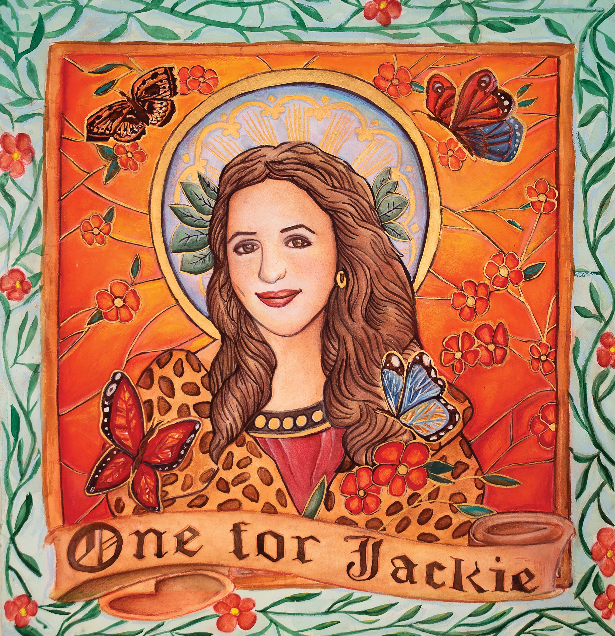
Album artwork, credit: Miriam Cortez-Các
RETT MADISON—ONE FOR JACKIE

1. Jacqueline
2. How It All Began
3. Flea Market
4. Lipstick
5. St. Luke’s
6. Ballet
7. Death Don’t Make a Bitch an Angel
8. Skydiving
9. Fortune Teller
10. One for Jackie, One for Crystal
11. Mediums, Therapists and Sheriffs
12. Kiki feat. Iron & Wine
RETT MADISON LIVE
October 27—Los Angeles, CA—Record Safari
October 30—Los Angeles, CA—Grandmaster Recorders
November 1—Pittsburgh, PA—Stage AE*
November 2—Detroit, MI—St. Andrew’s Hall*
November 3—Carmel, IN—Palladium*
November 4—Cleveland, OH—Agora Ballroom*
November 5—Rocky Mount, VA—Harvester Performance Center*
November 6—Washington, D.C.—Pie Shop
November 8—New York, NY—Mercury Lounge
November 10—Nashville, TN—The Basement
* with Grace Potter
Bold = Rett Madison headlining
# # #

For more information, please contact:
Rick Gershon | Warner Records Rick.Gershon@warnerrecords.com
Reid Kutrow | Sacks & Co. Reid.Kutrow@sacksco.com
Ethan Jacobs | Sacks & Co. Ethan.Jacobs@sacksco.com
Carla Sacks | Sacks & Co. Carla@sacksco.com
