RISING STAR RETT MADISON’S NEW ALBUM
ONE FOR JACKIE OUT OCTOBER 27 VIA WARNER RECORDS/WAR BUDDHA RECORDS FEATURING THE TRACK/VIDEO “SKYDIVING”
CONFIRMS HEADLINE DATES IN NEW YORK, NASHVILLE AND D.C. PLUS UPCOMING U.S. TOUR WITH MEDIUM BUILD AND GRACE POTTER

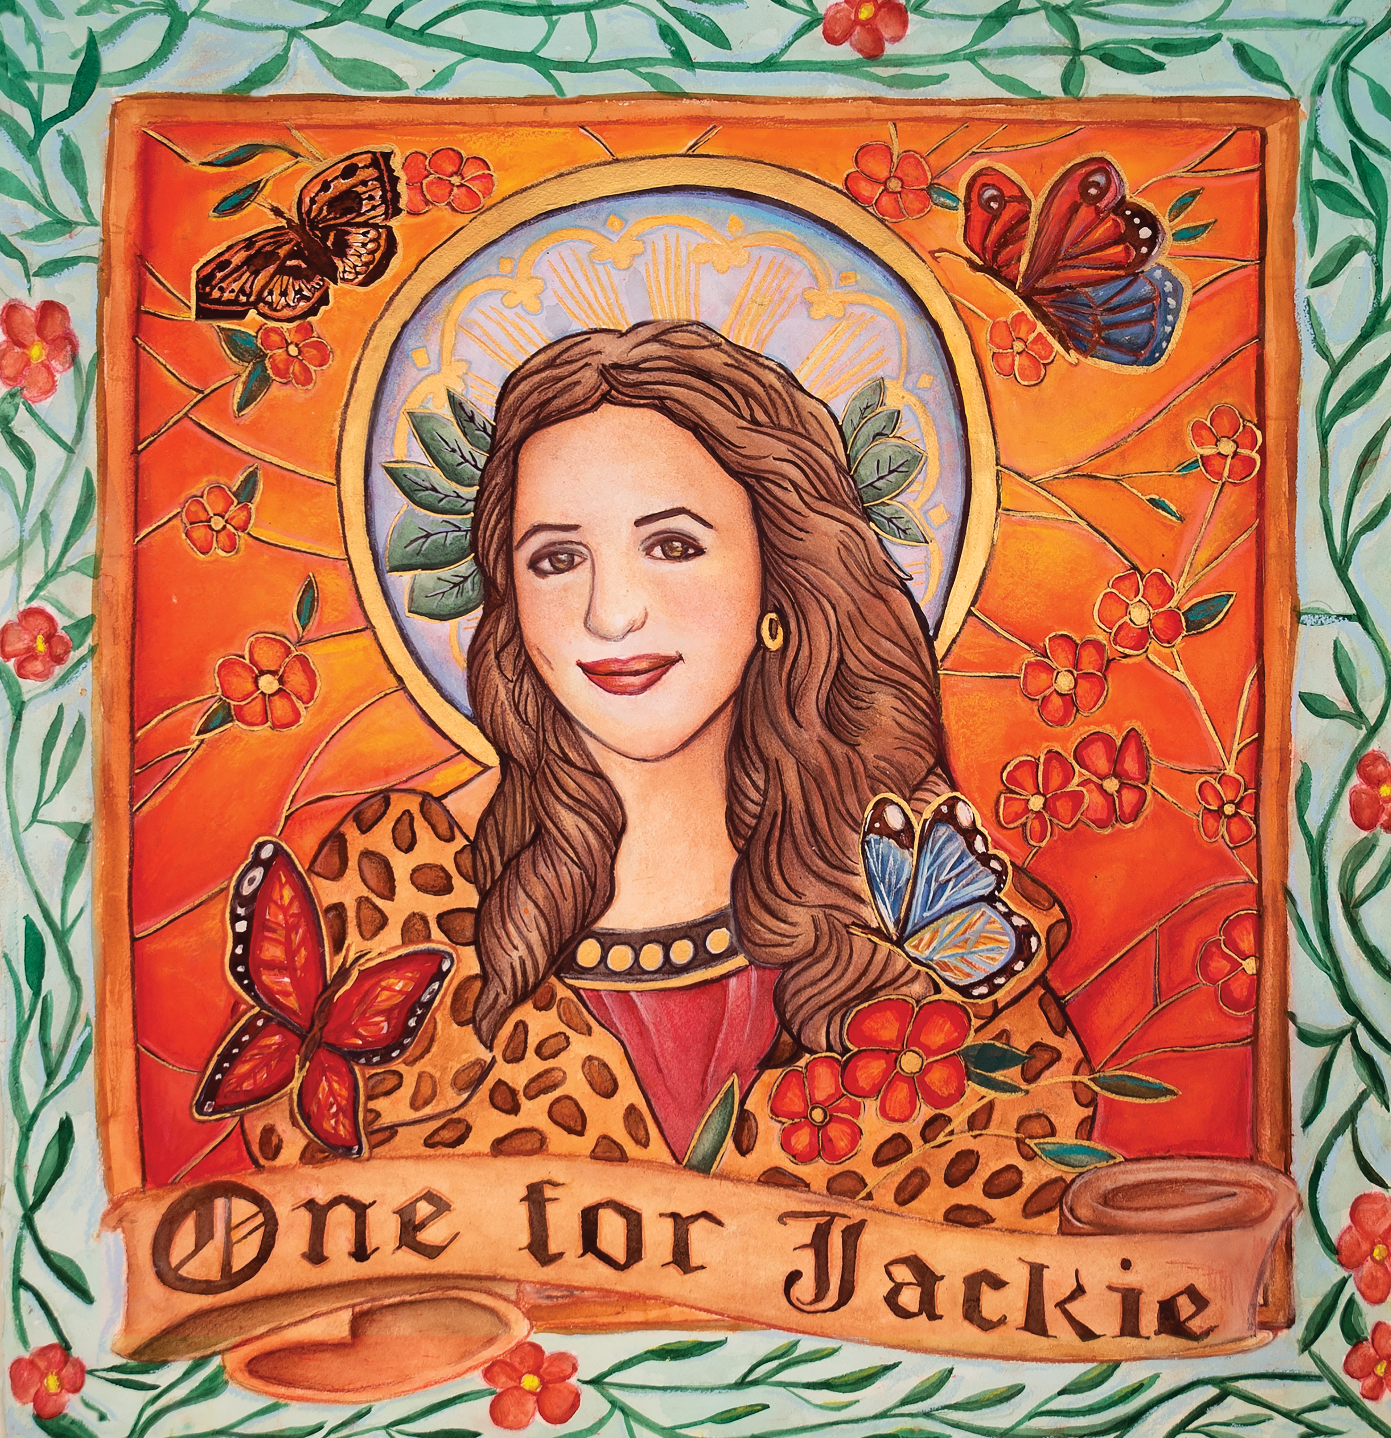
(Album artwork by Miriam Cortez-Cáceres HERE | Press photo by Mikayla Miller HERE)
September 15, 2023 (Los Angeles, CA) — One for Jackie, the new album from Los Angeles-based vocalist, songwriter and multi-instrumentalist Rett Madison, is slated for release on October 27 via Warner Records/War Buddha Records — pre-order HERE. Today, Madison debuts a new track from the album, “Skydiving,” which arrives alongside a video directed by and featuring Madison’s partner Wes O’Connor — listen HERE and watch HERE.
“‘Skydiving’ was the first song I brought to Tyler Chester,” Madison says. “We were working out of his home studio in a garage where we tracked my vocal that was originally intended to just be on the demo but is what ultimately became the final vocal on the album. Working with Tyler that day was so exciting. I felt so creatively inspired by his instincts with arrangement and production. He totally transformed this song I’d brought in on acoustic guitar to a full rock vibe.”
Additionally, Madison adds three headline dates in New York, Nashville and Washington D.C. later this year following a run of U.S. shows with Medium Build and Grace Potter—get tickets HERE and see full routing below. She recently played her first headline show in London and toured the U.S. with The Head And The Heart, Andy Grammer, and Fitz & The Tantrums.
The new track follows the album’s lead single, “Fortune Teller”—which arrived alongside a video directed by Joelle Grace Taylor (Kaytranada, Ariana Greenblatt, Rob Lowe) and choreographed by Carlena Britch (Justin Bieber, Beyonce, Gwen Stefani) and inspired Madison’s recently-launched Fortune Teller Arcana Tarot Card website and a new version of “Pin-Up Daddy,” featuring acclaimed vocalist and songwriter Katie Pruitt, released in June in celebration of Pride month. The original version of “Pin-Up Daddy” is taken from Madison’s debut album of the same name, produced by Theo Katzman (Kesha, Carly Rae Jepsen, Vulfpeck) and released independently in 2021 to critical acclaim.
One for Jackie is a tribute to Madison’s mom, who struggled with depression, PTSD and alcoholism for Madison’s whole life before she passed by suicide in 2019, leaving her only child with the harrowing responsibility to try and better understand her mother while she mourned her. “Writing this album, I was moving through grief,” Madison says. “It was part of my healing process.”
Recorded in Tornillo, Texas at the storied Sonic Ranch and produced by the Grammy Award-winning Tyler Chester (Madison Cunningham, Sara Bareilles, Watkins Family Hour) and featuring a collaboration with Iron & Wine, One for Jackie simultaneously borrows from legendary storytellers of the past like Bob Dylan and Bruce Springsteen while cementing itself as an American classic for fans of Phoebe Bridgers, Angel Olsen and Brandi Carlile. Between Madison’s gutting lyrics, her singular voice and her exacting creative vision, One for Jackie immerses the listener in Madison’s grief, relying on memory and raw emotion to paint a lasting picture of Jackie. Rather than flattening and sanctifying her mother in the wake of her death, Madison portrays Jackie in all her glory and complexity. The result is an album that brings Jackie to life.
Originally from West Virginia, Rett Madison is a queer singer-songwriter and multi-instrumentalist based in Los Angeles. She has been featured in publications such as Billboard, American Songwriter and Rolling Stone, where her music was described as “simultaneously brazen and vulnerable,” giving her a place “in the new school of acclaim-worthy troubadours.” She has sung backing vocals for artists such as Lorde and Kate Nash and opened for artists including Melissa Etheridge, Sheryl Crow, Elle King, and more. Having independently released a handful of singles ahead of her 2021 debut album, Pin-Up Daddy, she’s worked with some of the most talented players today, including Theo Katzman, Brian Jones, Lee Pardini and Joe Dart.

One For Jackie Tracklisting:
1. Jacqueline
2. How It All Began
3. Flea Market
4. Lipstick
5. St. Luke’s
6. Ballet
7. Death Don’t Make a Bitch an Angel
8. Skydiving
9. Fortune Teller
10. One for Jackie, One for Crystal
11. Mediums, Therapists and Sheriffs
12. Kiki (Feat. Iron & Wine)

Rett Madison Live:
§ with Medium Build
* with Grace Potter
Bold = Rett Madison headlining
Sep 21 Louisville, KY Zanzabar §
Sep 22 Pittsburgh, PA Club Café §
Sep 23 Columbus, OH The Basement §
Sep 25 Chicago, IL Schubas Tavern §
Sep 26 Minneapolis, MN 7th Street Entry §
Sep 27 Omaha, NE Reverb Lounge §
Sep 29 Denver, CO Globe Hal l§
Oct 01 Oklahoma City, OK Pony Boy §
Oct 27 Los Angeles, CA Record Safari
Nov 01 Pittsburgh, PA Stage AE *
Nov 02 Detroit, MI St. Andrew’s Hall *
Nov 03 Carmel, IN Palladium *
Nov 04 Cleveland, OH Agora Ballroom *
Nov 06 Washington, D.C. Pie Shop
Nov 08 New York, NY Mercury Lounge
Nov 10 Nashville, TN The Basement

# # #

For more information, please contact:
Rick Gershon | Warner Records Rick.Gershon@warnerrecords.com
Reid Kutrow | Sacks & Co. Reid.Kutrow@sacksco.com
Ethan Jacobs | Sacks & Co. Ethan.Jacobs@sacksco.com
Carla Sacks | Sacks & Co. Carla@sacksco.com
