THE FLAMING LIPS LIVE AT THE FORUM, LONDON, UK JAN. 22, 2003 AVAILABLE NOW VIA WARNER RECORDS
15 TRACK IN-CONCERT SET TAKEN FROM YOSHIMI BATTLES THE PINK ROBOTS 20TH ANNIVERSARY DELUXE EDITION ON LIMITED EDITION PINK VINYL
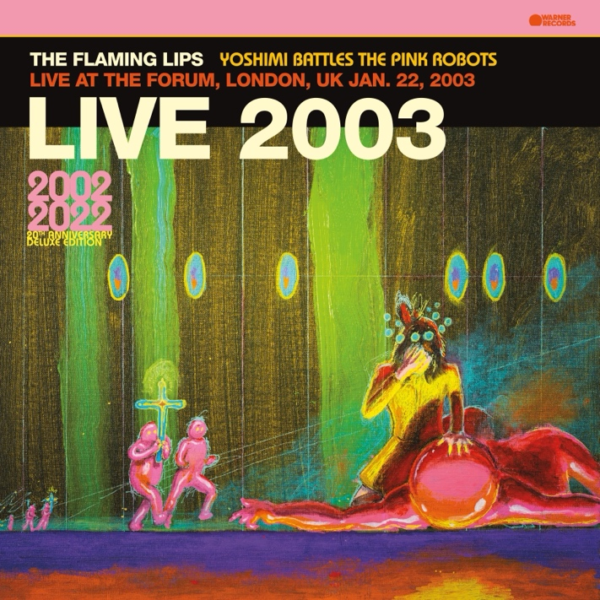
(Download hi-res artwork HERE)

October 27, 2023 — (Los Angeles, CA): Today, The Flaming Lips unveil a very special vinyl only concert album, Live At The Forum, London, UK Jan. 22, 2003, via Warner Records. The vintage live collection, recorded by the BBC, was originally included in the 6-CD format of the 20th Anniversary Deluxe Edition of YOSHIMI BATTLES THE PINK ROBOTS box set is available on vinyl for the first time as a stand-alone release. The limited edition first-pressing of Live At The Forum is on pink vinyl. Click HERE to order, and click HERE to watch Wayne Coyne’s unboxing video.

Following the original release of the classic YOSHIMI BATTLES THE PINK ROBOTS in 2002, The Flaming Lips visited the UK multiple times due to the critical reception of YOSHIMI and the demand for tickets. The band concluded their UK run in 2003 with a sold-out show at London’s Forum Theatre on January 22, broadcast live across the country.
Live At The Forum TRACKLISTING:
1. Introduction
2. Race For The Prize
3. Fight Test
4. Lucifer Sam
5. Yoshimi Battles The Pink Robots
6. Lightning Strikes The Postman
7. In The Morning Of The Magicians
8. Happy Birthdays
9. She Don't Use Jelly
10. All We Have Is Now
11. Do You Realize??
12. Waitin' For A Superman
13. A Spoonful Weighs A Ton
14. What Is The Light?
15. The Observer

About The Flaming Lips:
Formed in Oklahoma City, OK in 1983, The Flaming Lips have since become one of the most iconic, influential, unpredictable, and vital forces in American alternative rock music. The band has garnered three GRAMMY® Awards, a Tony nomination, and an RIAA Gold-certified Record for YOSHIMI BATTLES THE PINK ROBOTS. UK’s Q Magazine named them one of the “50 Bands to See Before You Die.” The band has made countless late night television appearances, appeared in a Super Bowl commercial, contributed to many film soundtracks, and collaborated with artists such as Miley Cyrus, Coldplay’s Chris Martin, Kacey Musgraves, Yoko Ono, The Chemical Brothers, and so many more. They have set countless records, broken records, created spectacular interactive audio/visual events now regarded as legendary. Front man Wayne Coyne has been recognized for works of art that graced many LIPS album covers along with his traveling art exhibit “The King’s Mouth,” an audiovisual art installation that has been featured in many contemporary art museums around the US. Their latest LP, American Head, marks a return to a more melodic and song-oriented body of work and has critically been lauded as their best work in years placing on several Year End/Best Of lists around the world. Evan after a combination of 22 studio recordings, 16 singles, 11 compilations, 11 EP’s and 11 self-released experimental collaborative oddities released in various forms, quantities and unique mediums, The Flaming Lips remain in a creative apex that has no bounds. To that end, they have become an American Treasure and created a genre all to themselves.

# # #
For further information, contact Warner Records:
National: Rick.Gershon@warnerrecords.com
Regional: Delanee.Wilson@warnerrecords.com

Follow The Flaming Lips:
Website | Twitter | Instagram | Facebook | YouTube | TikTok | Spotify | Press Materials
