ZACH BRYAN ANNOUNCES THE QUITTIN TIME 2024 TOUR

NEW SELF-TITLED ALBUM OUT NOW VIA WARNER RECORDS

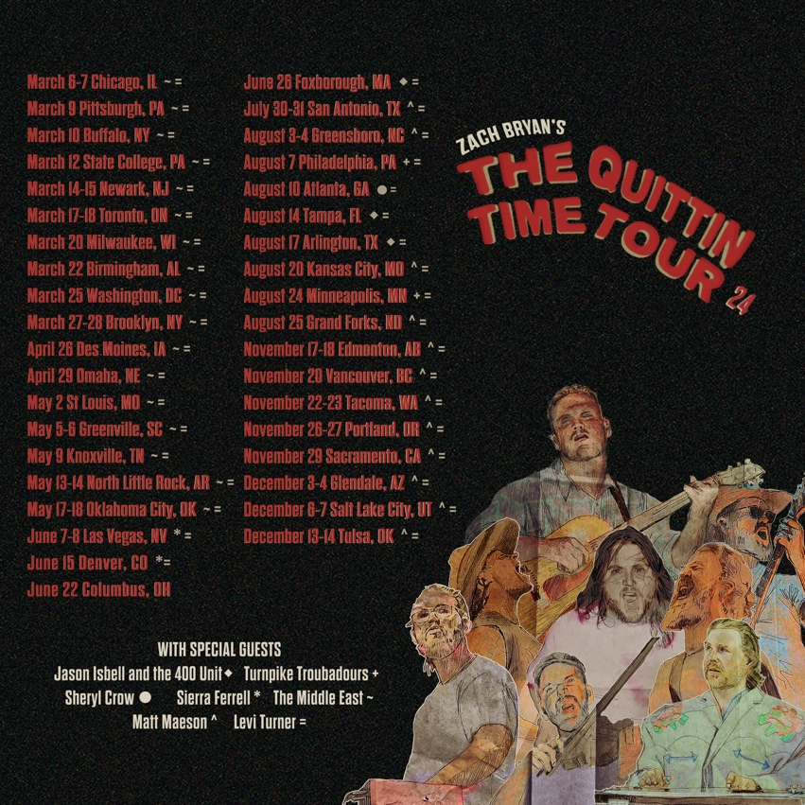

August 28, 2023 (Los Angeles, CA) – Today, Zach Bryan announces his 2024 North American run, The Quittin Time Tour. The news comes just days after the singer-songwriter-producer released his fourth full-length studio album, Zach Bryan, available HERE via Warner Records. Fans can register for presale access HERE, with presale beginning on September 6. General on-sale begins September 8.

Bryan's 2024 tour will take place in stadiums and major arenas across North America, kicking off in Chicago with two shows at the United Center on March 6 and 7, before heading out coast to coast with stops at football stadiums in Denver, Foxborough, Philadelphia, Atlanta, Tampa, Arlington, and Minneapolis. The tour will conclude in his hometown of Tulsa, Oklahoma with two shows at the BOK Center on December 13 and 14. The shows will be supported by The Middle East, Jason Isbell and the 400 Unit, Turnpike Troubadours, Sheryl Crow, Sierra Ferrell, Matt Maeson, and Levi Turner.

The 27-year-old has built a hard-won reputation as an in-concert force of nature, second to none, as evidenced by anyone who attended shows from his Burn, Burn, Burn Tour which wraps in Kansas City at the end of the month. All shows sold out instantly several months in advance, and he set new attendance records at several venues along the way.

The new 16-track body of work explores the Grammy-nominated singer’s southern states roots that combine a litany of varied musical and literary influences that might be best described as “Zach Bryan music.” Written and produced entirely by Bryan himself, the self-titled album features raw and unfiltered stories that speak from the heart directly to his ever-growing global fanbase. Zach Bryan boasts collaborations with Kacey Musgraves, The Lumineers, Sierra Ferrell, and The War and Treaty.

Zach Bryan’s The Quittin Time Tour 2024 Dates:
Support Acts:
* The Middle East
+ Jason Isbell and the 400 Unit
% Turnpike Troubadours
! Sheryl Crow
# Sierra Ferrell
@ Matt Maeson
^ Levi Turner

Italics indicate Live Nation date

March 06 Chicago, IL United Center *^
March 07 Chicago, IL United Center *^
March 09 Pittsburgh, PA PPG Paints Arena *^
March 10 Buffalo, NY KeyBank Center *^
March 12 State College, PA Bryce Jordan Center *^
March 14 Newark, NJ Prudential Center *^
March 15 Newark, NJ Prudential Center *^
March 17 Toronto, ON Scotiabank Arena *^
March 18 Toronto, ON Scotiabank Arena *^
March 20 Milwaukee, WI Fiserv Forum *^
March 22 Birmingham, AL Legacy Arena at the BJCC *^
March 25 Washington, D.C. Capital One Arena *^
March 27 Brooklyn, NY Barclays Center *^
March 28 Brooklyn, NY Barclays Center *^
April 26 Des Moines, IA Wells Fargo Arena *^
April 29 Omaha, NE CHI Health Center *^
May 02 St. Louis, MO Enterprise Center *^
May 05 Greenville, SC Bon Secours Wellness Arena *^
May 06 Greenville, SC Bon Secours Wellness Arena *^
May 09 Knoxville, TN Thompson-Boling Arena at Food City Center *^
May 13 North Little Rock, AR Simmons Bank Arena *^
May 14 North Little Rock, AR Simmons Bank Arena *^
May 17 Oklahoma City, OK Paycom Center *^
May 18 Oklahoma City, OK Paycom Center *^
June 07 Las Vegas, NV T-Mobile Arena #^
June 08 Las Vegas, NV T-Mobile Arena #^
June 15 Denver, CO Empower Field at Mile High #^
June 22 Columbus, OH Buckeye Country Superfest
June 26 Foxborough, MA Gillette Stadium +^
July 30 San Antonio, TX AT&T Center @^
July 31 San Antonio, TX AT&T Center @^
August 03 Greensboro, NC Greensboro Coliseum @^
August 04 Greensboro, NC Greensboro Coliseum @^
August 07 Philadelphia, PA Lincoln Financial Field %^
August 10 Atlanta, GA Mercedes-Benz Stadium !^
August 14 Tampa, FL Raymond James Stadium +^
August 17 Arlington, TX AT&T Stadium +^
August 20 Kansas City, MO T-Mobile Center @^
August 24 Minneapolis, MN U.S. Bank Stadium %^
August 25 Grand Forks, ND Alerus Center @^
November 17 Edmonton, AB Rogers Place @^
November 18 Edmonton, AB Rogers Place @^
November 20 Vancouver, BC Rogers Arena @^
November 22 Tacoma, WA Tacoma Dome @^
November 23 Tacoma, WA Tacoma Dome @^
November 26 Portland, OR Moda Center @^
November 27 Portland, OR Moda Center @^
November 29 Sacramento, CA Golden 1 Center @^
December 03 Glendale, AZ Desert Diamond Arena @^
December 04 Glendale, AZ Desert Diamond Arena @^
December 06 Salt Lake City, UT Delta Center @^
December 07 Salt Lake City, UT Delta Center @^
December 13 Tulsa, OK BOK Center @^
December 14 Tulsa, OK BOK Center @^

ABOUT AEG PRESENTS
Combining the power of the live event with a focus on true artist development, AEG Presents is a world leader in the music and entertainment industries. Operating across five continents, the company has an unparalleled commitment to artistry, creativity, and community. Its tentpole festivals and multi-day music events — which include the iconic Coachella Valley Music & Arts Festival and the legendary New Orleans Jazz & Heritage Festival alongside British Summer Time at Hyde Park, Stagecoach, Hangout Festival, Electric Forest, Rock En Seine and All Points East — continue to set the bar for the live music experience. AEG Presents promotes global tours for artists such as Justin Bieber, Blackpink, Kenny Chesney, Celine Dion, Elton John, Karol G, Paul McCartney, Katy Perry, The Rolling Stones, Ed Sheeran, Taylor Swift, and Tyler, The Creator, in addition to — through its network of clubs, theatres, arenas, stadiums and renowned partner brands such as The Bowery Presents, Concerts West, Frontier Touring, Goldenvoice, Marshall Arts, Messina Touring Group, PromoWest Productions, and Zero Mile Presents — creating and developing an unmatched infrastructure for artist development and audience reach. More information can be found at www.aegpresents.com.

# # #

For more information, please contact:
National: Rick Gershon | Warner Records
Rick.Gershon@warnerrecords.com

Regional/Tour: Delanee Wilson | Warner Records
Delanee.Wilson@warnerrecords.com

FOLLOW ZACH BRYAN:
Website | Instagram | TikTok | Twitter | YouTube | Press Materials

