ZACH BRYAN RELEASES BOYS OF FAITH EP FEATURING COLLABORATIONS WITH NOAH KAHAN & BON IVER

ARRIVES JUST WEEKS AFTER #1 SELF-TITLED ALBUM

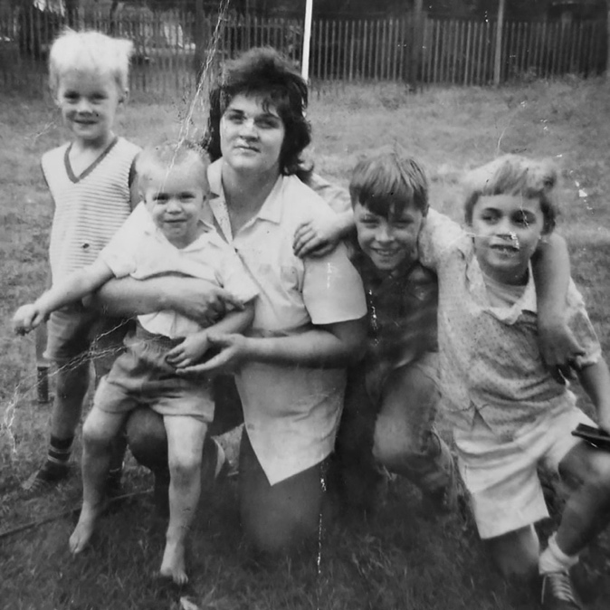
(Photo courtesy of Bryan family archives: grandmother, father, and uncles.
Click HERE for hi-res cover art)

September 22, 2023 (Los Angeles, CA) – Today, singer, songwriter, and producer Zach Bryan releases a brand new 5-song EP titled Boys Of Faith via Warner Records, featuring collaborations with Noah Kahan and Bon Iver. Boys Of Faith arrives only a matter of weeks after the Grammy-nominated artist's critically acclaimed self-titled, self-written and produced album, which entered the Billboard 200 chart at #1 and simultaneously topped Billboard’s Country, Rock & Alternative, Americana/Folk, and Rock album charts. Click HERE to stream Boys Of Faith.

Once again written and produced by Bryan, Boys Of Faith kicks off with “Nine Ball” followed by “Sarah’s Place” featuring Noah Kahan. "We always knew you were the better half of our good times," they harmonize on the rollicking track. "Those backyard lights don't shine as bright without your face."

Also included on the EP is the previously unreleased fan favorite “Deep Satin,” the only track co-produced along with Eddie Spear, with whom Bryan worked on American Heartbreak. The title track, a duet with Bon Iver, is particularly notable due to the pair's creative chemistry. “But you stuck around when I was down,” they sing over sparse guitar, drums, and piano, "and I’ll owe you all my days." The EP concludes with the emotionally unfiltered “Pain, Sweet, Pain.”

BOYS OF FAITH EP Tracklisting:
1. Nine Ball
2. Sarah’s Place (Feat. Noah Kahan)
3. Boys Of Faith (Feat. Bon Iver)
4. Deep Satin
5. Pain, Sweet, Pain

Boys Of Faith arrives in the wake of Zach Bryan, released on August 25, which immediately impacted charts around the world, including #1 in the US and Canada, #2 in Australia and Ireland, #4 in New Zealand, and #5 in Australia. Additionally, “I Remember Everything” featuring Kacey Musgraves topped the Billboard Hot 100, Hot Country Songs, Hot Rock Songs, and Hot Rock & Alternative Songs charts at once, making chart history by being the first song ever to do so.

As previously mentioned, Bryan and his band have concluded their sold-out 2023 Burn Burn Burn Tour, yet a few dates remain while prepping for The Quittin Time 2024 Tour. The massive live trek kicks off in Chicago at the United Center on March 6 and 7, before visiting major stadiums and arenas all over the U.S. and Canada. Support acts include Jason Isbell and the 400 Unit, Turnpike Troubadours, Sheryl Crow, Sierra Ferrell, Matt Maeson, Levi Turner, as well as the newly reformed Australian favorites The Middle East. The Quittin Time 2024 Tour will be Bryan's most ambitious set of live shows to date. Click HERE for the 2024 tour ticket details.

Remaining 2023 Show dates:
Sep 24 Franklin, TN Pilgrimage Music Festival (w/ Lumineers)
Oct 07 Opelika, Al Auburn Rodeo
Oct 20 Fort Worth, TX Gordy’s HWY 30 Music Fest Texas Edition
Oct 21 College Station, TX At the Station Festival
Dec 30 San Diego, CA Wild Horses Festival

# # #

For further information, please contact:

National: Rick Gershon | Warner Records
Rick.Gershon@warnerrecords.com

Regional/Tour: Delanee Wilson | Warner Records
Delanee.Wilson@warnerrecords.com

FOLLOW ZACH BRYAN:
Website | Instagram | TikTok | X | YouTube | Press Materials

