**BUZZING LOS ANGELES DUO SKYECHRISTY UNVEIL DEBUT EP**

***THE SUMMER I LOST MY LOVER***

[**LISTEN HERE**](https://SkyeChristy.lnk.to/tsilml)

**WATCH VIDEO FOR NEW TRACK “PRIME YEARS”** [**HERE**](https://SkyeChristy.lnk.to/PrimeYearsVideo)

**NEW DATES WITH JVKE & MANCHESTER ORCHESTRA JUST ANNOUNCED**

**July 21, 2023 (Los Angeles, CA) –** Buzzing Los Angeles sister duo **SkyeChristy** excitedlypresent their debut EP ***The Summer I Lost My Lover***, out now on **Warner Records**. Listen [**HERE**](https://SkyeChristy.lnk.to/tsilml). The new seven-track project features recent singles [**“Fake Love**,**”**](https://www.youtube.com/watch?v=n1jdhKn6yCw) [**“Beach Zombies,”**](https://www.youtube.com/watch?v=zclLOd_Zar0) [**“I’m Not Like Alice,”**](https://www.youtube.com/watch?v=TnGYk6-t9NY) and [**“Friday Night Thriller**,**”**](https://nam04.safelinks.protection.outlook.com/?url=https%3A%2F%2Fwww.youtube.com%2Fwatch%3Fv%3D4GDRO6Dx6iA&data=05%7C01%7CPatrice.Compere%40warnerrecords.com%7C96b20a2aacfc42ac66e508db86f5735d%7C8367939002ec4ba1ad3d69da3fdd637e%7C0%7C0%7C638252161007789282%7CUnknown%7CTWFpbGZsb3d8eyJWIjoiMC4wLjAwMDAiLCJQIjoiV2luMzIiLCJBTiI6Ik1haWwiLCJXVCI6Mn0%3D%7C3000%7C%7C%7C&sdata=vJSALqgVboj5NbBnzSFOJNKrBNsIqmw2tEwengPt51Q%3D&reserved=0)as well as nostalgic new track **“Prime Years,”** which debuts today alongside a stunning official video. Watch it [**HERE.**](https://SkyeChristy.lnk.to/PrimeYearsVideo)

***The Summer I Lost My Lover*** unspools vivid recollections of love in full bloom, heartbreak, confusion, anxiety, and acceptance over dusky handcrafted soundscapes. Distant chatter spills into hazy production on the vivid opener **“Family Barbecue**.**”** Through breathy delivery, the girls wonder, *“What will I tell my cousins at the next family barbecue when my whole life, whole life, is woven into you*.*”* Cinematic strings accent the nostalgic **“Prime Years**,**”** while the conclusion **“Night Before”** layers quietly cathartic harmonies above soft finger-picked acoustic guitar.

Next up, **SkyeChristy** will hit the road with **JVKE**. This run kicks off on August 3 at Vogue Theater in Vancouver, BC, visits a handful of major West Coast markets, and concludes on August 8 at The Wiltern in Los Angeles, CA. In October, they venture across the pond to support **Manchester Orchestra** on four UK shows. See a full list of dates below.

The sister duo is a sonic union of Georgia Christy Edwards and Sophie Skye Edwards. The Los Angeles natives began writing and recording music together in high school. They honed their voices in choir, even performing at Carnegie Hall as part of their school ensemble choir. Since 2020, they’ve unlocked the power of their familial harmony and have captivated fans around the globe. With their distinct signature sound and forthcoming debut project, the **SkyeChristy’s** bond will only grow stronger. Get ready for a whole lot more coming soon.

**EP TRACKLISTING:**

1. “Family Barbecue”

2. “I’m Not Like Alice”

3. “Beach Zombies”

4. “Fake Love”

5. “Prime Years”

6. “Friday Night Thriller”

7. “Night Before”

**UPCOMING TOUR DATES**

**w/ JVKE**

8/3 Vancouver, BC Vogue Theater

8/4 Seattle, WA Showbox Sodo

8/5 Portland, OR McMenamins Crystal Ballroom

8/7 Oakland, CA Fox Theater

8/8 Los Angeles, CA The Wiltern

**w/ Manchester Orchestra**

10/1 London, UK Union Chapel

10/2 London, UK Union Chapel

10/3 London, UK Union Chapel

10/5 Manchester, UK Academy 2

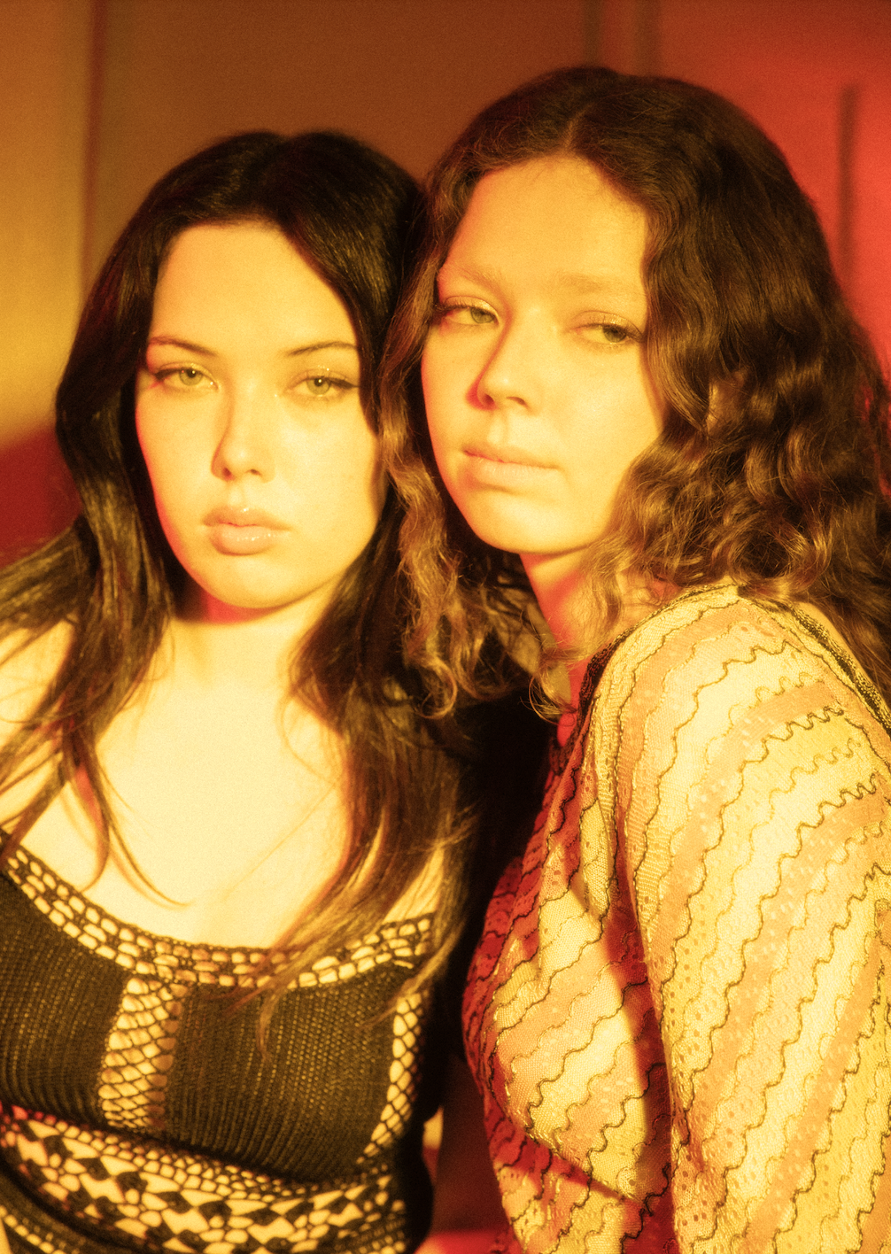

Credit: Joelle Grace Taylor – [High Res HERE](https://press.warnerrecords.com/skyechristy)

# # #

**Stay Up-To-Date With SkyeChristy**

[TikTok](https://nam04.safelinks.protection.outlook.com/?url=https%3A%2F%2Fwww.tiktok.com%2F%40skyechristytheband&data=05%7C01%7CConnor.Hunt%40warnerrecords.com%7Cd05c318dea8b4a69b53f08dacd7c26a8%7C8367939002ec4ba1ad3d69da3fdd637e%7C0%7C0%7C638048230356038633%7CUnknown%7CTWFpbGZsb3d8eyJWIjoiMC4wLjAwMDAiLCJQIjoiV2luMzIiLCJBTiI6Ik1haWwiLCJXVCI6Mn0%3D%7C3000%7C%7C%7C&sdata=xII%2FaAnT7mNSR8bibmlKS9BjoJHOw2tkuvvYoGXyLdk%3D&reserved=0) | [Instagram](https://nam04.safelinks.protection.outlook.com/?url=https%3A%2F%2Fwww.instagram.com%2Fskyechristytheband%2F&data=05%7C01%7CConnor.Hunt%40warnerrecords.com%7Cd05c318dea8b4a69b53f08dacd7c26a8%7C8367939002ec4ba1ad3d69da3fdd637e%7C0%7C0%7C638048230356038633%7CUnknown%7CTWFpbGZsb3d8eyJWIjoiMC4wLjAwMDAiLCJQIjoiV2luMzIiLCJBTiI6Ik1haWwiLCJXVCI6Mn0%3D%7C3000%7C%7C%7C&sdata=60t%2BQ%2F%2B1aboOBIAozhsDBepILXVbhj2zuq5ciOHU%2Fzo%3D&reserved=0) | [YouTube](https://www.youtube.com/@skyechristytheband)

**For More Information:**

Connor Hunt // [connor.hunt@warnerrecords.com](mailto:connor.hunt@warnerrecords.com)

Patrice Compere // [patrice.compere@warnerrecords.com](mailto:patrice.compere@warnerrecords.com)