MULTI-GRAMMY AWARD WINNER GARY CLARK JR. RETURNS
WITH FIRST NEW MUSIC IN NEARLY FIVE YEARS

FOUR NEW SONGS AVAILABLE NOW AS INTRODUCTION TO HIGHLY ANTICIPATED LP JPEG RAW SET FOR MARCH 22 RELEASE VIA WARNER RECORDS

CLICK HERE TO LISTEN / CLICK HERE TO PRE-ORDER ALBUM

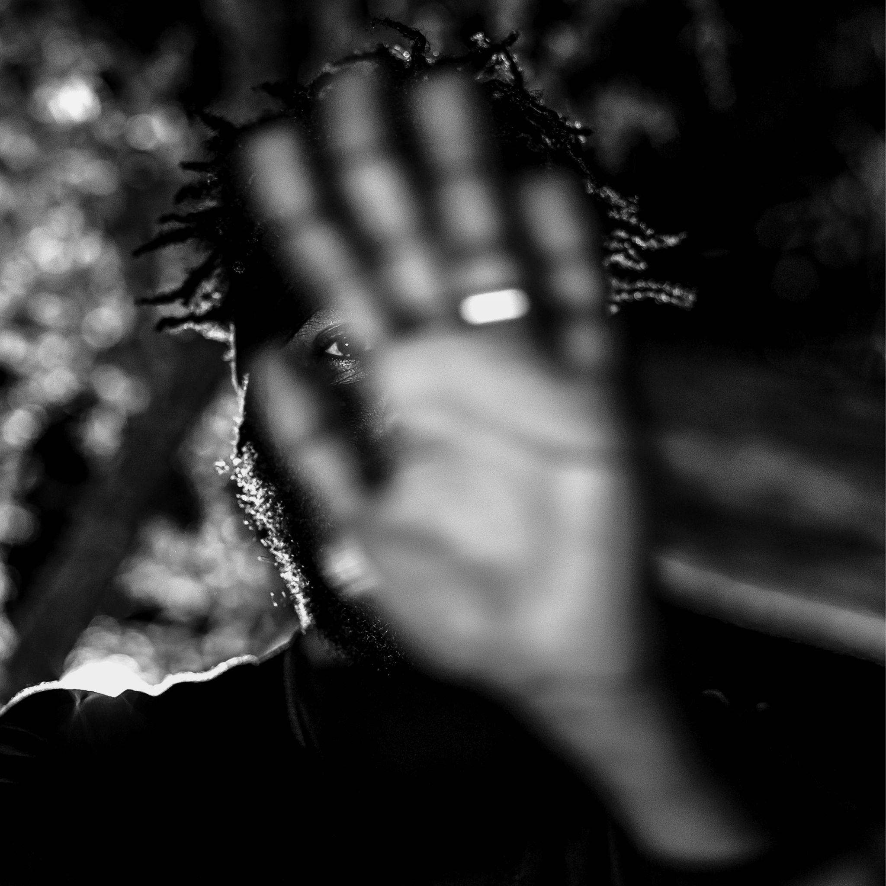
(Download hi-res artwork HERE)

January 26, 2024 (Los Angeles, CA) – Today, four-time Grammy Award winning artist Gary Clark Jr. surprises fans with a taste of new music; four new studio tracks from his much-anticipated upcoming album, JPEG RAW, set for release on March 22 via Warner Records. Listen to the 4-track sampler HERE — including “Maktub,” “JPEG RAW,” “This Is Who We Are” and “Hyperwave” — and click HERE to pre-order JPEG RAW.

This new body of work signals a brave new world for Clark’s ever-expanding creative palette. The new music is dense and adventurous with a more cohesive synthesis of his eclectic musical universe. His samples, Thelonious Monk and Sonny Boy Williamson, decorate flourishes of African, World Music, and even Jazz while merging with rock, R&B, hip-hop and blues; familiar areas he has ventured before, this time with more unity forging a fresh new style. Clark’s lyrics are pointed, deeply personal, outspoken and socially conscious with occasional forays into rap and spoken word from Clark himself. The sonics are immersive, verging on modern groove-oriented psychedelia with hip-hop driven beats in verses giving way to anthemic choruses, rich with power-chording and wide fuzz riffage.
Songs like “Maktub,” “JPEG RAW,” “This Is Who We Are,” “Hyperwave,” and the epic 10-minute “Habits” break fresh ground defying categorization in the ever predictable music world. The co-written Stevie Wonder duet, “What About The Children,” feels like an immediate classic that could have lived on Innervisions or Talking Book if not for Clark’s fuzzed out riff and hip-hop pocket.

JPEG RAW is Clark's first album since 2019’s critically lauded This Land, which became his third consecutive top 10 on the Billboard 200 chart and garnered three Grammy Awards, including Best Rock Song and Best Rock Performance (“This Land”) and Best Contemporary Blues Album (This Land). Clark’s first Grammy win was awarded in 2014 for Best Traditional R&B Performance (“Please Come Home”).

Since its release, the singer-songwriter has toured extensively and stretched his wings as an actor, playing American blues legend Arthur “Big Boy” Crudup in Baz Luhrmann’s Elvis, which received eight Academy Award nominations.

Clark also served as the official Music Director for Jon Stewart’s acceptance of the 23rd Annual Mark Twain Prize for American Humor in the Kennedy Center Concert Hall. In addition to programming the event, he delivered a powerful tribute on stage, which aired on PBS nationwide.

With an eclectic range that contains multitudes, Clark continues to defy boundaries of any kind. Highlighted by an impressive coterie of awards, critical accolades, collaborations, sold-out tours that span the globe, billions of streams, endless television performances, and appearances in acclaimed films and TV series, Clark steps back into the light with JPEG RAW and breaks new ground that is both thrilling and inspiring on every level.

Tracklisting:
Maktub*
JPEG RAW*
Don’t Start (feat. Valerie June)
This Is Who We Are (feat. Naala)*
To The End Of The Earth
Alone Together (feat. Keyon Harrold)
What About The Children (feat. Stevie Wonder)
Hearts In Retrograde
Hyperwave*
Funk Which U (feat. George Clinton)
Triumph
Habits

*Included on 4-track sampler

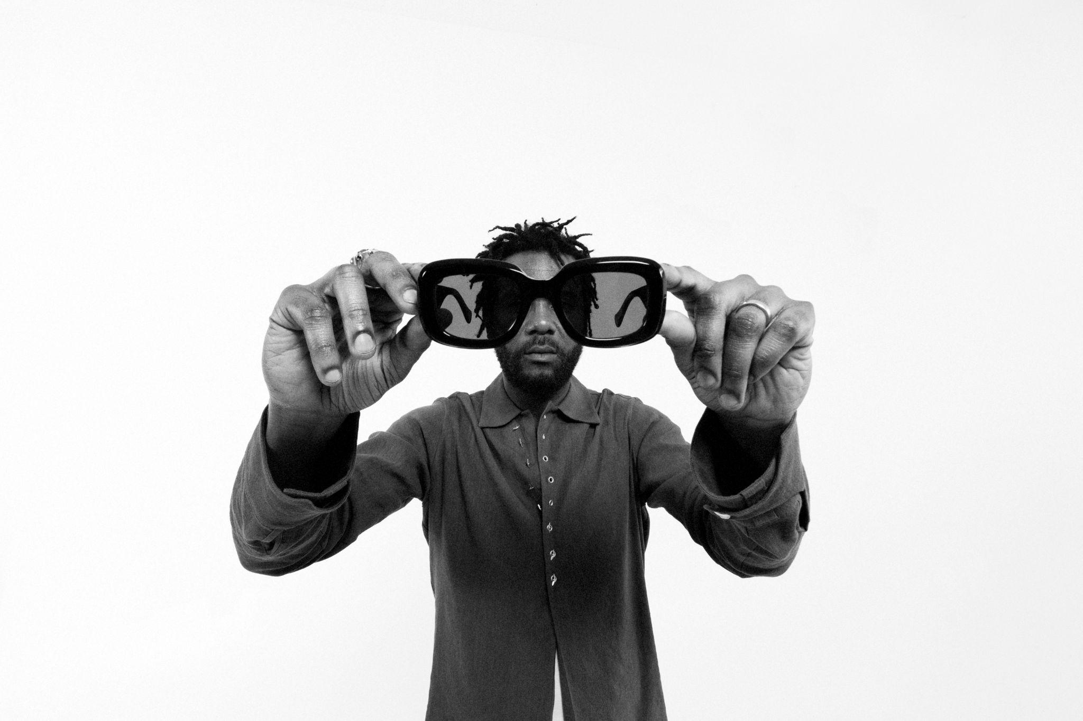
Credit: Mike Miller
Hi-res download HERE

About Gary Clark Jr.:
Clark achieved global impact following his first Grammy Award® in 2014, winning Best Traditional R&B Performance for the track “Please Come Home” from his Warner Records debut album Blak And Blu, and seemingly never left the road. 2015’s The Story Of Sonny Boy Slim wrought hard-won international acclaim as a critical force to be reckoned with. Throughout 2019, Clark ascended to greater heights with the release of This Land – his third full-length studio album which bowed at #6 on the Billboard 200 chart, marking his third consecutive Top 10 debut. The album and single of the same name attracted acclaim from the likes of The New York Times, The Washington Post, The Los Angeles Times, Rolling Stone, Pitchfork and more. He has performed on Saturday Night Live, The Late Show with Stephen Colbert, The Ellen DeGeneres Show, The Tonight Show Starring Jimmy Fallon, The Late Late Show with James Corden, Jimmy Kimmel Live!, Good Morning America, CBS News Sunday, CBS This Morning, The Today Show, Late Night with Seth Meyers, The Daily Show with Trevor Noah, The Howard Stern Show, WTF with Marc Maron, and more. Clark’s domestic tours became instant sell-outs and his international profile found him topping bills at legendary festivals around the world and venues including the Hollywood Bowl, along with multiple appearances in stadiums supporting and sharing the stage with The Rolling Stones. Most recently, Clark won three more Grammy Awards, including Best Rock Performance and Best Rock Song for “This Land,” and Best Contemporary Blues Album for This Land. Clark also performed his award-winning single “This Land” backed by The Roots at the 2020 Grammy Award ceremony and released their version of the track. Countless collaborations have been recorded with Stevie Wonder, Andra Day, John Legend, Alicia Keys, Foo Fighters, Nas, Sheryl Crow, Brandi Carlile, Eric Clapton, Gustavo Santaolalla, Booker T. Jones, and many more. To date, Clark has been nominated for six Grammy Awards and won four. Clark has just completed his fourth and most compelling body of work to date, titled JPEG RAW, set for release in March 2024 via Warner Records.

# # #
﻿
Contact:
Rick Gershon at Warner Records
Rick.Gershon@warnerrecords.com

FOLLOW GARY CLARK JR.:
Official | Facebook | Twitter | Instagram | YouTube | Spotify | Publicity Materials
