THE BLACK KEYS ANNOUNCE 12TH STUDIO ALBUM, OHIO PLAYERS, OUT APRIL 5 ON NONESUCH/WARNER RECORDS

FIRST SINGLE “BEAUTIFUL PEOPLE (STAY HIGH)” + VIDEO OUT NOW

LISTEN TO THE TRACK HERE
AND WATCH THE LYRIC VIDEO HERE

PRE-ORDER THE ALBUM HERE

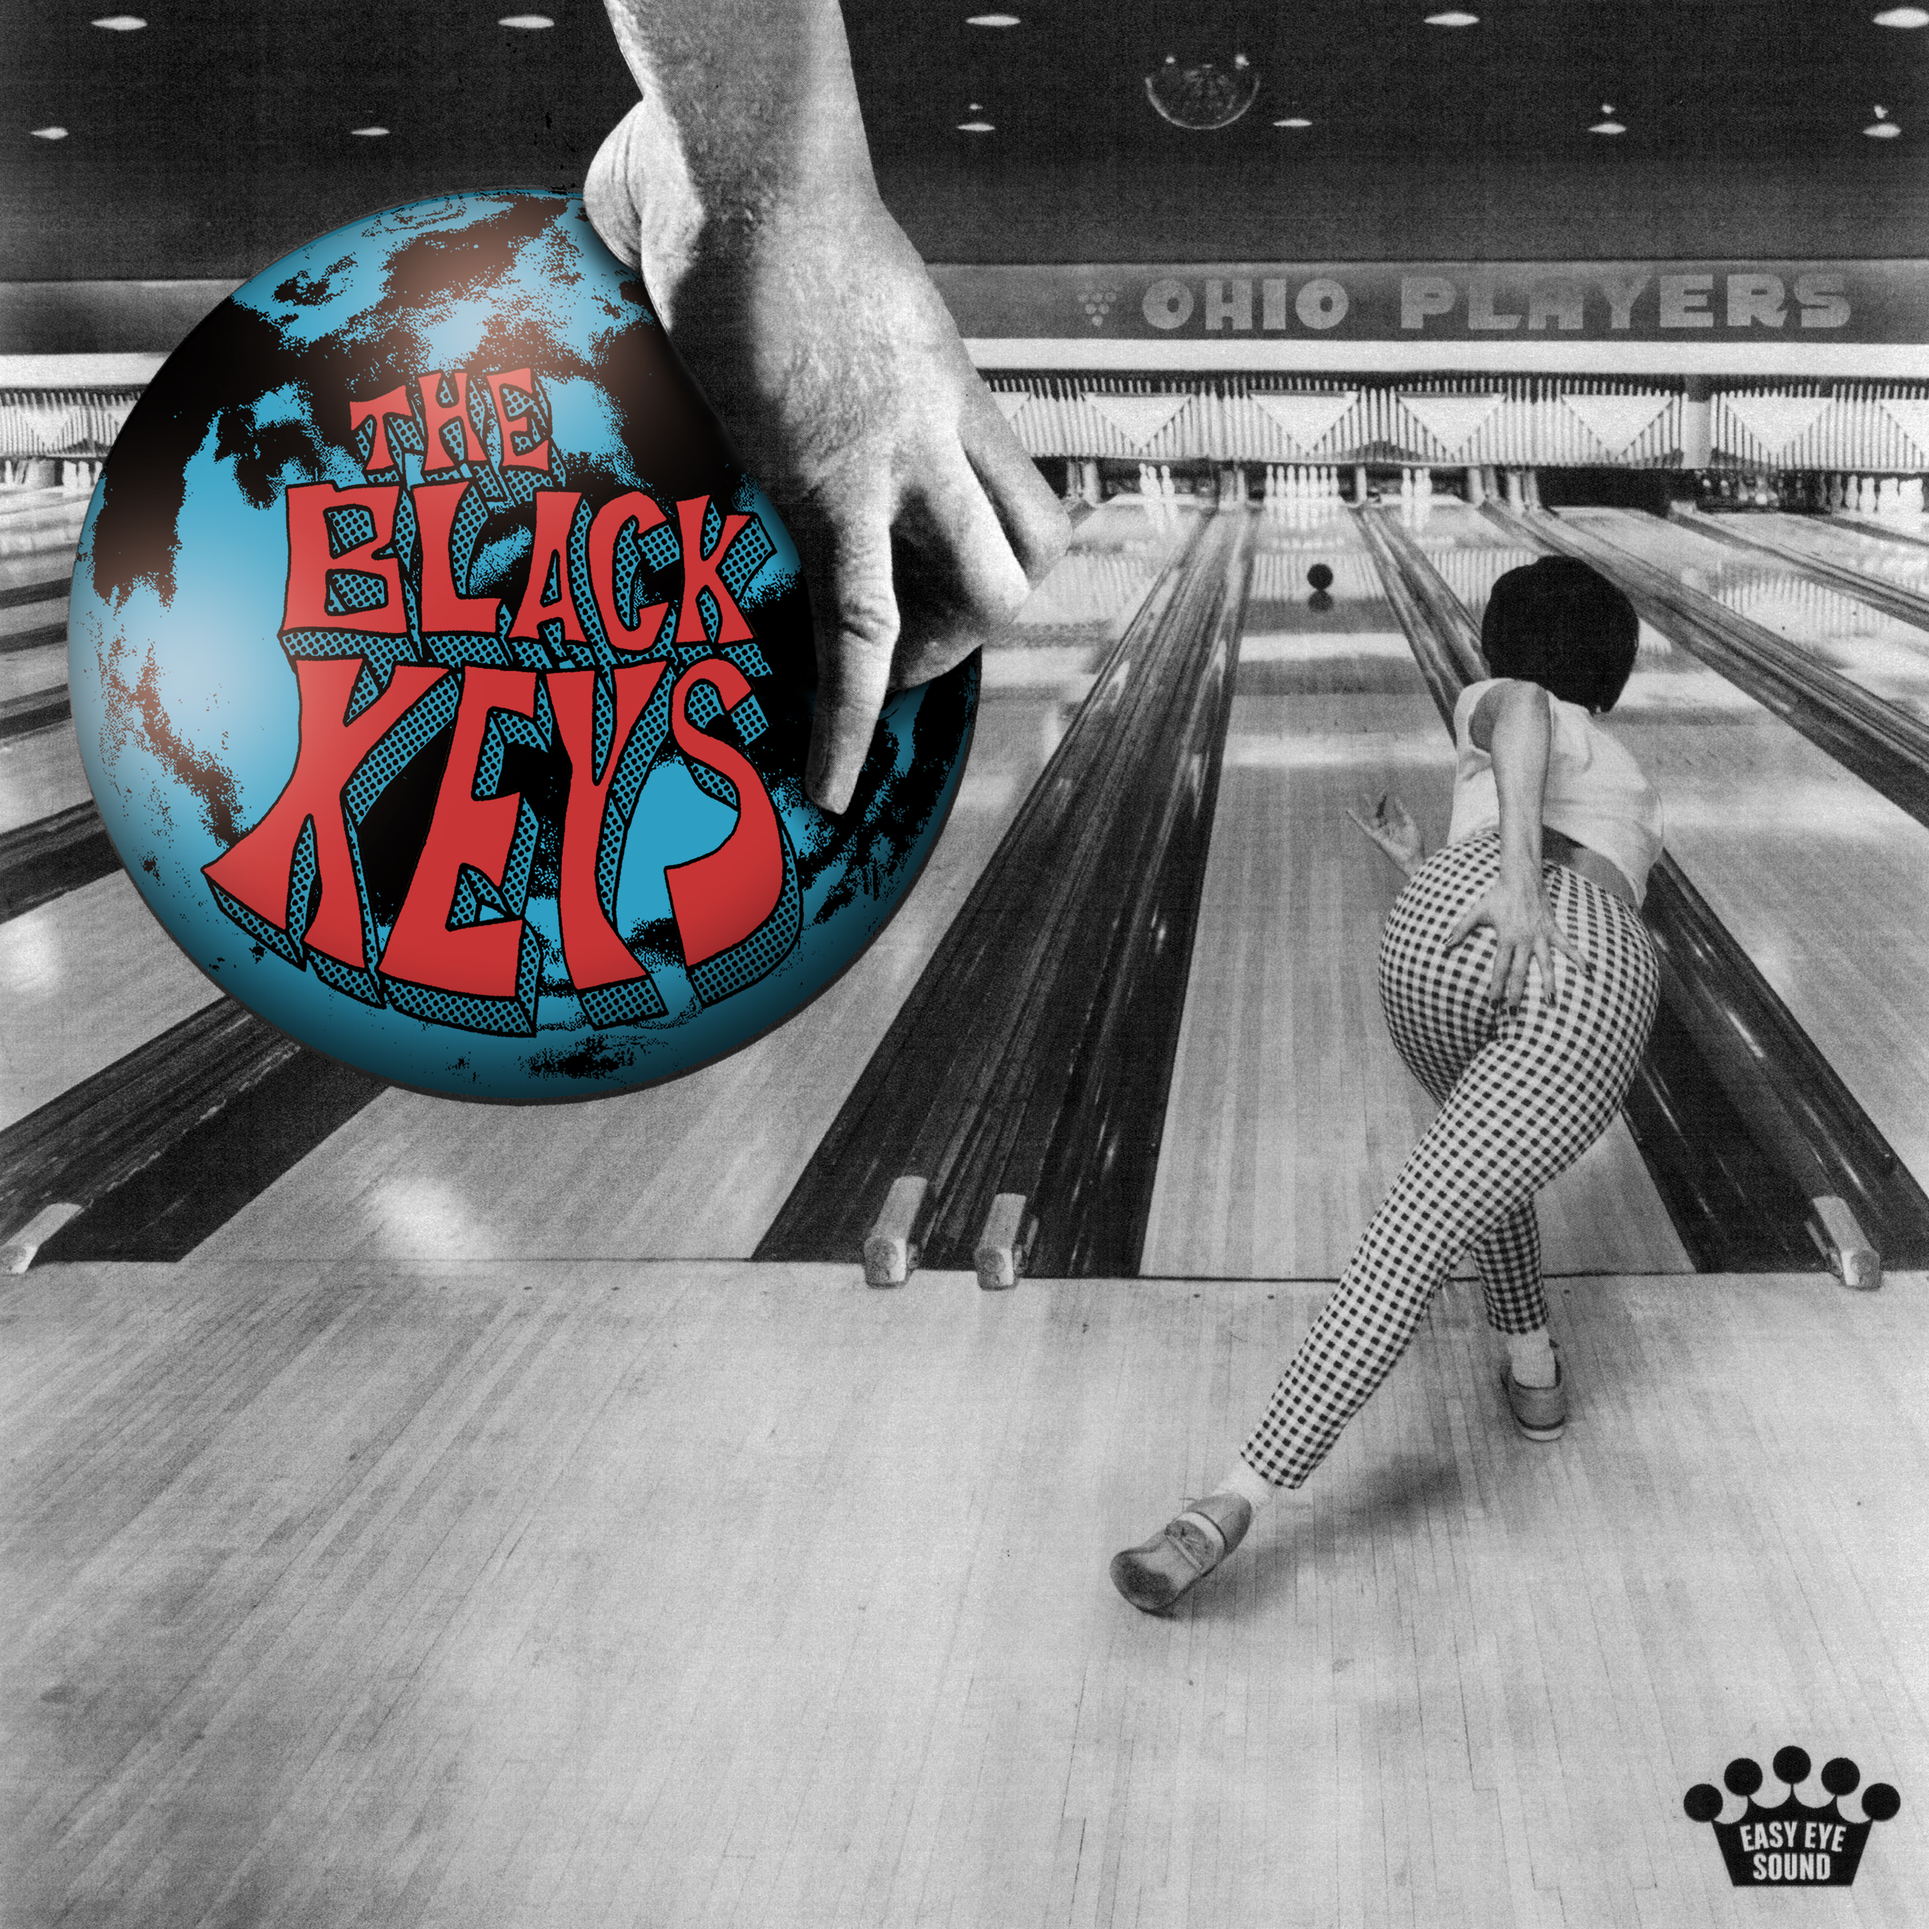

Download Album Artwork: HERE
Download Press Photos: HERE

January 12, 2024 – The Black Keys kick off the new year with the release of their new single “Beautiful People (Stay High)” – available now on all streaming platforms. The song arrives alongside the announcement of the multiple-Grammy Award-winning, Akron, OH natives’ twelfth studio album Ohio Players, out April 5 via Nonesuch/Warner Records. Listen to “Beautiful People (Stay High)” here and watch the lyric video here. Pre-order Ohio Players here. An extensive international tour will be announced later.

Written by The Black Keys’ Dan Auerbach and Patrick Carney with longtime friends Dan “The Automator” Nakamura and Beck, the celebratory, joyful “Beautiful People (Stay High)” is one of several songs on the album that feature collaborations between the band and various additional friends and colleagues, including Noel Gallagher, Greg Kurstin, and others.

Speaking on the collaborative nature of the album, Carney shares, “We had this epiphany: ‘We can call our friends to help us make music.’ It’s funny because we both write songs with other people – Dan all the time [as a solo artist and producer], me when I'm producing a record. That’s what we do.”

Auerbach adds, “No matter who we work with, it never feels like we're sacrificing who we are. It only feels like it adds some special flavor. We just expanded that palette with people we wanted to work with. We were there to support them and their ideas, to do whatever we could to see that moment flourish. But when it came time to finish the album, it was just Pat and me.”

“We'd never worked harder to make a record,” he continues. “It's never taken us this long to make an album. We took our time and did it right.”

“What we wanted to accomplish with this record was make something that was fun,” Carney says. “And something that most bands 20 years into their career don’t make, which is an approachable, fun record that is also cool.”

While making Ohio Players, a title inspired by the legendary Dayton, OH funk band of the same name, The Black Keys were also DJing dance parties in cities around the world that they called “record hangs,” spinning 45s from their own eclectic and growing collections. Mojo reports, “The spirit of those parties infused the album’s DNA. ‘That’s been the fun of it,’ [says] Auerbach. ‘Letting go a little bit.’”

The Black Keys first introduced 'Beautiful People (Stay High)' to audiences via a string of mysterious teasers across social media platforms at the start of year. The band will make their debut live performance of the song at iHeartRadio’s ALTer Ego concert at the Hondo Center in Anaheim, CA on January 13; the show begins at 7pm PT.

Earlier this week, SXSW announced the inclusion of the world-premiere for the new documentary This is a Film About The Black Keys at their 2024 festival. The documentary traces Auerbach and Carney remarkable journey from two neighborhood kids jamming in a basement in Ohio to rock ‘n roll superstardom.

###

About The Black Keys:
Formed in Akron, Ohio in 2001, The Black Keys are singer/guitarist Dan Auerbach and drummer Patrick Carney. Last year, the duo received two Grammy nominations for their eleventh studio album Dropout Boogie. The Black Keys have been called “rock royalty” by the Associated Press and “one of the best rock ‘n’ roll bands on the planet” by Uncut. Cutting their teeth playing small clubs, the band has gone on to sell out arena tours and has released eleven previous studio albums: the debut The Big Come Up (2002), followed by Thickfreakness (2003) and Rubber Factory (2004), along with their releases on Nonesuch Records: Magic Potion (2006), Attack & Release (2008), Brothers (2010), El Camino (2011), Turn Blue (2014), “Let’s Rock” (2019), Delta Kream (2021), and Dropout Boogie (2022). The band has won six Grammy Awards and a BRIT and headlined festivals in North America, South America, Mexico, Australia, and Europe.

Media Contacts
For The Black Keys:
full coverage communications
Kristen Foster | kristen.foster@fullcov.com
Stephanie Rutcofsky | stephanie.rutcofsky@fullcov.com

For international enquiries, please contact:
Matthew Rankin, +44 207 938 5552 or matthew.rankin@nonesuch.com

