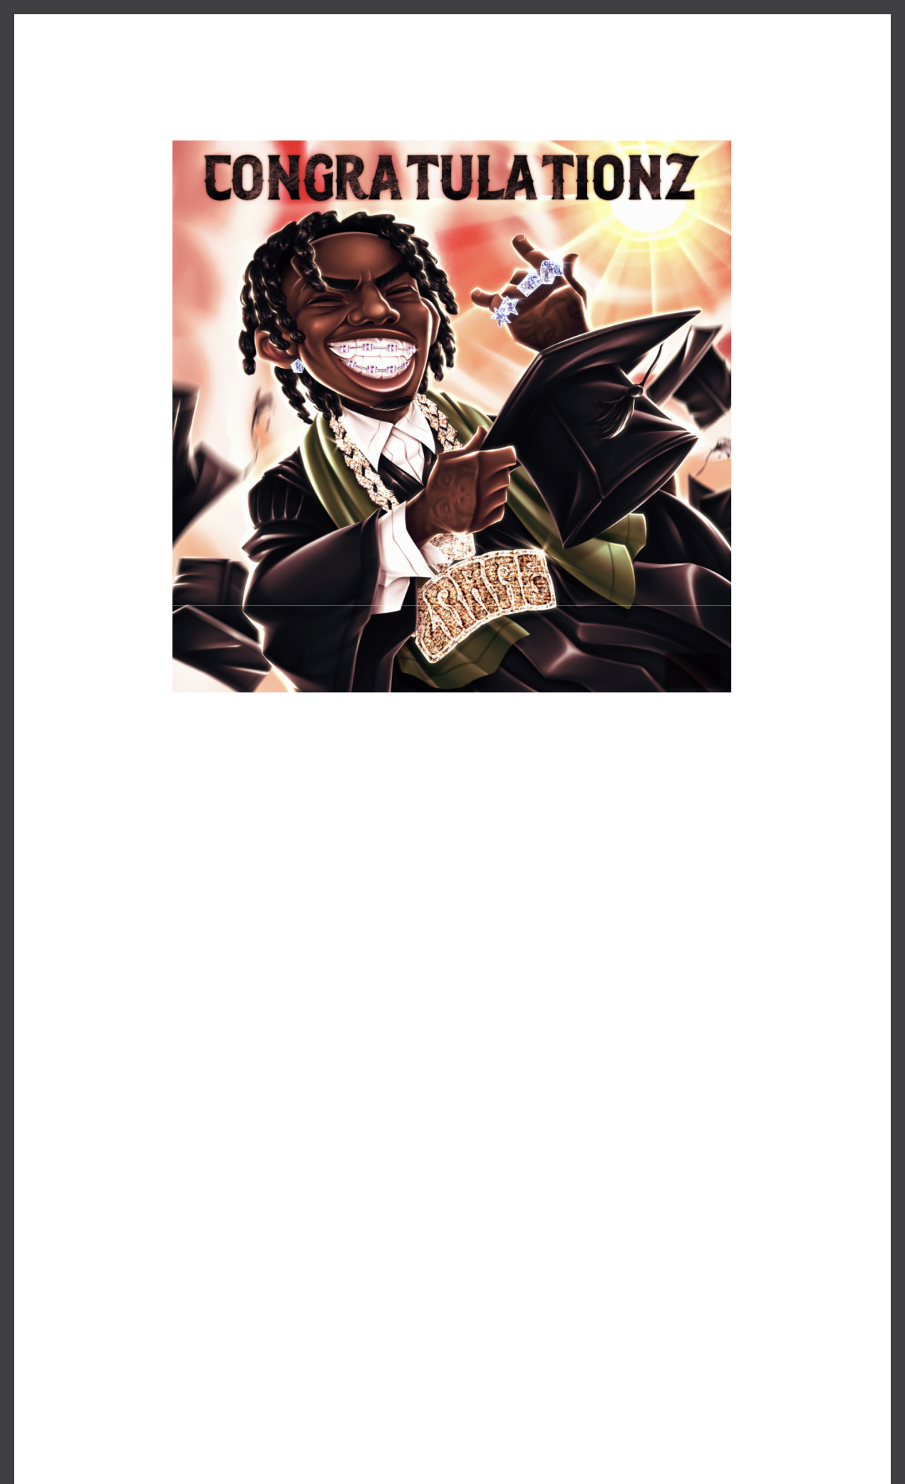
2RARE RELEASES CELEBRATORY NEW SINGLE “CONGRATULATIONZ”

LISTEN HERE - WATCH HERE

DOWNLOAD ART HERE

June 21, 2024 (Los Angeles, CA) — Today, breakout Philadelphia rapper 2Rare
drops his new anthemic single “Congratulationz.” Listen HERE and watch the video HERE

via Warner Records/Second Estate. Until now, 2Rare has showcased his versatility through high-energy tracks like “Don’t Run” and “Rare Steppa.” Now, with “Congratulationz,” he takes a cathartic victory lap — and invites listeners to come along for the ride.

“I did it," 2Rare declares over joyous piano chords and finger snaps. "I just wanna thank my Mom and Pa — last but least, I cannot forget God.” Later, on the chorus, he sings: “Congratulations! We waited our turn, took a lot of patience.” Primed to become a graduation staple, the sing-along single was made to soundtrack unforgettable moments.

“When I first heard the beat to ‘Congratulationz,’ I automatically felt like it had a commercial vibe,” the rising artist said. “Everyone in the studio felt the beat, so I just challenged myself to come correct and not curse." 2Rare wanted it to be accessible to the widest possible audience. "It’s a song for people to be able to relate to, whether that's for making it in life, graduating school, and reaching new heights & goals.”

“Congratulationz” arrives just a week after 2Rare ignited the stage at Lyrical Lemonade Summer Smash Festival in Bridgeview, Illinois. Additionally, his addictive new single “C4” featuring Skilla Baby and Rob49 just dropped. That track got an Alternative Version Pack featuring sped-up, slowed-down, and instrumental versions. Prior to that, 2Rare cranked up the voltage at Rolling Loud in Los Angeles, flaunting his customary showmanship while diving into his catalog, starting 2024 off right. Last year, he was named a 2023 XXL Freshman and appeared on NLE Choppa’s “Do It Again,” which has already gone RIAA Certified Gold. Now, with
“Congratulationz,” 2Rare unleashes a celebratory party anthem for the ages.

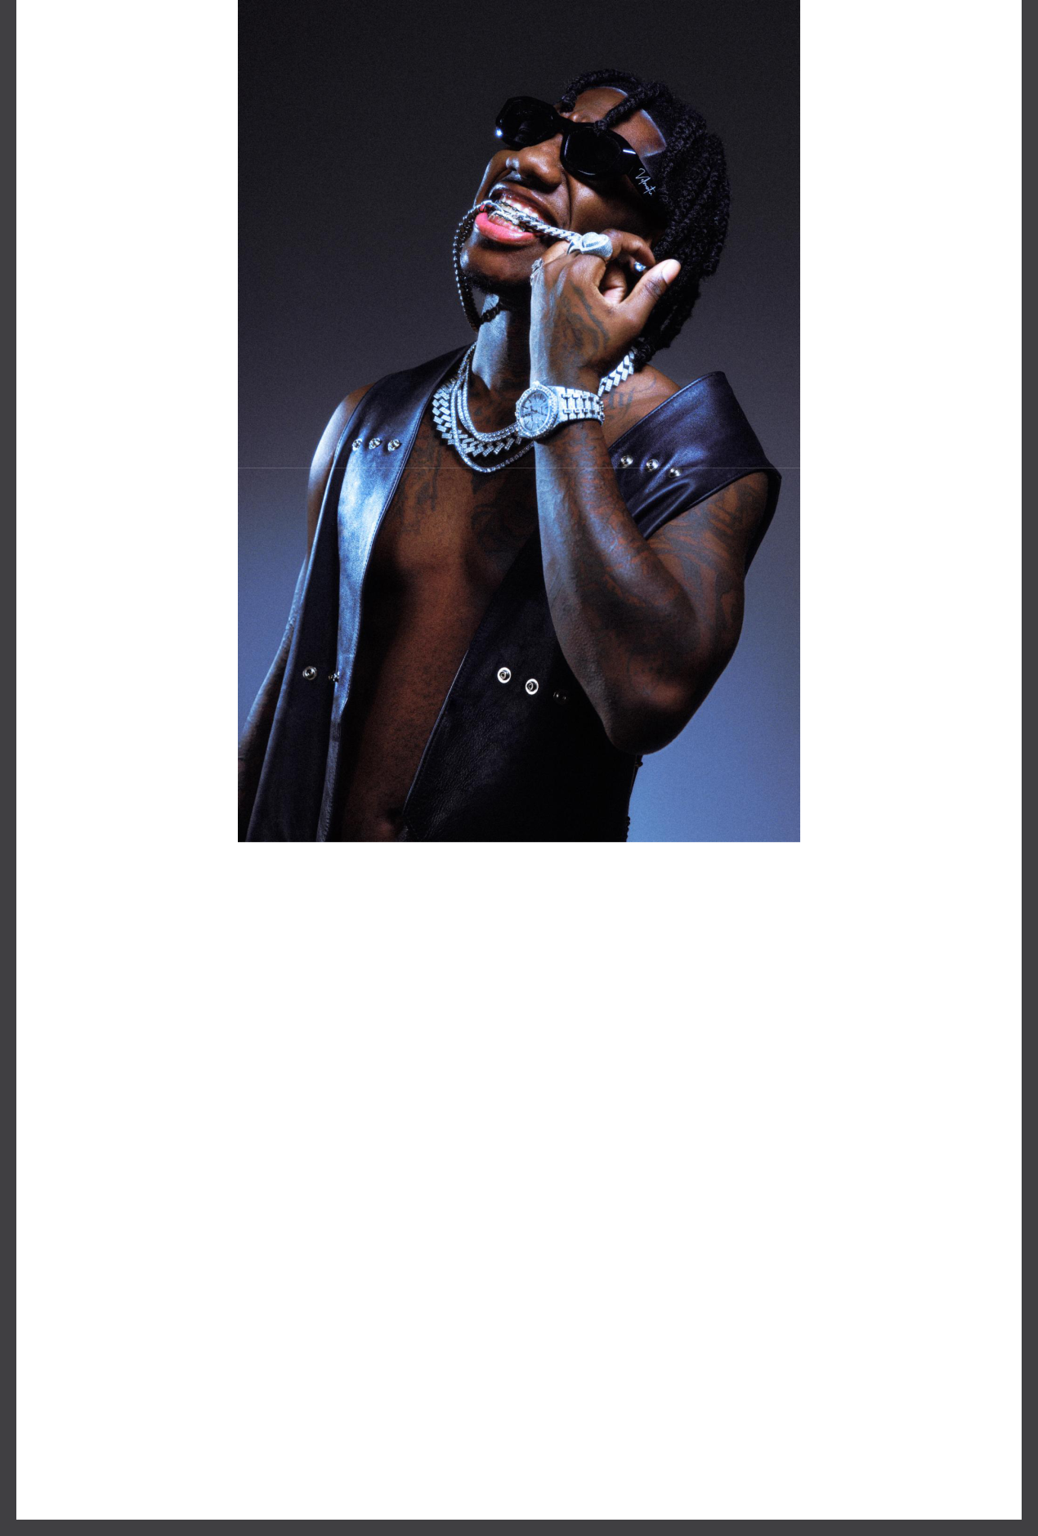

DOWNLOAD PRESS IMAGE HERE

Credit - Sean Behr

ABOUT 2RARE:
2Rare is on a mission to bring the fun back to rap. The North Philadelphia artist born Naseem Young has immediately set himself apart from his peers over the last few years with his irrepressible charisma and the furious energy of dancefloor-ready hits. East Coast club music has been booming in the mainstream of late, but 2rare’s rapid-fire bars and uncommon ear for hooks make his songs echo in your head way after you leave the club. Growing up a football player, 2Rare says that his brother and other family members rapped but that none of them broke out to the degree that he has. He and the people around him have realized that in his time making music, he’s already developed a gift. The attention is extreme, but 2Rare knows he deserves it. “It’s to that point where people say, ‘Rare runs everything he hopped on,’” he says. “They’ll hear a party song or a dance song and be like, ‘Yo, put Rare on it.’” He’s already proved he’s more than ready for the challenge.

FOLLOW 2RARE:
Instagram | TikTok | Press Site

For more information, please contact:
Yash Zadeh
Warner Records
Yashar.Zadeh@warnerrecords.com

Warner Records | 1633 Broadway | New York, NY 10019 US

Unsubscribe | Constant Contact Data Notice

