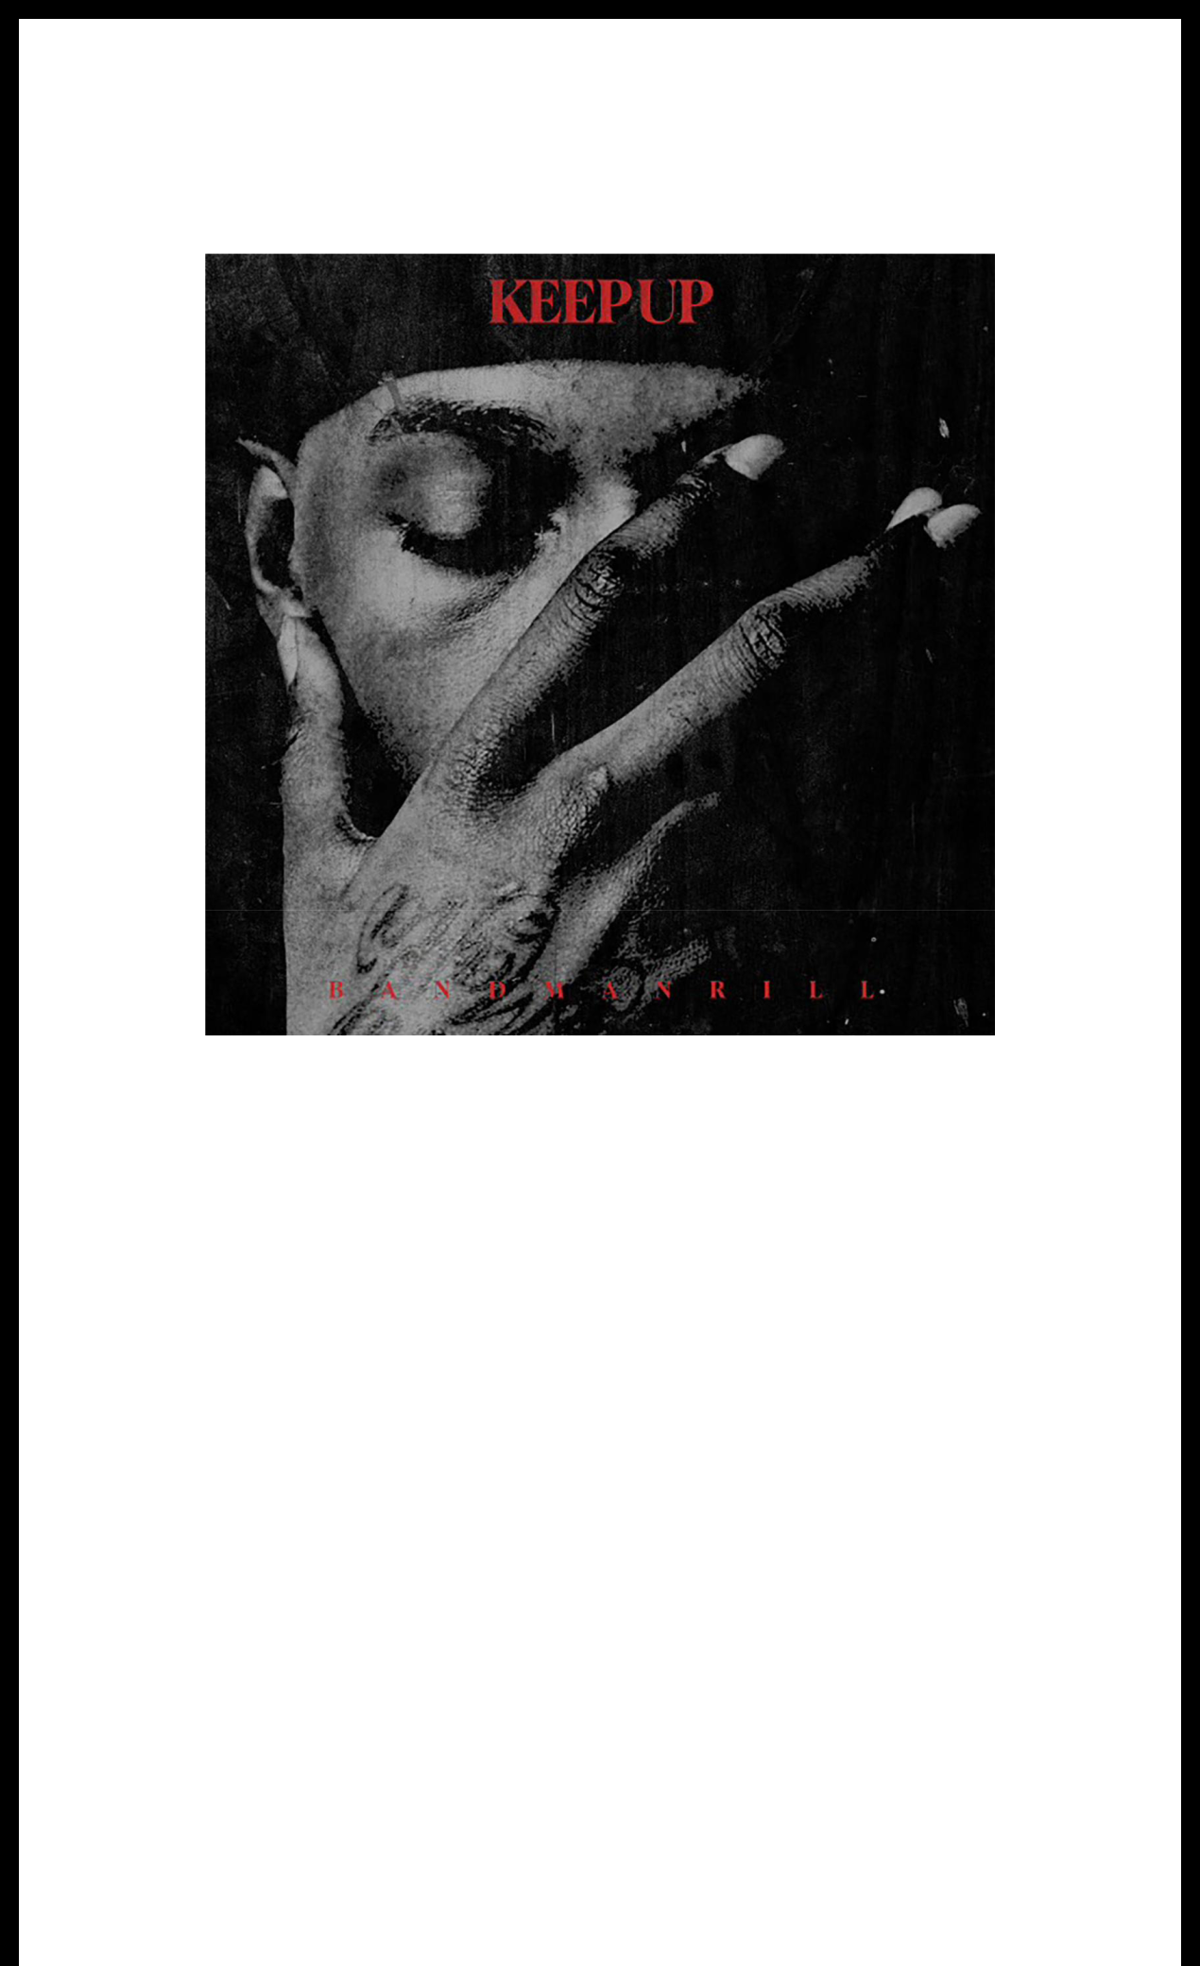
BANDMANRILL DROPS HIGH-ENERGY NEW SINGLE “KEEP UP”

LISTEN HERE

MORE MUSIC COMING SOON

DOWNLOAD ART HERE

April 19, 2024 (Los Angeles, CA)—Newark Hip-Hop and Jersey club phenom Bandmanrill serves up a scorching new single entitled “KEEP UP.” It sees him once again firing on all cylinders with a relentless cadence and razor-sharp delivery without comparison. Listen HERE via Warner Records.

The track’s skittering beat wildly pulsates through a haze of distorted keys. Simultaneously, the sound of a cocked glock clacks in time with the rhythm as Bandmanrill practically sets the production on fire with his flow. The East Coast titan actualizes his intent as he proclaims, “Now I see I got a purpose,” effectively going on to dare the competition to try to “KEEP UP.”

It lands in the wake of “GET RIGHT!” Everything sets the stage for more to come from Bandmanrill very soon.

Bandmanrill capped off a prolific 2024 by joining forces with Sha EK and MCVERTT on the collaborative tape, Defiant Presents: Jiggy In Jersey. Right out of the gate, Brooklyn Vegan hailed the latter among the “10 Best Rap Albums of August 2023” and applauded how “It shows how much magic can be made when three powerful artists come together and have this much chemistry.” The FADER christened him a “Jersey club scene leader” and described the project as the moment “Bronx drill and Jersey Club collide.”

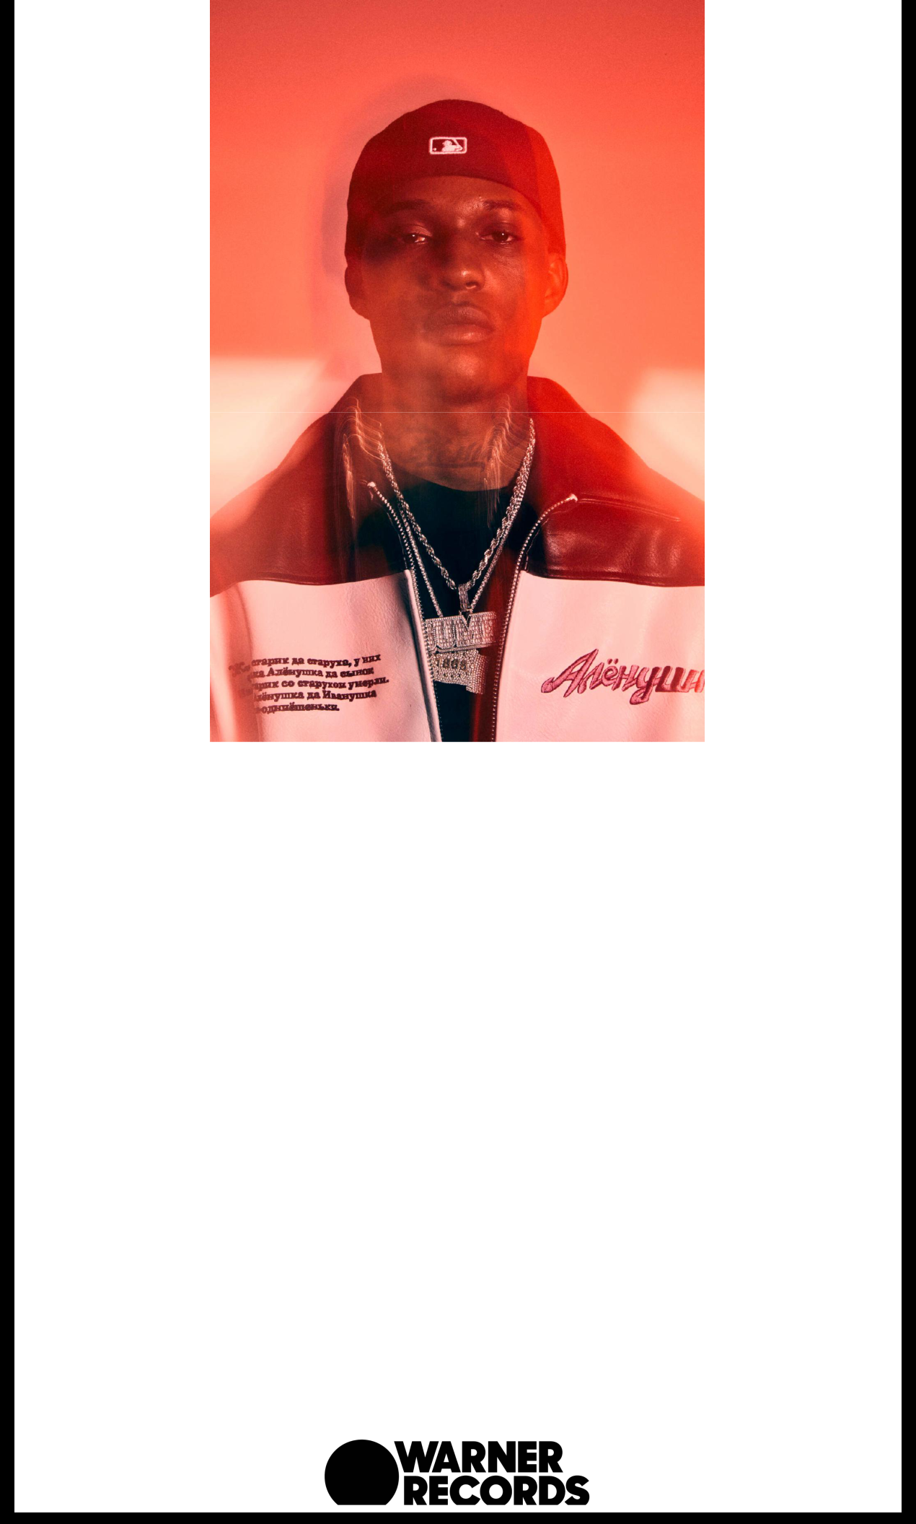

DOWNLOAD PRESS IMAGE
Credit - Jimmy Fontaine

ABOUT BANDMANRILL:

Despite his short time in the spotlight, Bandmanrill revolutionized hip-hop by rhyming dexterously over the club music from his native New Jersey. Yet even if the 20-year-old doesn’t sport the years of experience some of his friends and collaborators can claim, dance is something of a birthright to those who grew up immersed in the scene. That universality is evidenced by the way Bandman was able to almost immediately connect with a huge audience before being backed by any label. He uploaded his breakthrough hit, “Heartbroken,” in the spring of 2021, the Jersey native was discovered by hometown entrepreneurs from his beloved Newark, NJ by Dawan “DB” Brown and Saad Amin who welcomed him to their combined label imprints 100% Pure and 1865 Black Flag Entertainment. The tandem forged a partnership with the legendary record executive “Steve-O” Carless and his Defiant Records imprint, Bandman is poised to break his disruptive style even wider. In the two years since “Heartbroken”—which introduced Bandman to a national audience and cemented a relationship with Mcvertt, his go-to producer—the artist has become something of a phenomenon. His debut album, November 2022’s Club Godfather, showcased his versatility, proving that being nimble and forceful is not a contradiction—it’s simply the mark of an expert MC. As he turns his attention to the future, it’s difficult to imagine a version of rap in the 2020s without Bandman close to its center.

FOLLOW BANDMANRILL:
Twitter | Instagram | Press Site

For more information, please contact:
Yashar Zadeh | Warner Records
Yashar.Zadeh@warnerrecords.com

Warner Records | 1633 Broadway, New York, NY 10019

Unsubscribe laura.swanson@warnerrecords.com Constant Contact Data Notice Sent byyashar.zadeh@warnerrecords.compowered by

Try email marketing for free today!

