KANII LINKS WITH WOLFACEJOEYY FOR MENACING NEW SINGLE “hate me”

LISTEN HERE – WATCH HERE

DOWNLOAD ARTWORK HERE

May 3, 2024 (Los Angeles, CA) – Today, genre-defying artists Kanii and Wolfacejoeyy join forces for the scorching new single “hate me.” Listen HERE via Masked Records/Warner Records. Boasting dark synths, rapid-fire drums, skittering high hats and angelic vocals, the track documents the East Coast pair's cynical outlook on love. The collaborators also unleash a suitably shadowy music video. Watch it HERE.

"I was struggling with a horrible relationship, feeling betrayed but still in love with this girl,"Kanii says of the track. "Despite trying to figure a way to fix the issues, I'm always left questioning why this girl continues to hurt me." That contemplative tone is reflected in the accompanying music video, which finds Kanii and Wolfacejoeyy in NY exuding their magnetic charisma and palpable chemistry.

"hate me" arrives while Kanii is on tour as main support for PinkPantheress and just matter of months after he teamed up with Riovaz and Nimstarr for their joint EP The Heart Racers, which includes synth-centric, throwback creations such as “tell me” and “lost without you.” Prior to that, Kanii dropped the infectious pop tracks “nightcrawler,” “it was nice knowing u,” and “pretty photos.” His momentum first began with the RIAA Gold-certified hit "I Know," which entered the Billboard Hot 100. To date, Kanii has earned over half a billion global streams.

Kanii’s surging output, starkly different yet equally addictive, makes his ascent inevitable. Now, with “hate me,” he delivers another bold and brazen banger to add to his discography.

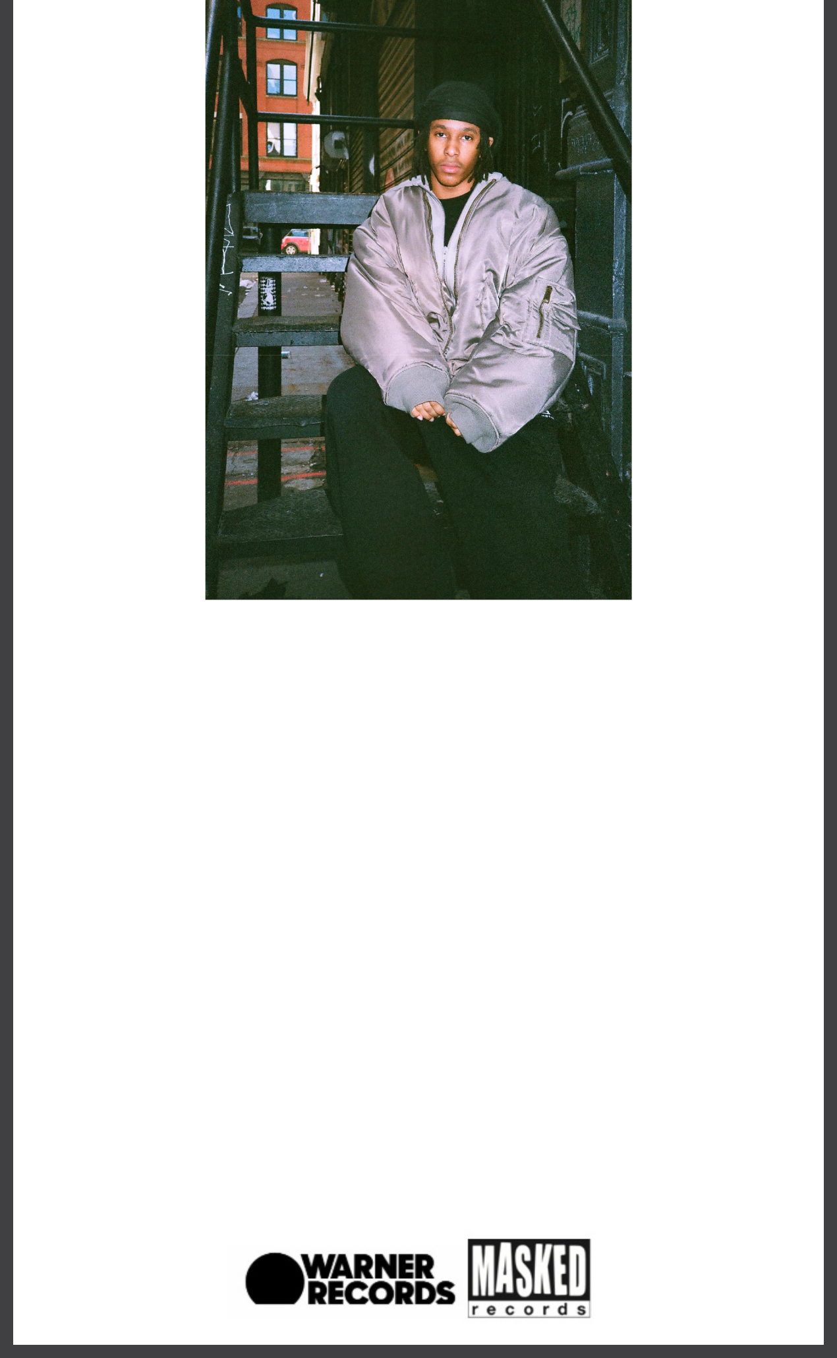

DOWNLOAD HI-RES HERE
Credit - @shotbycharlie

ABOUT KANII:

D.C.-born singer Kanii is focused on the future. Though he’s just graduated high school, he’s looking ahead to where his boundary-pushing music is taking him next with a fearless proclivity for new sounds and styles he might conquer. In doing so, Kanii continues to create energetic anthems like “I Know” from his debut EP exiit via Masked Records / Warner Records which became a cultural phenomenon amongst young people all over the world and is now RIAA Certified Gold status. On his new EP, it was nice knowing u, Kanii trades in dancefloor-ready beats and dynamic synth melodies to create addictive refractions of R&B. Kanii may still be a teenager, but he already displays the songwriting chops of a seasoned veteran. It’s a blend of old-school wisdom and new-school ingenuity, informed by the music he grew up listening to plus the digital recording software he taught himself to use. Kanii acknowledges his influences but refuses to be pigeonholed: He wants to be boundless. Throughout it was nice knowing u, Kanii shows he isn’t willing to rein himself in or commit to any one musical subgenre. His brilliance as a songwriter lies in his ability to fuse strands of pop, R&B, and jersey club—and all sorts of otherworldly sounds beyond that— into a style that feels informed by just about everything you can think of, while never sounding like any one thing in particular. He takes the familiar and makes it sound wholly new.

Follow Kanii:
Instagram | YouTube | TikTok | Press Site

For more information, please contact:
Yash Zadeh | Warner Records
Yashar.Zadeh@warnerrecords.com

Warner Records | 1633 Broadway | New York, NY 10019 US

Unsubscribe | Constant Contact Data Notice

