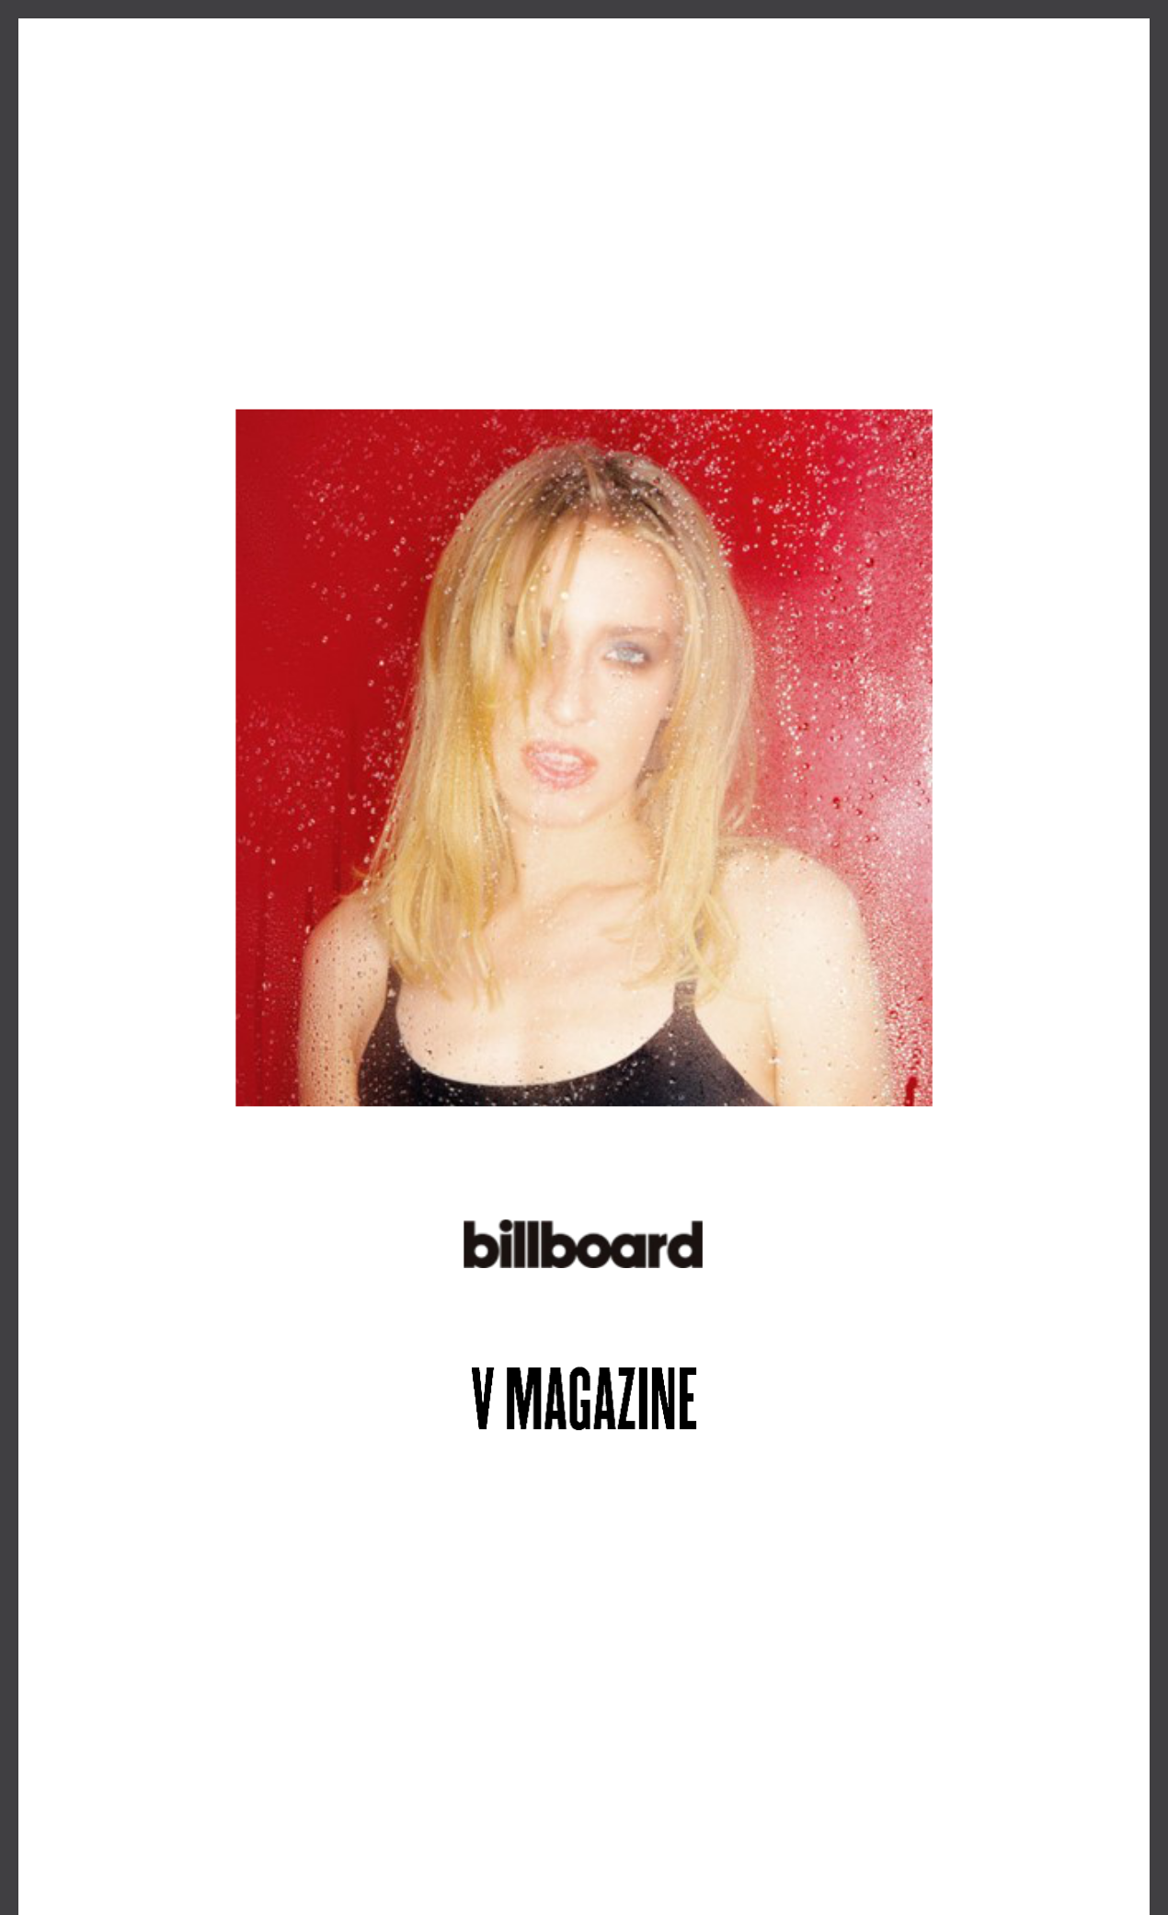
ALT-POP BREAKOUT MAUDE LATOUR RELEASES NEW SINGLE “CURSED ROMANTICS”
LISTEN HERE

DEBUT ALBUM COMING THIS SUMMER

FALL TOUR WITH FLETCHER ON SALE NOW

"It’s easy to picture rising alt-pop star Maude Latour enjoying the kind of breakthrough hit that Tate McRae recently enjoyed with 'Greedy'"

“a rising star to watch this year"

May 17, 2024 (Los Angeles, CA) – Rising alt-pop star Maude Latour shares new single “Cursed Romantics” today via Warner Records. As the latest off her highly-anticipated debut album arriving this summer, the new track follows her euphoric anthem “Too Slow” which received instantaneous buzz from the likes ofStereogum, PAPER, V Magazine, Rolling Stone, UPROXX, and Billboard. Listen to “Cursed Romantics” HERE.

Following the successes of her viral lockdown-era hit“One More Weekend” and four infectious EPs, Maude has firmly cemented her status as a leading artist-to-watch in 2024, winning over critics from The New York Times to NPR, and performing at Lollapalooza, Governors Ball, Austin City Limits, and many more. Now, with her forthcoming debut album on the horizon, the 24 year-old is doubling down on her formula of combining studio experimentation with undeniable cosmic-pop hooks and thoughtful lyrics.

This fall, Maude will join Fletcher on her upcoming US tour, making stops at iconic venues across the country, including Radio City Music Hall in her hometown New York City and the Greek Theatre in Los Angeles. See a full list of dates below, and tickets are available now at www.maudelatour.com.

UPCOMING TOUR DATES:
June 2 | Asbury Park, NJ | The Stone Pony Summer Stage*
June 27 | Milwaukee, WI | Summerfest
July 17 | Calgary, AB | The Calgary Stampede
September 12 | Minneapolis, MN | The Fillmore*
September 14 | Chicago, IL | Byline Bank Aragon Ballroom*
September 15 | Detroit, MI | The Fillmore*
September 17 | Philadelphia, PA | The Fillmore*
September 18 | Washington, DC | The Anthem*
September 19 | Boston, MA | Roadrunner*
September 21 | New York, NY | Radio City Music Hall*
September 27 | Nashville, TN | Marathon Music Works*
September 29 | Atlanta, GA | Coca-Cola Roxy*
October 2 | Houston, TX | Bayou Music Center*
October 3 | Dallas, TX | South Side Ballroom*
October 6 | Phoenix, AZ | Arizona Financial Theatre*
October 7 | San Diego, CA | SOMA*
October 9 | Los Angeles, CA | Greek Theatre*

- with Fletcher

###

FOLLOW MAUDE LATOUR:
TikTok | Instagram | Twitter | Facebook | YouTube | Press Materials

For more information, please contact:
Patrice Compere | Warner Records
Patrice.Compere@warnerrecords.com

Warner Records | 1633 Broadway, New York, NY 10019

Unsubscribe laura.swanson@warnerrecords.com Constant Contact Data Notice Sent bypatrice.compere@warnerrecords.compowered by

Try email marketing for free today!

