WARREN ZEIDERS SEEKS REVENGE ON NEW SINGLE “BETRAYAL”
LISTEN HERE

Zeiders’ next era follows his first No. 1 on Country Radio, his CMT Award Win,
and his recent ACM Lifting Lives LIVE performance

Set to hit the road with Jelly Roll as direct support on his Fall The Beautifully Broken Tour

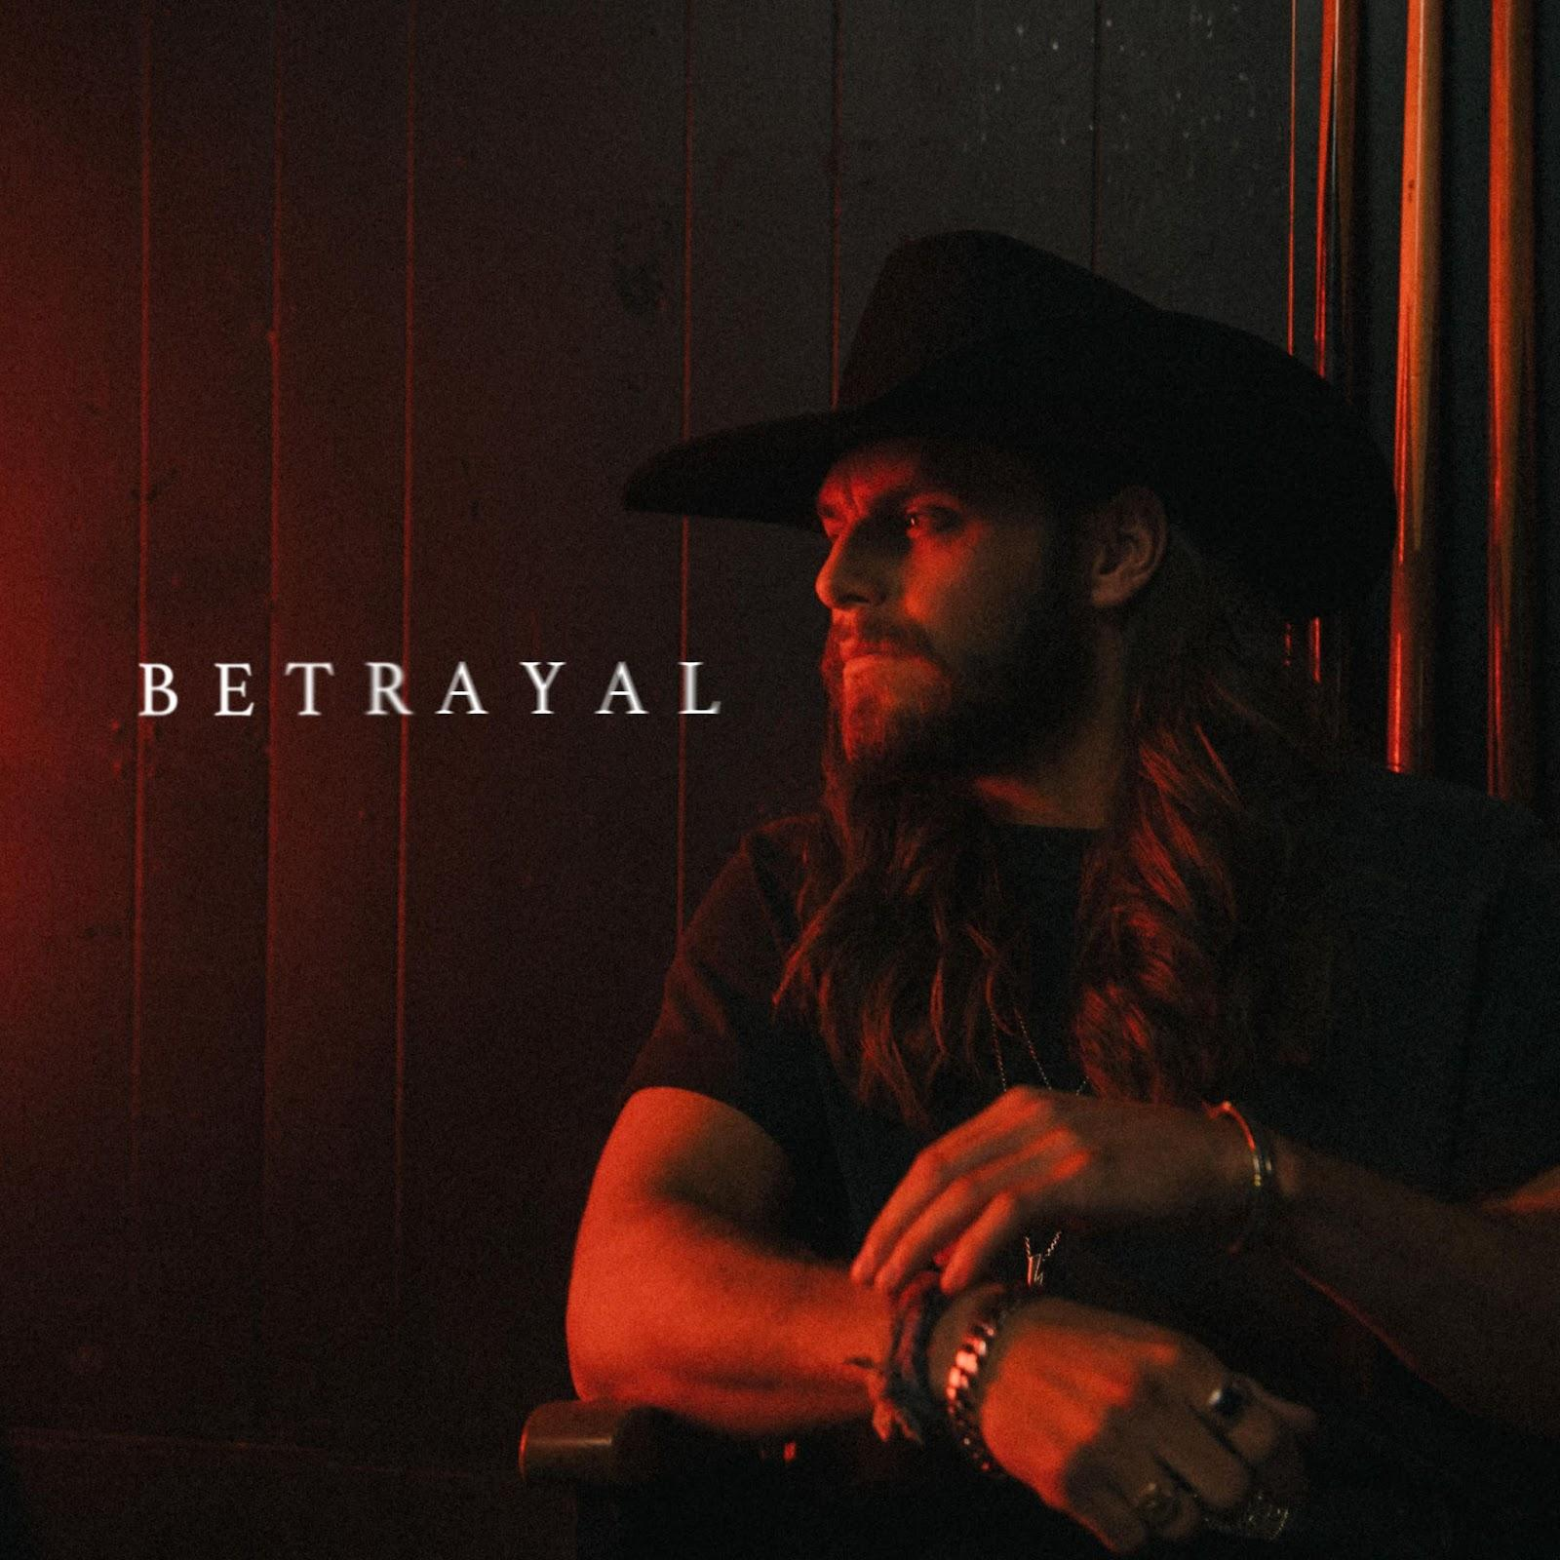

May 17, 2024 (Los Angeles, CA) — Warner Records artist Warren Zeiders enters his revenge era with his ​​fiery single, "Betrayal.” Written by Zeiders, Blake Pendergrass (Morgan Wallen, Chris Lane), Justin Ebach (Brett Young, Dustin Lynch), Jacob “JKash” Hindlin (Charlie Puth, Maroon 5) and Ali Tampos (Dua Lipa, Justin Bieber), the track finds Zeiders at his most vindictive, with his raw-edged voice dripping with hurt as he cries out to the person who did him wrong. Listen HERE via Warner Records.

The single follows a standout spring for Zeiders – he recently won the CMT Award for “Breakthrough Male Video of the Year” for his chart-topping hit “Pretty Little Poison,” the song that earned his first No.1 single on country radio. The track also peaked in the Top 24 on Billboard’s Hot 100 and landed him his second RIAA Platinum-certified single.

Zeiders is currently on his nearly sold-out 2024 North American headlining tour, and then will join Jelly Roll as direct support for his Fall The Beautifully Broken Tour. The arena tour kicks off on August 27th in Salt Lake City and includes stops at NYC’s Madison Square Garden, LA’s Crypto.com Arena, Chicago’s United Center and more. Earlier this week, Zeiders performed alongside Parker McCollum at the ACM Lifting Lives LIVE Concert.

He currently boasts 2 billion career streams, 1 billion+ TikTok views and 7.3M monthly Spotify listeners, solidifying his place as one of Nashville’s hottest headliners. He was also recently announced as one of the artists featured on the upcoming star-studded Twisters soundtrack.

UPCOMING TOUR DATES:
ITALICS - denote dates w. Jelly Roll
May 19 - North Wilkesboro Speedway / NASCAR All-Star Pre-Race Concert - North Wilkesboro, NC
May 23 - Patriotic Festival - Norfolk, VA
May 24 - Charleston Coliseum - Charleston, WV
May 29 - 101 Bold Nights Concert Series - Charlotte, NC
June 5 - Grand Ole Opry - Nashville, TN
June 6 - CMA Fest / Chevy Riverfront Stage - Nashville, TN
June 8 - Rock the Country - Ocala, FL
June 14 - Fourth Street Live! - Louisville, KY
June 15 - Old Settlers Day Festival - Rockton, IL
June 16 - Tailgate N’ Tallboys - Bloomington, IL
June 20 - KC Live! - Kansas City, MO
June 21 - Harrah’s Stir Cove - Council Bluffs, IA
June 22 - Denny Sanford Premier Center - Sioux Falls, SD
June 28 - Country Fest 2024 - Cadott, WI
June 29 - Crash My Crater 2024 - Mason City, IA
July 5 - Ottawa Bluesfest - Ottawa, ON
July 7 - Cavendish Beach Music Festival - Cavendish, PEI
July 11 - Clinton County Fair - Plattsburgh, NY
July 12 - Clearfield County Fair - Clearfield, PA
July 13 - Country Concert - Fort Loramie, OH
July 18-20 - Rock The South - Cullman, AL
July 21 - Cheyenne Frontier - Cheyenne, WY
July 26 - Milwaukee, WI - Harley Davidson Homecoming Fest
July 27 - Tailgate N’ Tallboys - Midland, MI
Aug. 1 - WE Fest - Detroit Lakes, MN
Aug. 7 - Sikeston Rodeo - Sikeston, MO
Aug. 8 - Washington Town & Country Fair - Washington, MO
Aug. 9 - Missouri State Fair - Sedalia, MO
Aug. 21 - Bash on the Bay - Put-In-Bay, OH
Aug. 23 - Festival Country Lotbiniere - Saint-Agapit, QC
Aug. 27 - Delta Center - Salt Lake City, UT
Aug. 28 - Ford Idaho Center Arena - Nampa, ID
Aug. 30 - Spokane Arena - Spokane, WA
Aug. 31 - Climate Pledge Arena - Seattle, WA
Sep. 1 - Moda Center - Portland, OR
Sep. 3 - SAP Center - San Jose, CA
Sep. 4 - Golden 1 Center - Sacramento, CA
Sep. 6 - Crypto.com Arena - Los Angeles, CA
Sep. 7 - Honda Center - Anaheim, CA
Sep. 9 - UTEP Don Haskins Center - El Paso, TX
Sep. 11 - Frost Bank Center - San Antonio, TX
Sep. 13 - Cajundome - Lafayette, LA
Sep. 14 - Smoothie King Center - New Orleans, LA
Sep. 17 - Kia Center - Orlando, FL
Sep. 19 - North Charleston Coliseum - Charleston, SC
Sep. 20 - PNC Arena - Raleigh, NC
Sep. 21 - Capital One Arena - Washington, DC
Sep. 24 - MVP Arena - Albany, NY
Sep. 26 - TD Garden - Boston, MA
Sep. 27 - Madison Square Garden - New York, NY
Sep. 28 - UBS Arena - Elmont, NY
Sep. 29 - Prudential Center - Newark, NJ
Oct. 1 - Pennsylvania State University - Bryce Jordan Center - State College, PA
Oct. 2 - Wells Fargo Center - Philadelphia, PA
Oct. 4 - Country Calling Festival - Ocean City, MD
Oct. 5 - PPG Paints Arena - Pittsburgh, PA
Oct. 6 - KeyBank Center - Buffalo, NY
Oct. 9 - Nationwide Arena - Columbus, OH
Oct. 11 - United Center - Chicago, IL
Oct. 12 - KFC Yum! Center - Louisville, KY
Oct. 15 - INTRUST Bank Arena - Wichita, KS
Oct. 18 - BOK Center - Tulsa, OK
Oct. 20 - Brookshire Grocery Arena - Bossier City, LA
Oct. 22 - Simmons Bank Arena - Little Rock, AR
Oct. 23 - Enterprise Center - Saint Louis, MO
Oct. 25 - Thompson–Boling Arena - Knoxville, TN
Oct. 26 - State Farm Arena - Atlanta, GA
Oct. 27 - Spectrum Center - Charlotte, NC

###

FOLLOW WARREN ZEIDERS:
Facebook | Instagram | Twitter | TikTok | YouTube | Spotify

PRESS CONTACTS:
Rick Gershon | Warner Records | rick.gershon@warnerrecords.com
Jaclyn D. Carter | Shore Fire Media | jcarter@shorefire.com
Andrea Evenson | Shore Fire Media | aevenson@shorefire.com
Maria Eilert | Shore Fire Media | meilert@shorefire.com

