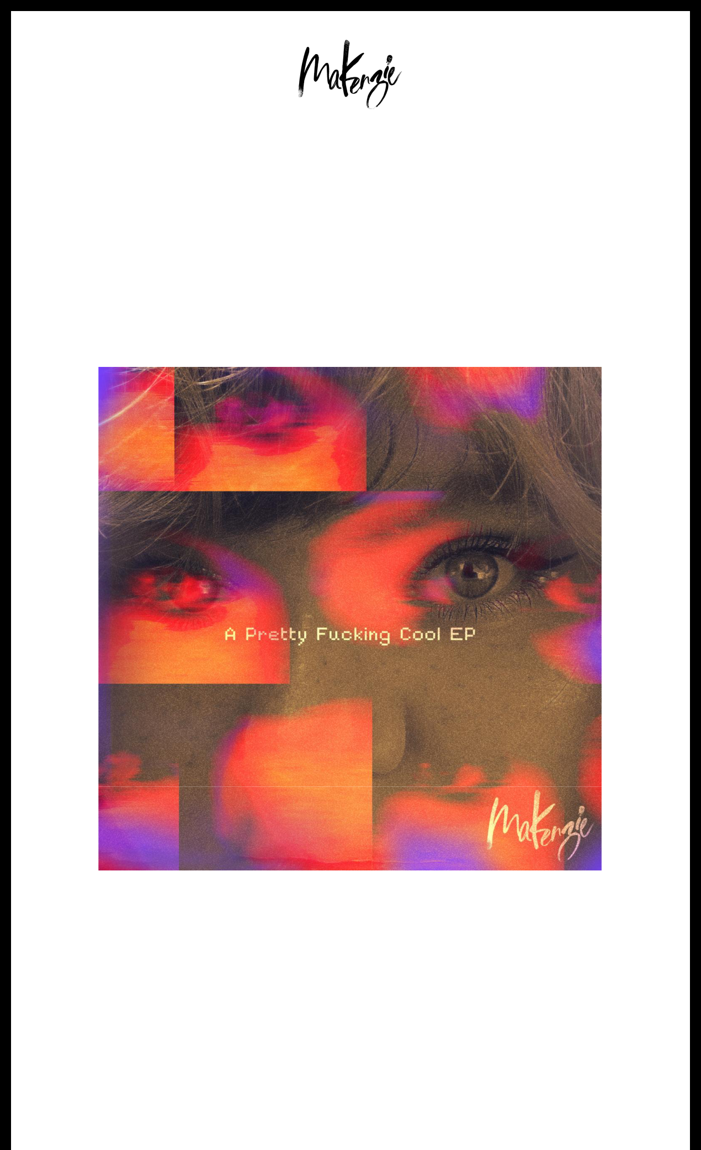

R&B/POP NEWCOMER MAKENZIE SHINES ON
A PRETTY FUCKING COOL EP

LISTEN HERE

“a powerful record that shines with pop flair over R&B production”

-UPROXX

“nostalgic and vibrant”

-VIBE

DOWNLOAD ARTWORK HERE

April 25, 2024 (Los Angeles, CA) – On the verge of a major breakthrough, rising Kentucky-born, Los Angeles-based R&B pop singer/songwriter MaKenzie releases A Pretty Fucking Cool EP today via Warner Records. Listen to A Pretty Fucking Cool EP, largely produced by Rob Knox (Justin Timberlake, Rihanna), HERE. Check out the full tracklisting below.

"To me, A Pretty Fucking Cool EP is simply: pretty fucking cool," MaKenzie states. "It’s a small compilation of some of my first experiences writing and creating with people who are as passionate and talented as I am. It’s a journey and hopefully a project that gives everybody a little something to enjoy."

Across these four tracks, MaKenzie introduces herself as both a vocal dynamo and a fiercely creative force of nature comfortable enough to strut between R&B and pop with unapologetic

style, sass, and edge. Bass thumps over distorted synths on the track “Cashmere” as she exudes attitude throughout the verses.

MaKenzie notably paved the way for the project with “Velvet” earlier this year. The EP also includes “LIPS” and “Maybe” ft. TA Thomas. A Pretty Fucking Cool EP spotlights MaKenzie’s versatility front and center. Whether on a throwback R&B banger or stretching into stratospheric pop heights, she asserts herself as a fluid, focused, and fiery force of nature with a unique and undeniable vision all her own.

This year, MaKenzie has appeared on coveted DSP playlists such as Spotify’s R&B Weekly and R&B Rising, Apple Music’s R&B Now and Breaking R&B, and Amazon Music’s Fresh R&B.

MaKenzie immediately embraced music as a kid. She went from performing with her family in church at barely two years old to immersing herself in the catalogs of formative influences such as Prince, Michael Jackson, Whitney Houston, Mariah Carey, Brandy, and Toni Braxton, in addition to the likes of Led Zeppelin and Dream Theater. She made a popular appearance on The Terrell Show, while her cover of the Supremes’ classic “You Can’t Hurry Love” tallied just shy of six million streams. She continued to build an audience with consistent R&B and gospel covers on social media. In 2024, MaKenzie inked a deal with Warner Records and released her debut project, A Pretty Fucking Cool EP.

A Pretty Fucking Cool EP Tracklist:
- Maybe
- Cashmere
- Lips
- Velvet

DOWNLOAD PRESS IMAGE HERE
Credit: Drew Cabral

STAY TUNED WITH MAKENZIE
TikTok | Instagram | YouTube

# # #

For More Information Contact:

Aishah White // Aishah.White@warnerrecords.com

Connor Hunt // Connor.Hunt@warnerrecords.com

Warner Records | 1633 Broadway, New York, NY 10019

Unsubscribe laura.swanson@warnerrecords.com Constant Contact Data Notice Sent byaishah.white@warnerrecords.compowered by

Try email marketing for free today!

