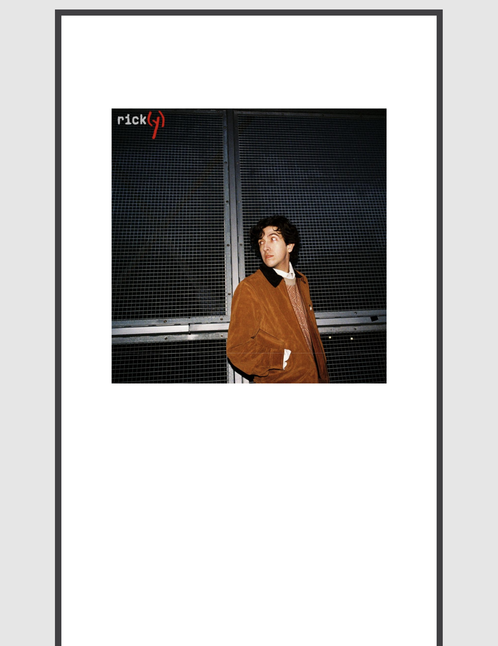
RICKY MONTGOMERY SHARES NEW RENDITION OF “REPTILIA”

LISTEN HERE

RICK(Y) DELUXE ALBUM OUT MAY 10

April 19, 2024 (Los Angeles, CA) – Breakout alt -pop artist Ricky Montgomery unveils his delicate new rendition of The Strokes’ classic “Reptilia” today via Warner Records. Rick(y)’s version of the track sets the stage for the arrival of Rick(y)—the deluxe edition of his acclaimed major label debut album Rick—out May 10. Listen to “Reptilia” HERE and pre-save the deluxe album HERE.

Earlier this year, Ricky wrapped up his biggest North America headline tour yet —"The Rick Tour: Another Rick in the Wall” – plus a completely sold-out leg throughout the UK/Europe. Next up, he’ll perform at The Wiltern in LA before descending upon Singapore and Australia for more sold-out shows later this month. Check out the full confirmed itinerary below, and stay tuned for more dates to be announced soon!

With 2 billion streams and 8.3 billion TikTok views, Ricky continues to foster his devoted young fanbase that hangs onto every word of his sunny, soul -searching alt-pop about life in all its messy and mundane glory. The recent release of his major label debut album Rick incited unanimous praise from fans and critics alike, with WONDERLAND promising, “this album is set to be a defining chapter in the career of Montgomery, fully coming into his own as an artist with depth, character and presence.” Billboard raved, “The listener can’t help but pay attention to Montgomery” and FAULT Magazine professed, “The album is a soul-searching journey through life’s trials and triumphs, woven together by Montgomery’s eloquent

songwriting skills, sometimes whimsical narratives and always emotive storytelling.” Thanks in part to his 1.7M TikTok followers, the album was fueled by a buzzing anime trend that’s historically become a unique and powerful driving force for his catalog. Check out Ricky’s perspective on the hot topic of TikTok in these features by Polygon and Vox.

Listen to Rick HERE, and purchase physical formats of Rick HERE, including vinyl, CD, and cassette.

UPCOMING TOUR DATES:

5/15 Los Angeles, CA

5/24 Singapore

5/26 Jakarta, Indonesia

5/29 Melbourne, VIC

5/31 Sydney, NSW

6/1 Brisbane, QLD

The Wiltern (Rescheduled)

Pasir Panjang Power Station Block A (LOW TIX!)

Java Jazz Festival

Max Watts (SOLD OUT!)

Metro Theatre (SOLD OUT!)

The Triffid (SOLD OUT!)

###

For more information, contact:
Ceri Roberts, Ceri.Roberts@warnerrecords.com
Patrice Compere, Patrice.Compere@warnerrecords.com

Press Materials:
Press.warnerrecords.com/rickymontgomery

Follow Ricky Montgomery:

INSTAGRAM | TWITTER | YOUTUBE | TIKTOK

Warner Records | 1633 Broadway, New York, NY 10019

Unsubscribe laura.swanson@warnerrecords.com Constant Contact Data Notice Sent byceri.roberts@warnerrecords.compowered by

Try email marketing for free today!

