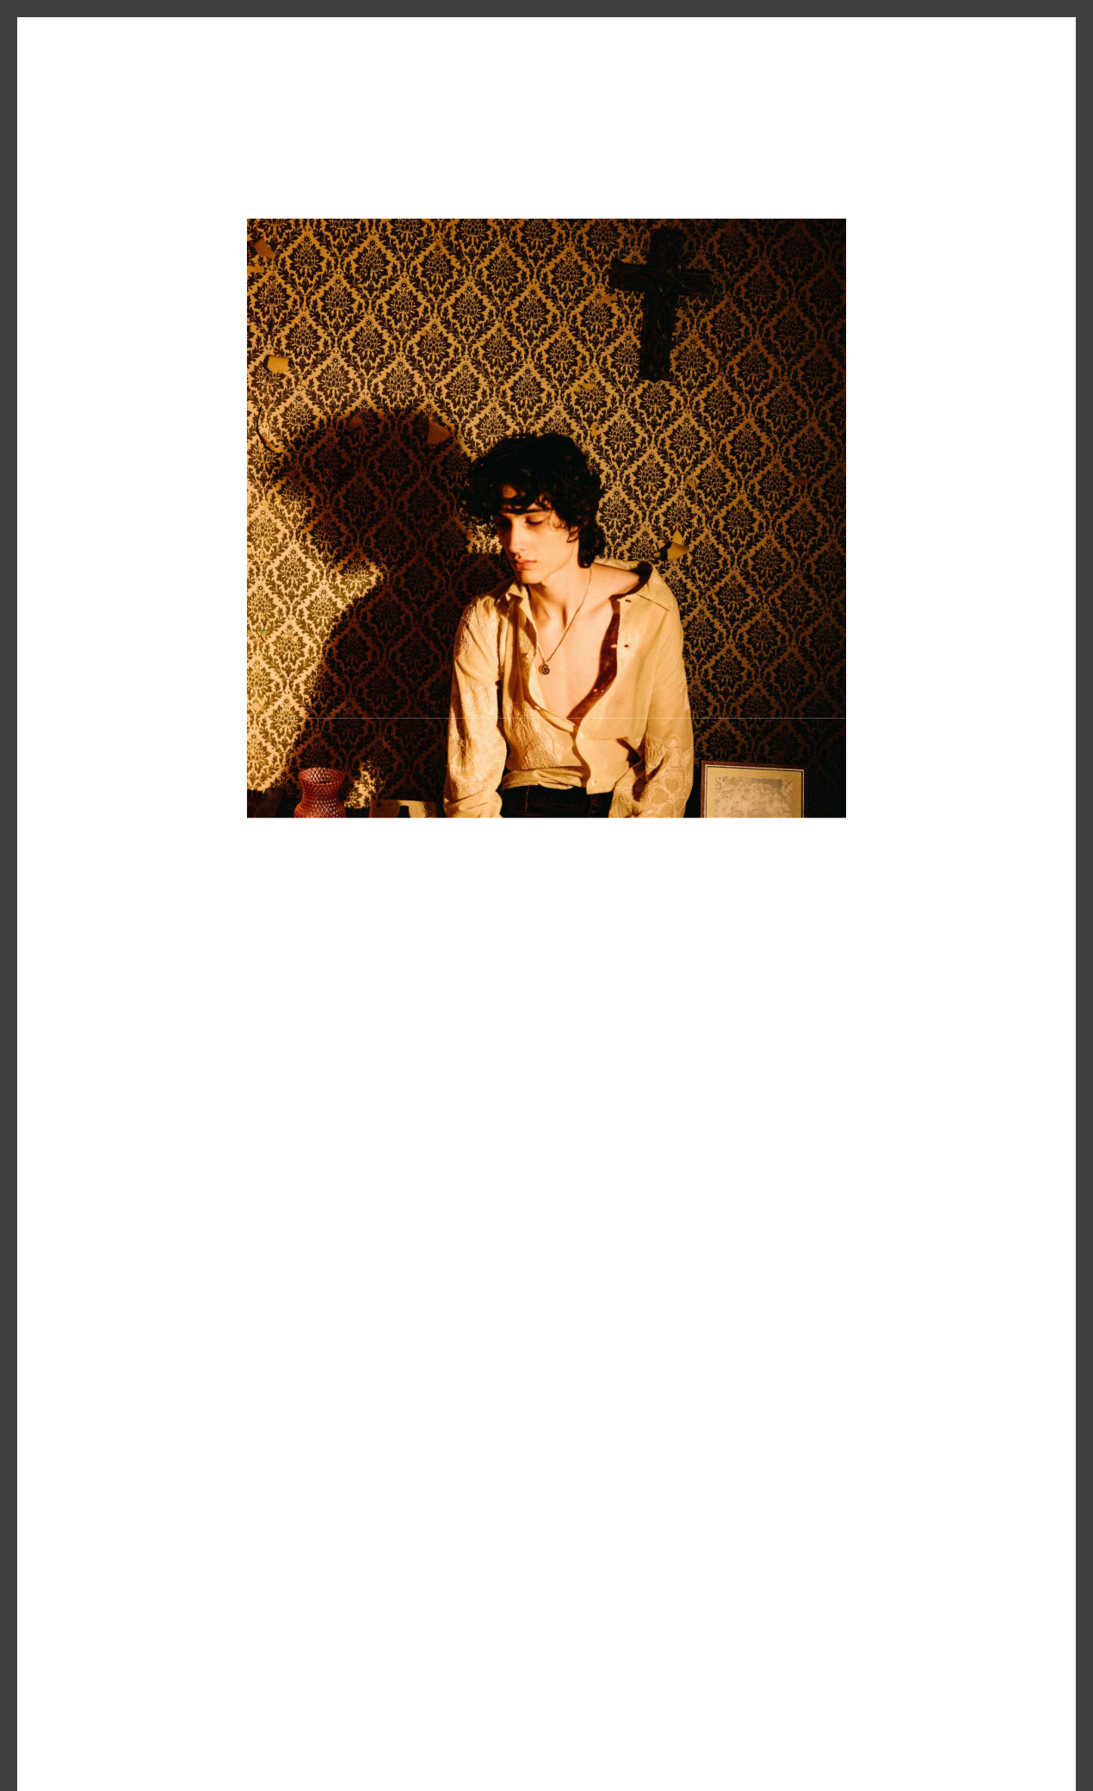

LO-FI ARTIST sombr DROPS NEW SINGLE “savior”
LISTEN HERE

MORE MUSIC COMING SOON

April 19, 2024 (Los Angeles, CA) –Responding to overwhelming fan demand, burgeoning singer, songwriter, and producer sombr serves up his new single en tled “savior” out now via Warner Records – listen HERE.

He first teased the track on TikTok last month, drumming up an cipa on amongst fans. “savior” illuminates the delicate dynamics at the heart of his signature sound. Co-produced by sombr and Tony Berg [Phoebe Bridgers, Taylor Swi ], icy piano echoes through hues of violin and organ. Emo on overflows on the chorus as he wonders, “Why’d you have to become a stranger? You were supposed to be my savior.” He goes on to lament, “All my hope was pinned on you,” as a guitar solo cries out with the same force.

It lands in the wake of “i’ll remember tonight” and “in your arms.” Around his recent sold-out New York show at Baby’s All Right, Atwood Magazine christened him “the rising indie prince of heartbreak,” and Oﬀ The Record Press raved, “Each song is sonically moving with his impeccable touch for composi on, adding in so notes of instruments when needed, such as piano and guitar.”

Surrounded by music since childhood, sombr has gleaned inspira on from his days at legendary public performing arts school LaGuardia High, a fascina on with classical music, and countless nights wri ng and recording out of a bedroom studio in his childhood home in the Lower East Side of New York City. He notably introduced himself with a series of independent fan favorite singles before breakout track “Caroline” cracked 32 million-plus streams on Spotify alone.

ABOUT sombr:
At 14 years old, Shane became sombr via a make-shi recording studio in his bedroom funded by
- summer of scooping ice cream. The now 18-year-old honed his talents at New York’s LaGuardia High, the public performing arts school celebrated for inspiring the film Fame, spending his days studying classical music and nights invested in his bedroom studio. While other high school juniors obsessed over driving tests or dates, sombr recorded roman c indie-rock melodies while trawling for like-minded musicians to sign to his label. When COVID hit, crea ng music became an escape for the young ar st from the physical and social isola on brought on by the pandemic - all leading sombr to launch his own major label imprint while his single “Caroline” earned over a million listens within its first week. S ll, the ar st project sombr remains the most passionate

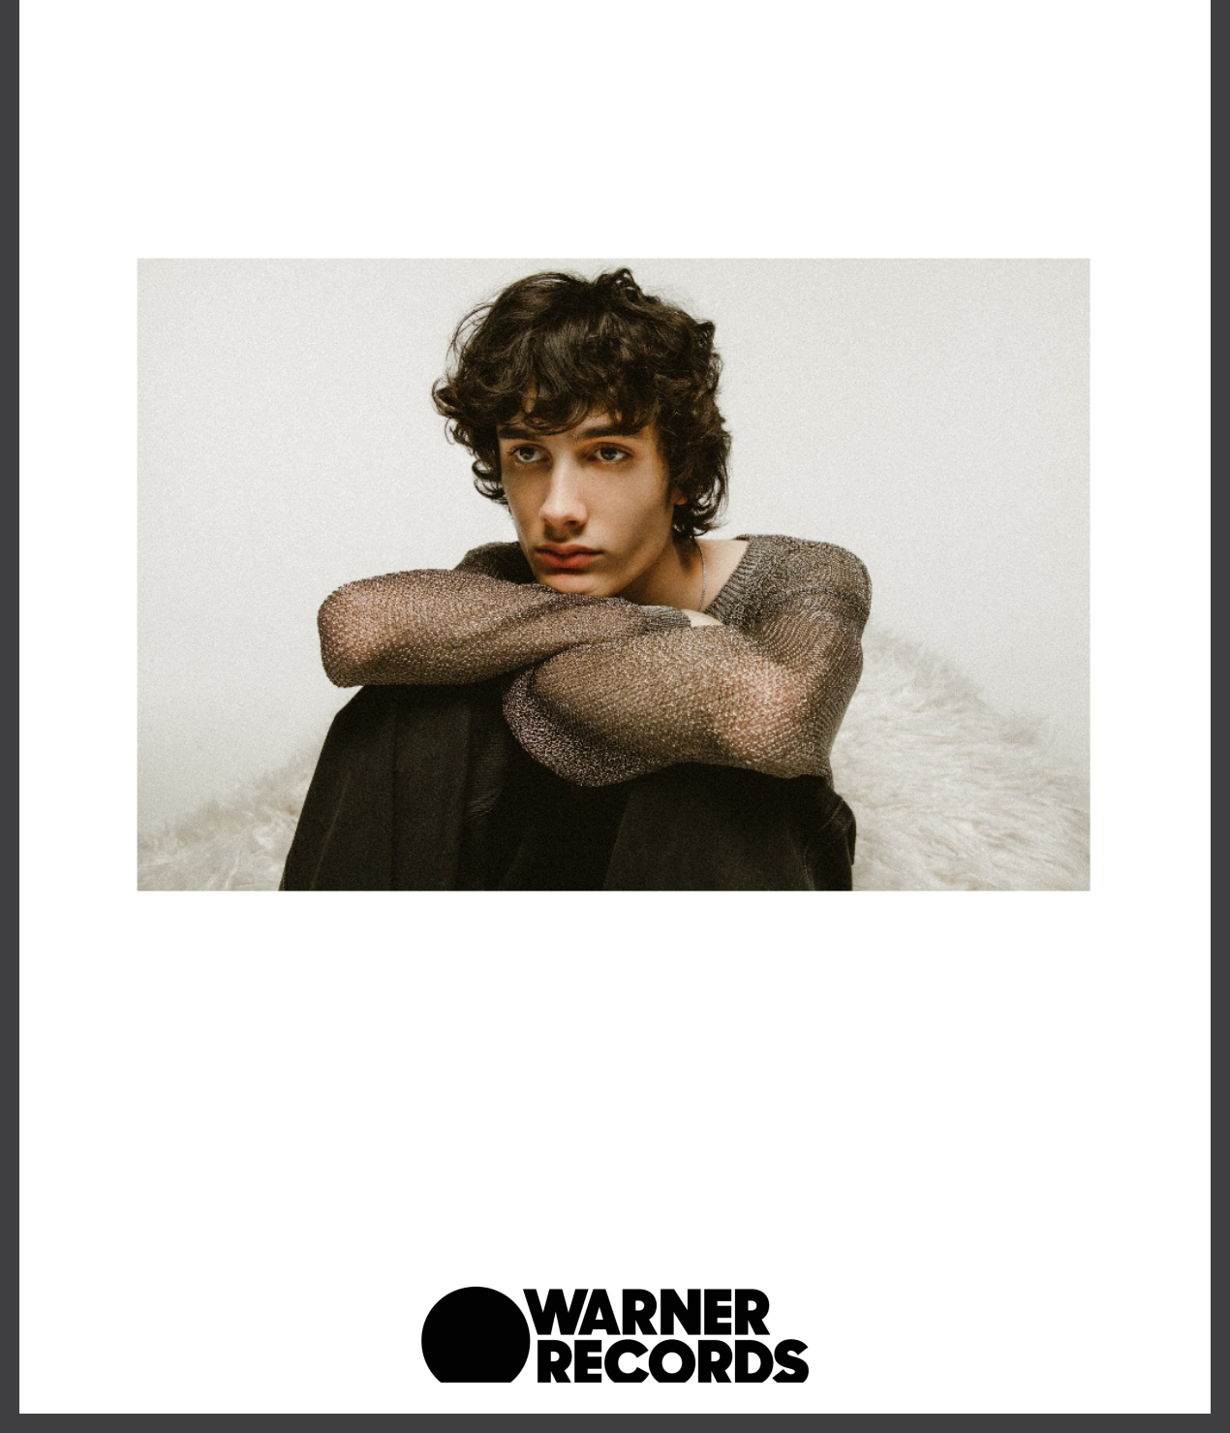
about is his own, and rightly so. “Caroline” and “Willow” have become sad girl anthems — popula ng Zillennial playlists across Spo fy. Informed by the alt-pop greats – from Bon Iver to Phoebe Bridgers – the singer-songwriter’s newer releases are certain to cement the ar st’s ascension, though sombr says he’d be happy enough with a “timeless alternative project.”

Stay Up-To-Date With Sombr

Instagram | Tiktok | YouTube | Press Website

Credit: Claire Marie Vogel

##

For More Information, Contact:

Ceri Roberts // Ceri.Roberts@warnerrecords.com

Connor Hunt // Connor.Hunt@warnerrecords.com

Warner Records | 1633 Broadway, New York, NY 10019

Unsubscribe laura.swanson@warnerrecords.com Constant Contact Data Notice Sent byconnor.hunt@warnerrecords.compowered by

Try email marketing for free today!

