VEEZE SHARES NEW SINGLE "POP YO SHIT"

AND VIDEO VIA NAVY WAVY / WARNER RECORDS

LISTEN HERE - WATCH HERE

DOWNLOAD ARTWORK HERE

“Let’s talk about real music –– Veeze, cult-hero, Detroit rapper....one of a big wave of Detroit guys putting out an
insane amount of really special, really funny, really original music."
– Jon Caramanica, The New York Times

"[Ganger is] a strong effort by an inimitable, effortlessly entertaining MC who’s mastered his world."
– Andre Gee, Rolling Stone

"Veeze is a Swiss Army Knife, able to adapt his scratchy, unrushed delivery to any environment."
– Matthew Ritchie, Pitchfork (8.0)

May 30, 2024 (Los Angeles, CA) - Following the release of his cult classic debut album Ganger, Detroit's own Veeze has shared his highly-anticipated first single of 2024, “Pop Yo Shit,” via Navy Wavy/Warner Records. Backed by an accompanying video shot in London, the uptempo track is defined by its eclectic beat and breakneck, in-your-face bar work coated in Veeze's signature flow.

Known for deep-cut references and lighthearted lyricism, Veeze’s standout instrumentals and unpredictable hooks combine for an irresistible formula, making each release an essential listening event. Hailing from Detroit’s 7 Mile neighborhood, Veeze garnered momentous acclaim with the release of Ganger, which earned spots on year-end “Best Of” lists from the likes of The Washington Post, Pitchfork, Rolling Stone, Complex, The FADER, and Stereogum. Stamping his first release of 2024, “Pop Yo Shit” marks the elusive, off-the-wall artist’s long-anticipated return as he

prepares to drop more music later this summer.

A beloved cult artist with unconventional flows and ear for progressive instrumentation, Veeze has all the trappings of a bonafide superstar in the making. After first making a splash in the Detroit rap scene with his 2019 debut mixtape Navy Wavy, standout efforts like his 2020 viral hit "Law 'N' Order", key contributions to Lil Yachty’s 2021 album Michigan Boy Boat, and the stellar “U-Digg” alongside close collaborators 42 Dugg and Lil Baby propelled his homegrown hype to a national scale. The momentum reached a tipping point with the landmark release of Veeze’s 2023 debut album Ganger, which boasted standout songs “Not a Drill” (52M+ Streams), “Safe 2” (36M+ streams), and “GOMD” (69M+ streams), the latter of which saw Lil Uzi Vert hop on a remix of the track. The Detroit heavyweight followed up the release with a deluxe edition of the album, which featured hit single “Get Lucki” (38M+ streams), after launching his own label imprint, Navy Wavy, in partnership with Warner Records.

Veeze flaunted his multifaceted appeal on his 2023 Ganger Tour with sold-out dates in NY, LA, ATL, and Detroit, which featured opening stints from breakout female acts Anycia and Myaap, who are currently taking the internet by storm. Recent months have seen him open for Travis Scott on the remainder of his Circus Maximus tour alongside Babyface Ray and Skilla Baby and embark on his first European tour, flexing his growing international fanfare — and making his case as Gen Z’s definitive rap superstar.
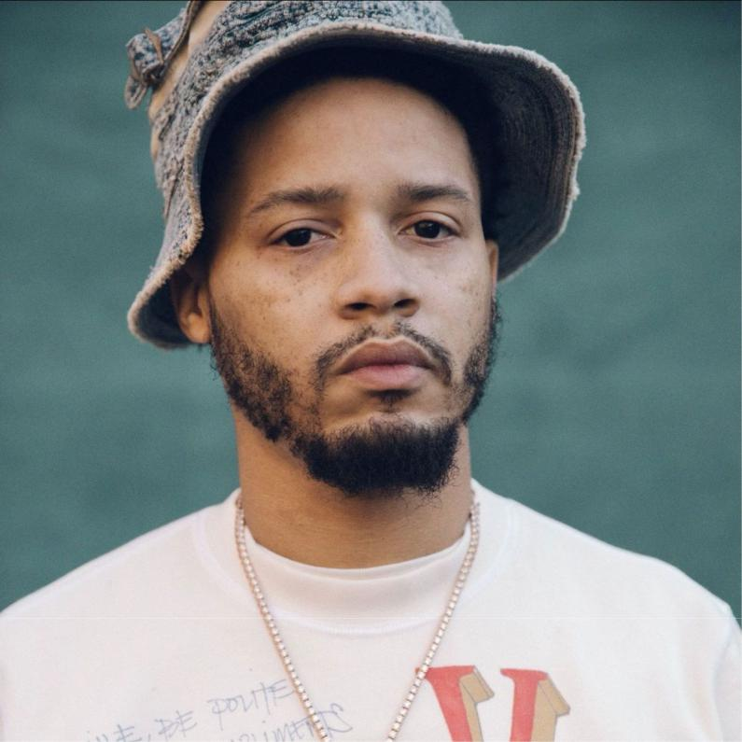

DOWNLOAD PRESS IMAGE HERE

​Photo Credit: Diwang Valdez

Follow Veeze

Instagram | Twitter | SoundCloud | YouTube | Spotify | Apple Music

For more information on Veeze, please contact:
Yash Zadeh | Warner Records
Yashar.Zadeh@warnerrecords.com

Scott Jawson | Dark Matter Media

scott@darkpr.com

Sam Hadelman | Dark Matter Media

sam@darkpr.com

Warner Records | 1633 Broadway | New York, NY 10019 US

Unsubscribe | Constant Contact Data Notice

