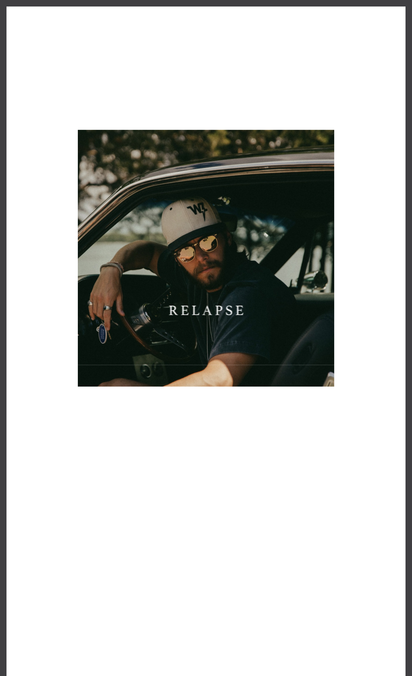

WARREN ZEIDERS SHARES NEW COUNTRY-ROCK SINGLE

“RELAPSE”

Capped CMA Fest week, including the Rock N' Jock: Celebrity Softball with Folds of Honor TN, Grand Ole Opry performances, and a jam-packed Riverfront Stage performance

Kicking off 2025 with his debut European tour - dates below

June 7, 2024 (Los Angeles, CA) — Today, Warner Records artist Warren

Zeiders shares another tease of what’s next with the country-rock banger

“Relapse.” Produced by Mike Elizondo (Brothers Osborne, Sheryl Crow), and co-

written with Zeiders, Blake Pendergrass (Morgan Wallen, Chris Lane) and Justin

Ebach (Brett Young, Dustin Lynch), the track fist perfectly into the hard-rock edge

Zeiders brings to Country.

Zeiders continues to prove he’ll soon be a household name in the genre. He recently won the CMT Award for “Breakthrough Male Video of the Year” for his chart-topping hit “Pretty Little Poison.” The song – which peaked in the Top 24 on Billboard’s Hot 100 chart – earned his first No.1 single on country radio and his second RIAA Platinum-certified single.

Zeiders is currently on his nearly sold-out 2024 North American headlining tour, and then will join Jelly Roll as direct support for his Fall The Beautifully Broken Tour. The arena tour kicks off on August 27th in Salt Lake City and includes stops at NYC’s Madison Square Garden, LA’s Crypto.com Arena, Chicago’s United Center and more. He will kick-off 2025 with this first-ever European headlining tour.

He currently boasts 2 billion career streams, 1 billion+ TikTok views and 8M monthly Spotify listeners, solidifying his place as one of Nashville’s hottest headliners. He was also recently announced as one of the artists featured on the upcoming star-studded Twisters soundtrack.

Stay tuned for much more from Warren Zeiders.

Upcoming Tour Dates:

ITALICS denotes show with Jelly Roll

June 8 - Rock the Country - Ocala, FL

June 14 - Fourth Street Live! - Louisville, KY

June 15 - Old Settler’s Day Festival - Rockton, IL

June 16 - Tailgate N’ Tallboys - Bloomington, IL

June 20 - KC Live! - Kansas City, MO

June 21 - Harrah’s Stir Cove - Council Bluffs, IA

June 22 - Denny Sanford Premier Center - Sioux Falls, SD June 28 - Country Fest 2024 - Cadott, WI June 29 - Crash My Crater 2024 - Manson, IA

July 5 - Ottawa Bluesfest - Ottawa, ON

July 7 - Cavendish Beach Music Festival - Cavendish, PEI July 11 - Clinton County Fair - Plattsburgh, NY July 12 - Clearfield County Fair - Clearfield, PA

July 13 - Country Concert - Fort Loramie, OH

July 18-20 - Rock The South - Cullman, AL

July 21 - Cheyenne Frontier Days - Cheyenne, WY

July 26 - Harley Davidson Homecoming Fest - Milwaukee, WI July 27 - Tailgate N’ Tallboys - Midland, MI Aug. 1 - WE Fest - Detroit Lakes, MN

Aug. 2 - Wean Park - Youngstown, OH

Aug. 7 - Sikeston Rodeo - Sikeston, MO

Aug. 8 - Washington Town & Country Fair - Washington, MO Aug. 9 - Missouri State Fair - Sedalia, MO Aug. 21 - Bash on the Bay - Put-In-Bay, OH

Aug. 22 - The Great New York State Fair, New York State Fair Grounds - Syracuse,

NY

Aug. 23 - Festival Country Lotbiniere - Saint-Agapit, QC Aug. 27 - Delta Center - Salt Lake City, UT Aug. 28 - Ford Idaho Center Arena - Nampa, ID

Aug. 30 - Spokane Arena - Spokane, WA

Aug. 31 - Climate Pledge Arena - Seattle, WA

Sep. 1 - Moda Center - Portland, OR

Sep. 3 - SAP Center - San Jose, CA

Sep. 4 - Golden 1 Center - Sacramento, CA

Sep. 6 - Crypto.com Arena - Los Angeles, CA

Sep. 7 - Honda Center - Anaheim, CA

Sep. 9 - UTEP Don Haskins Center - El Paso, TX

Sep. 11 - Frost Bank Center - San Antonio, TX

Sep. 13 - Cajundome - Lafayette, LA

Sep. 14 - Smoothie King Center - New Orleans, LA

Sep. 17 - Kia Center - Orlando, FL

Sep. 19 - North Charleston Coliseum - North Charleston, SC

Sep. 20 - PNC Arena - Raleigh, NC

Sep. 21 - Capital One Arena - Washington, DC

Sep. 24 - MVP Arena - Albany, NY

Sep. 26 - TD Garden - Boston, MA

Sep. 27 - Madison Square Garden - New York, NY

Sep. 28 - UBS Arena - Belmont, NY

Sep. 29 - Prudential Center - Newark, NJ

Oct. 1 - Pennsylvania State University - Bryce Jordan Center - State College, PA

Oct. 2 - Wells Fargo Center - Philadelphia, PA

Oct. 4 - Country Calling Festival - Ocean City, MD

Oct. 5 - PPG Paints Arena - Pittsburgh, PA

Oct. 6 - KeyBank Center - Buffalo, NY

Oct. 9 - Nationwide Arena - Columbus, OH

Oct. 11 - United Center - Chicago, IL

Oct. 12 - KFC Yum! Center - Louisville, KY

Oct. 15 - INTRUST Bank Arena - Wichita, KS

Oct. 18 - BOK Center - Tulsa, OK

Oct. 20 - Brookshire Grocery Arena - Bossier City, LA Oct. 22 - Simmons Bank Arena - North Little Rock, AR Oct. 23 - Enterprise Center - Saint Louis, MO

Oct. 25 - Thompson–Boling Arena At Food City Center - Knoxville, TN Oct. 26 - State Farm Arena - Atlanta, GA Oct. 27 - Spectrum Center - Charlotte, NC

Jan. 24 - Rockefeller Music Hall - Oslo, Norway

Jan. 26 - Berns - Stockholm, Sweden

Jan. 27 - Vega - Copenhagen, Denmark

Jan. 29 - Docks - Hamburg, Germany

Jan. 31 - Muffathalle - Munich, Germany

Feb. 2 - Kaufleuten - Zurich, Switzerland

Feb. 3 - Carlswerk Victoria - Cologne, Germany

Feb. 4 - Melkweg Max - Amsterdam, Netherlands

Feb. 7 - Ulster Hall - Belfast, UK

Feb. 9 - O2 Academy Glasgow - Glasgow, UK

Feb. 11 - Albert Hall - Manchester, UK

Feb. 12 - O2 Academy Bristol - Bristol, UK

Feb. 14 - O2 Institute Birmingham - Birmingham, UK

Feb. 15 - O2 Shepherd’s Bush Empire - London, UK
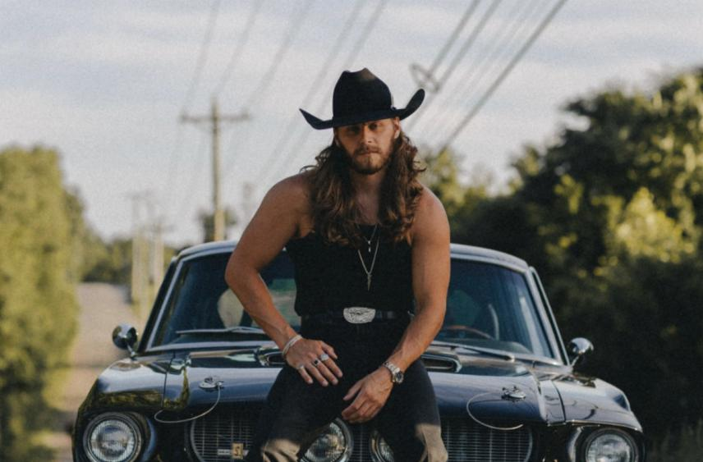

# # #

FOLLOW WARREN ZEIDERS:

Facebook | Instagram | Twitter | TikTok | YouTube | Press Materials

PRESS CONTACTS:

Rick Gershon | Warner Records | rick.gershon@warnerrecords.com

Jaclyn D. Carter | Shore Fire Media | jcarter@shorefire.com

Andrea Evenson | Shore Fire Media | aevenson@shorefire.com

Maria Eilert | Shore Fire Media | meilert@shorefire.com
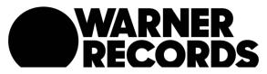

Warner Records | 777 S Santa Fe Ave. | Los Angeles, CA 90021 US

Unsubscribe | Constant Contact Data Notice
