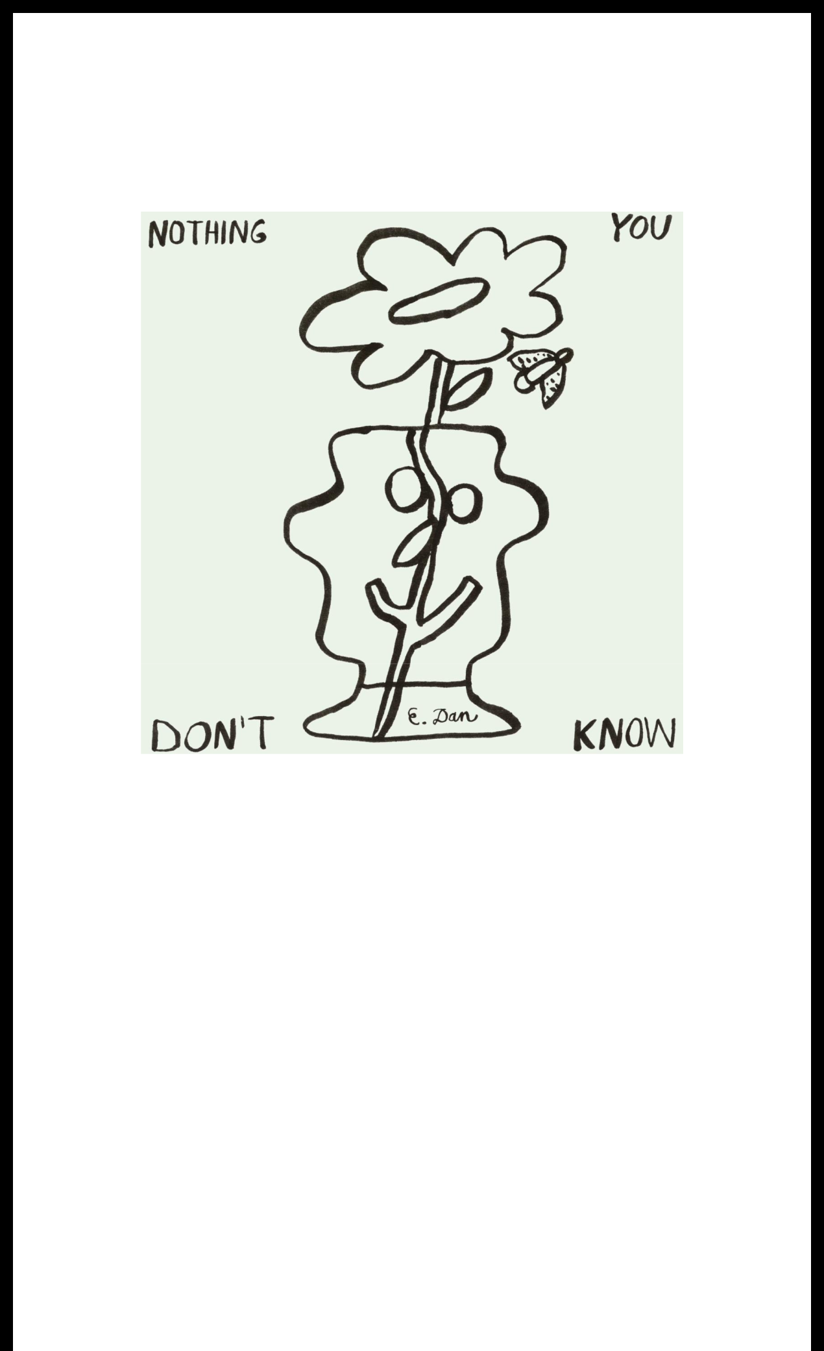
ID LABS DROPS NEW ALBUM NOTHING YOU DON’T KNOW
ON REMEMBER MUSIC / WARNER RECORDS

INCLUDES NEW SINGLE "MINDSET"

LISTEN HERE

DOWNLOAD ART HERE

April 26, 2024 (Los Angeles, CA) — Today, storied production studio ID Labs helmed by veteran Pittsburgh producer E. Dan, drops Nothing You Don’t Know, a mesmerizing new instrumental album via Mac Miller's REMember Music label and Warner Records. Listen HERE. Each song is accompanied by playful hand drawn visualizers by Miller McCormick who also illustrated the album cover. Watch them all HERE.

Checking in at 16 tracks, Nothing You Don’t Know is both meticulous and free — highlighting ID Labs’ attention to detail and varied musical impulses. The diverse textures lead to the best kind of artistic juxtaposition and experimentation where dense layers give way to escapist thrill.

With a remarkable instinct for cultivating moods, ID Labs takes listeners through feelings that are as kaleidoscopic as the sounds the studio uses to distill them. Some standouts in the eclectic soundscape are the lead single "Mindset," as well as "Snail Parade," "Slow Drip," and "Peanut." Nothing You Don’t Know is ID Labs’ second instrumental album. The title derives from a line in an Amira Baraka poem featured in the Roots song “Something In The Way Of Things (In Town).” It’s the kind of multi-layered flourish that ID Labs has developed since its days as an emerging music hub in Pittsburgh.

If you’re familiar with acts like the late Mac Miller or Wiz Khalifa, there’s a good chance you know about ID Labs, which played a crucial role in their early careers. In subsequent years, ID Labs has also produced for the likes of Juicy J., Freddie Gibbs, Smoke Dza, J.I.D, Logic, and Snoop Dogg, among others, bringing the studio's sound and curatorial expertise to folks across the world of hip-hop and beyond.

Nothing You Don’t Know is proof that ID Labs is creating with a freedom — and understanding —

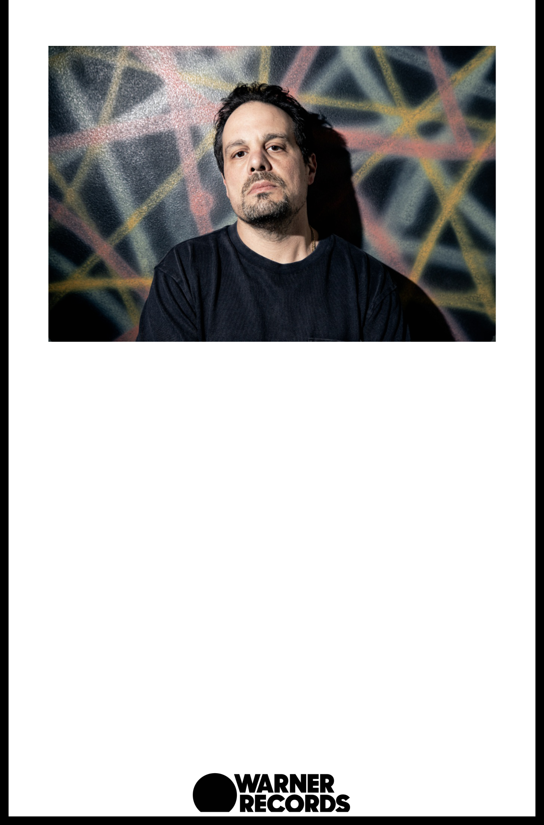
they’ve never had before. With the new album, fans can join ID Labs on the journey to good vibes and even better music.

DOWNLOAD PRESS IMAGE

Credit - Justin Boyd

ABOUT ID LABS:

E. Dan has always been a bit of a musical omnivore. For more than 20 years, the producer and studio proprietor has been a pivotal figure in Pittsburgh hip-hop, first as a member of the local group Strict Flow, later as one of the scene’s key beatsmiths, and eventually as the founder of ID Labs, the studio from which local legends like Wiz Khalifa and the late Mac Miller would emerge. Through his production for (and mentorship of) those artists and others, E. Dan has been crucial in growing hip-hop in Pittsburgh and exporting it nationwide. Now he’s ready to pursue a new journey: making solo music that takes him deeper within himself. His second instrumental album, Nothing You Don’t Know, reflects his varied appetites for sound, style, and experience, with technical precision (“Loaner”) and inescapable groove (“Bottomed Out”) delightfully sparring with one another. Enamored of songs by New Yorkers like Slick Rick and Public Enemy, the young E. Dan began to make pause tapes as he listened to the radio. This kicked off a lifelong obsession with the music itself and rendering it just so. While his work with Khalifa and Miller brought his sound to listeners around the world (and onto albums by the likes of Juicy J., Freddie Gibbs, Smoke Dza, J.I.D, Logic, and Snoop Dogg, among others), E. Dan never left the city for too long, preferring to focus on his family, his community, and the larger ecosystem of which he’d become such an important part. And, of course, Dan is still pushing musical boundaries—free from worries about conformity or commercial whims.

FOLLOW ID Labs:

Instagram | Twitter

For more information, please contact:
Yashar Zadeh | Warner Records
Yashar.Zadeh@warnerrecords.com

Warner Records | 1633 Broadway, New York, NY 10019

Unsubscribe laura.swanson@warnerrecords.com

Constant Contact Data Notice

Sent byyashar.zadeh@warnerrecords.compowered by

Try email marketing for free today!

