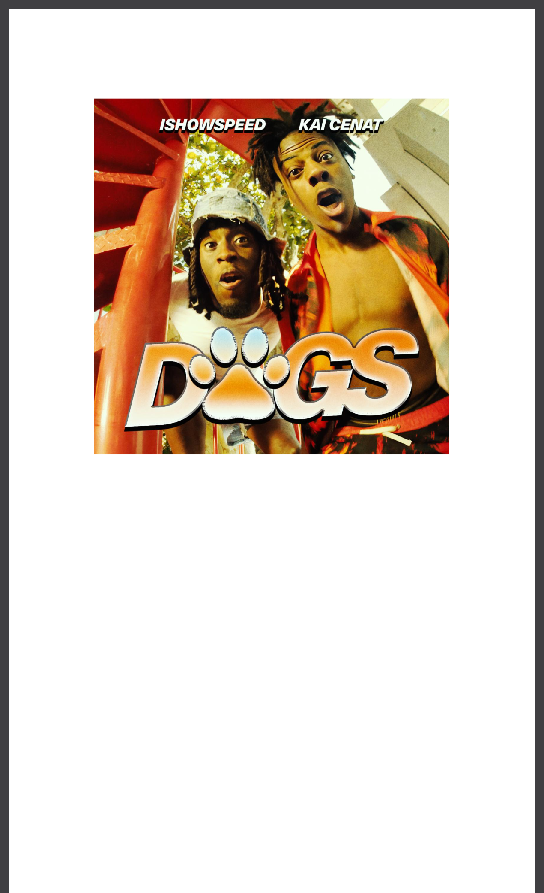
ISHOWSPEED TAPS KAI CENAT FOR NEW SINGLE “DOGS”

LISTEN HERE - WATCH HERE

DOWNLOAD ART HERE

April 28, 2023 (Los Angeles, CA) – Today, streamer and rapper IShowSpeed teams up with fellow streaming star Kai Cenat for their relentless new single, “Dogs.” Listen HERE and watch HERE

via Warner Records. Built around a sample of the Baha Men’s massive 2000 hit “Who Let the Dogs Out,” the song showcases the charismatic personalities that have made Speed and Cenat magnetic presences across various mediums.

Though best known as a feel-good summer novelty, Speed and Kai turn the Baha Men’s song into something more. And Speed's ability to ride such a rush of energy proves that he has quickly become as adept in the booth as he is when speaking directly to fans.

“Dogs” comes in the wake of “World Cup,” which charted around the world and has racked up nearly 90 million views on YouTube alone. It also continues Speed’s penchant for flipping familiar samples in unfamiliar but potent ways.

In addition to his burgeoning music career, IShowSpeed continues to be one of the most streamed creators on the planet. At the end of 2022, his trip to Qatar to attend the World Cup was followed by his audience of more than 16 million subscribers. In December, he and Kai Cenat were honored alongside one another at the 12th annual Streamy Awards, where Speed took home the Breakout Streamer trophy and Cenat was named Streamer of the Year.

FOLLOW ISHOWSPEED:
Twitter | Instagram | YouTube | TikTok

For more information, please contact:
Yash Zadeh
Warner Records

Yashar.Zadeh@warnerrecords.com

Warner Records | 1633 Broadway, New York, NY 10019

Unsubscribe laura.swanson@warnerrecords.com Constant Contact Data Notice Sent byyashar.zadeh@warnerrecords.compowered by

Try email marketing for free today!

