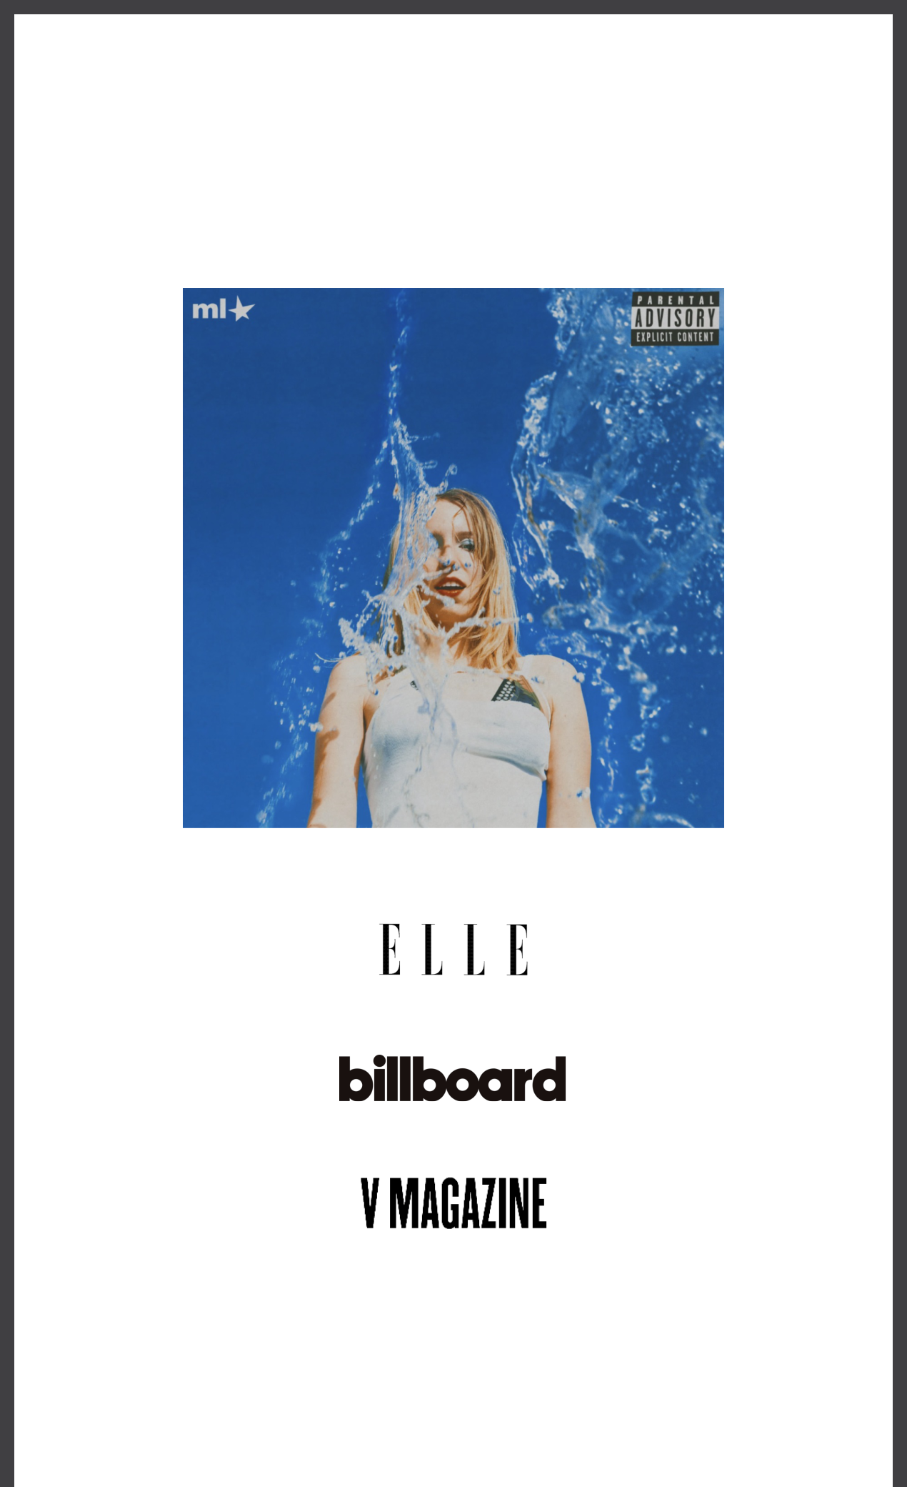
MAUDE LATOUR ANNOUNCES DEBUT ALBUM SUGAR
WATER OUT AUGUST 16

NEW SINGLE “COMEDOWN” OUT TODAY
LISTEN HERE

TOUR WITH FLETCHER KICKS OFF THIS SEPTEMBER

“An unabashedly confident pop star.”

"It’s easy to picture rising alt-pop star Maude Latour enjoying the kind of breakthrough hit that Tate McRae recently enjoyed with 'Greedy'"

“a rising star to watch this year"

June 28, 2024 (Los Angeles, CA) – Continuing her most anticipated year to date, alt-pop star Maude Latour has announced her debut album, Sugar Water, arriving August 16th via Warner Records. Pre-order/pre-save the record HERE.

Alongside the announcement, she shares nostalgic new single“Comedown” today, following her recently released cosmic-pop anthems “Too Slow” and “Cursed Romantics,” which both earned acclaim right out of the gate from Stereogum, PAPER, V Magazine, Rolling Stone, UPROXX, Billboard, and more. Listen to “Comedown” HERE, and stay tuned for the full album tracklisting to be announced soon.

Following the successes of her viral lockdown-era hit“One More Weekend” and four infectious EPs, Maude has firmly cemented her status as a leading artist-to-watch in 2024, winning over critics from The New York Times to NPR, and performing at Lollapalooza, Governors Ball, Austin City Limits, and many more. Now, with her highly-anticipated debut album – crafted alongside longtime collaborator Mike Adubato, plus hitmakers Austen Healey (Chappell Roan, Olivia Rodrigo), Zhone (Kesha, Troye Sivan), and Alex Chapman (Troye Sivan, Kim Petras) – the 24 year-old is doubling down on her formula of combining studio experimentation with undeniable cosmic-pop hooks and thoughtful lyrics, inviting her audience to come along for the ride, eyes and mind wide open, and stereo turned up as far as it can go.

About the forthcoming album, Maude shares, “‘Sugar Water’ is about growing up and learning how to lose things, people, and love— all parts of getting older. This album is an attempt at trying to hold onto the sweetness of this short life while it is still happening. It’s my most existential, deepest thoughts coated in pop music. I hope it takes you on the journey of a lifetime.”

This fall, Maude will join Fletcher on her upcoming US tour, making stops at iconic venues across the country, including Radio City Music Hall in her hometown New York City and the Greek Theatre in Los Angeles. See a full list of dates below, and tickets are available now at www.maudelatour.com.

UPCOMING TOUR DATES:
July 17 | Calgary, AB | The Calgary Stampede
September 12 | Minneapolis, MN | The Fillmore*
September 14 | Chicago, IL | Byline Bank Aragon Ballroom*
September 15 | Detroit, MI | The Fillmore*
September 17 | Philadelphia, PA | The Fillmore*
September 18 | Washington, DC | The Anthem*
September 19 | Boston, MA | Roadrunner*
September 21 | New York, NY | Radio City Music Hall*
September 27 | Nashville, TN | Marathon Music Works*
September 29 | Atlanta, GA | Coca-Cola Roxy*
October 2 | Houston, TX | Bayou Music Center*
October 3 | Dallas, TX | South Side Ballroom*
October 6 | Phoenix, AZ | Arizona Financial Theatre*
October 7 | San Diego, CA | SOMA*
October 9 | Los Angeles, CA | Greek Theatre*

* with Fletcher

###

FOLLOW MAUDE LATOUR:
TikTok | Instagram | Twitter | Facebook | YouTube | Press Materials

For more information, please contact:
Patrice Compere | Warner Records
Patrice.Compere@warnerrecords.com

Warner Records | 1633 Broadway | New York, NY 10019 US

Unsubscribe | Constant Contact Data Notice

