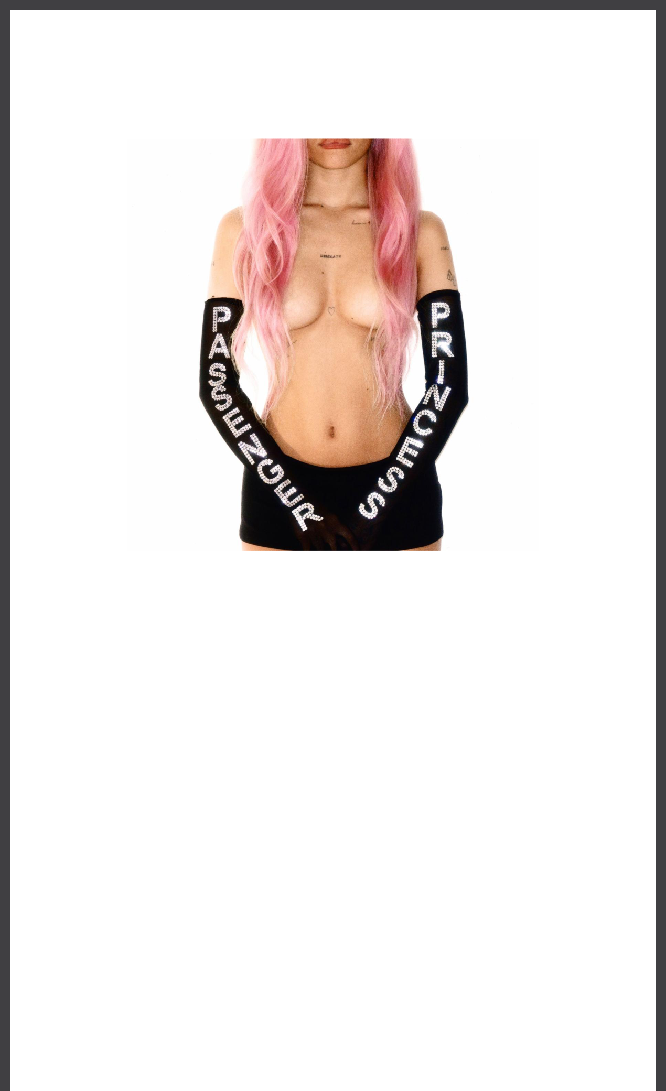

**NESSA BARRETT RETURNS WITH INFECTIOUS NEW SINGLE "PASSENGER PRINCESS”**

**LISTEN** [**HERE**](https://nessa.lnk.to/passengerprincess) **| WATCH** [**HERE**](https://nessa.lnk.to/PassengerPrincessLyric)

Download hi-res artwork [HERE](https://drive.google.com/file/d/1i9xlfCjmB3VH5sAOVXTW2ob-XLWKvQBh/view?usp=sharing)

**July 26, 2024 (Los Angeles, CA) –** Today, breakout alt-pop artist **Nessa Barrett** returns with the soaring **“PASSENGER PRINCESS.”** Listen [**HERE**](https://nessa.lnk.to/passengerprincess) via **Warner** **Records** and watch the lyric video [**HERE**](https://nessa.lnk.to/PassengerPrincessLyric). Showcasing **Barrett’s** signature sultry pop sound, the track marks her first release of 2024 and also serves as the first taste of her sophomore album, ***AFTERCARE***, arriving later this year.

*"****’PASSENGER PRINCESS'*** *represents the intense honeymoon phase when you first enter in a new relationship — the mindset where you would do anything for the one you love just to experience the passion of a connection,”* **Barrett** explains.

Earlier this summer, **Barrett** joined **Lana Del Rey** on stage at Hangout Festival, where the duo performed **Barrett’s** fan-favorite 2023 single **“**[**american jesus**](https://www.youtube.com/watch?v=wloenuNpnIY)**,”** from [her celebrated ***hell is teenage girl*** EP. Last year also saw her release **“girl in new**](https://www.youtube.com/watch?v=DJzPM-FE_WQ)[**york,”** the heartfelt **“**](https://www.youtube.com/watch?v=DJzPM-FE_WQ)[**club heaven**](https://www.youtube.com/watch?v=qwuAmw--vRM)[**,”** and her pulse-pounding collaboration with](https://www.youtube.com/watch?v=DJzPM-FE_WQ)Whethan, **“**[**sick of myself**](https://www.youtube.com/watch?v=HTBu8dE-Zs0)**.”** Shortly after, she hit the road for her fully sold-

out ***church club for the lonely* tour**, which included two main stage performances at Austin City Limits Festival.

After being named as one of *Billboard*’s “21 Under 21” twice — as well as being featured on *Forbes’* “Top Creators: Fashion 50,” *Uproxx’*s “Next Hitmakers List,” *People Magazine*’s “Emerging Artist List,” and *Ones to Watch’s* list of “25 Artists to Watch in 2022” — **Nessa Barrett** has gone on to accumulate nearly **2 billion** global streams to date. In 2022, she was also nominated for PushPerformance of the Year at the MTV VMAs, performed at When We Were Young Festival, and took her show on the road for her sold out North American and

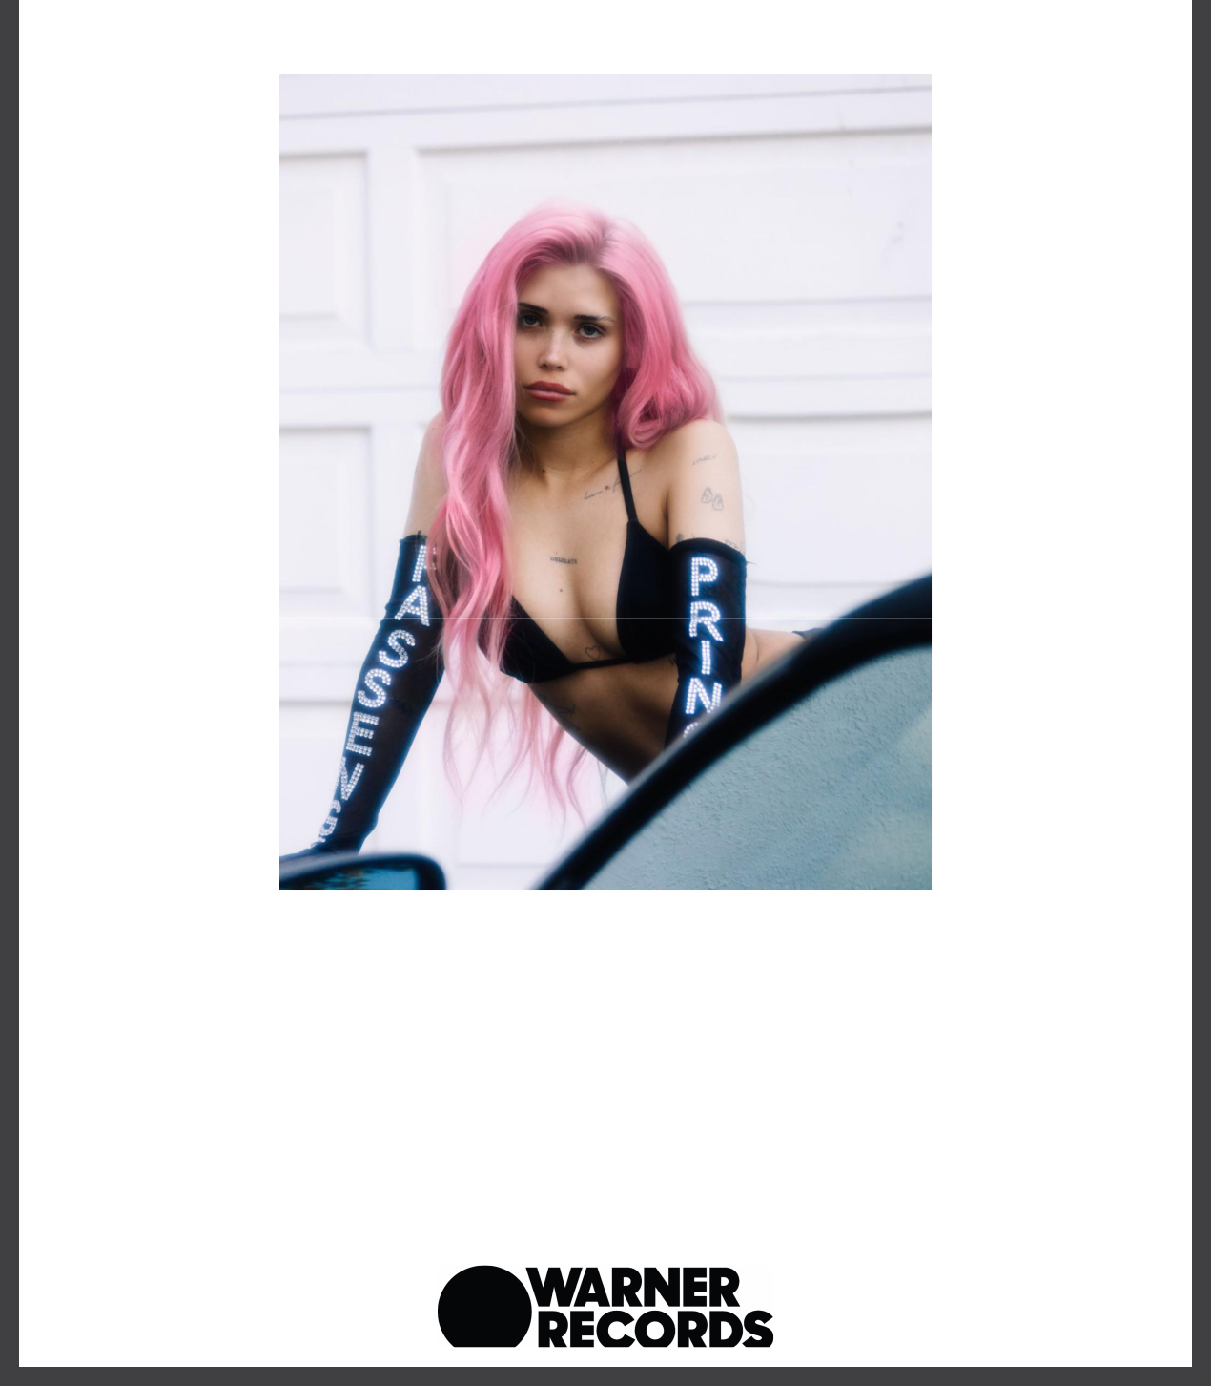European tours in support of her acclaimed debut album ***young forever***.

Photo credit: Quincy Banks

Download hi-res image [**HERE**](https://drive.google.com/file/d/1bjeRbfSGOIbYmfANW9VKCJEVjG4vn5ft/view?usp=sharing)

**Follow Nessa Barrett:**

[Official](https://shop-nessa.com/) | [TikTok](https://www.tiktok.com/@nessaabarrett?lang=en) | [Instagram](https://www.instagram.com/nessabarrett/?hl=en) | [Twitter](https://twitter.com/nessabarrett?ref_src=twsrc%5Egoogle%7Ctwcamp%5Eserp%7Ctwgr%5Eauthor) | [Facebook](https://www.facebook.com/Nessa-Barrett-2402853223078170) | [YouTube](https://www.youtube.com/channel/UCf2rs0a5IMVU4IwSX0Zne4Q) | [Press Materials](https://press.warnerrecords.com/nessa-barrett/) | [Store](https://youngforever.nessa-barrett.com/)

**Nessa Barrett contact:**

Darren Baber | Warner Records

[Darren.Baber@warnerrecords.com](mailto:Darren.Baber@warnerrecords.com)

Warner Records | 777 S Santa Fe Ave. | Los Angeles, CA 90021 US

Unsubscribe | [Constant Contact Data Notice](http://www.constantcontact.com/legal/about-constant-contact)

