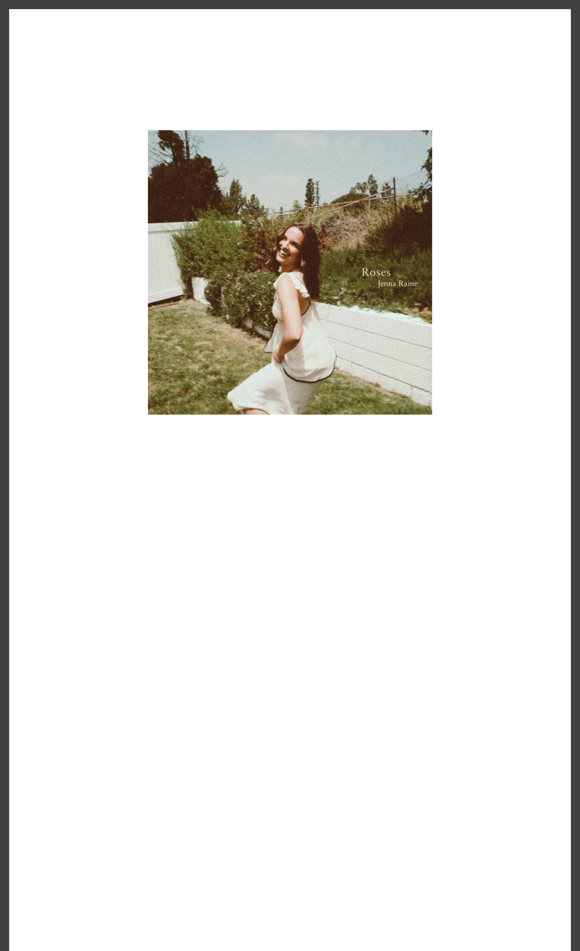

**BREAKOUT POP ARTIST JENNA RAINE SHARES**

**NEW SINGLE “ROSES”**

**LISTEN** [**HERE**](https://jennaraine.lnk.to/Roses) **| WATCH LYRIC VIDEO** [**HERE**](https://www.youtube.com/watch?v=gpq6BPus8n4)

Download hi-res artwork [HERE](https://drive.google.com/file/d/1lQ8f6kLeKcZGaa-TXwJE815eT_kIXVhR/view?usp=sharing)

**August 9, 2024 (Los Angeles, CA) –** Leveling up once more, rising pop artist **Jenna**

**Raine** shares an upbeat and empowering new single entitled **“Roses.”** Listen [**HERE**](https://jennaraine.lnk.to/Roses) via **Warner Records** and watch the lyric video [**HERE**](https://www.youtube.com/watch?v=gpq6BPus8n4).

A wistful harmony sets the tone for the track. In between softly sustained acoustic guitar chords, she urges, *“Don’t go killing all my roses, ‘cause I’ve only started growing* .*”* Handclaps and breezy strumming pick up the pace as a captivating chorus takes hold. During the bridge, she leans into her power with a confident and charismatic chant, *“I dig my roots into the ground. No you won’t ever cut me down*!*”*

**“Roses”** lands in the wake of **Raine’s** recent fan-favorite track **“**[**Hypothetically**](https://www.youtube.com/watch?v=_wJdaBATaQk)**.”** Released earlier this summer, the song was preceded by **“** [**Lovesick**](https://www.youtube.com/watch?v=2Wwfg9B2Ys8)**”** and **“**[**Big Dumb Heart**](https://www.youtube.com/watch?v=70aErZxd1P4)**.”** They [followed the release of 2023’s ***Big Dumb Heart****,* ***Chapter 2*** EP*,* including the viral hit **“It Is What**](https://www.youtube.com/watch?v=-p8Behv6ji0)[**It Is.”** The track exploded on TikTok, garnering over 5 million views on her video that inspired its](https://www.youtube.com/watch?v=-p8Behv6ji0) own dance trend and spawned over 40 thousand creates on the platform. Earlier in

2023, **Raine** kicked off her EP series with ***Big Dumb Heart, Chapter 1* ,** which boasts the infectious anthems **“Stupid Cupid”** and **“Crickets.”** In 2021, she became an online sensation with the defiantly hopeful **“see you later (ten years),”** which went on to amass over **100 million** streams.

These breakout moments earned **Raine** a performance at the 2023 MTV VMAs Block Party, garnered buzz from *Rolling Stone*, *Billboard,* and *V Magazine*, and landed her on the cover of [Girls' Life Magazine](https://www.girlslife.com/trending/must-list/41841/check-out-the-new-issue-of-girls-life-starring-jenna-raine).

**ABOUT JENNA RAINE:**

Jenna Raine takes life’s little lessons, moments of bliss, and unforgettable memories and turns them into the kind of pop music that you’ve got to sing with the windows down. The Dallas, Texas-born singer and songwriter continues to enchant audiences everywhere with her hyper-detailed, personal lyrics and towering hooks, tallying north of 250 million total streams to date. In 2021, “see you later (ten years)” initially took over TikTok, yet its success translated to DSPs, garnering over 100 million streams across platforms. Landing a deal with Warner Records, she maintained this momentum with “Fumbled the Bag” and “Stupid Cupid.” In 2023, she served up the *Big Dumb Heart* , *Chapter 1* EP followed by *Big Dumb Heart, Chapter 2* . The latter boasts the

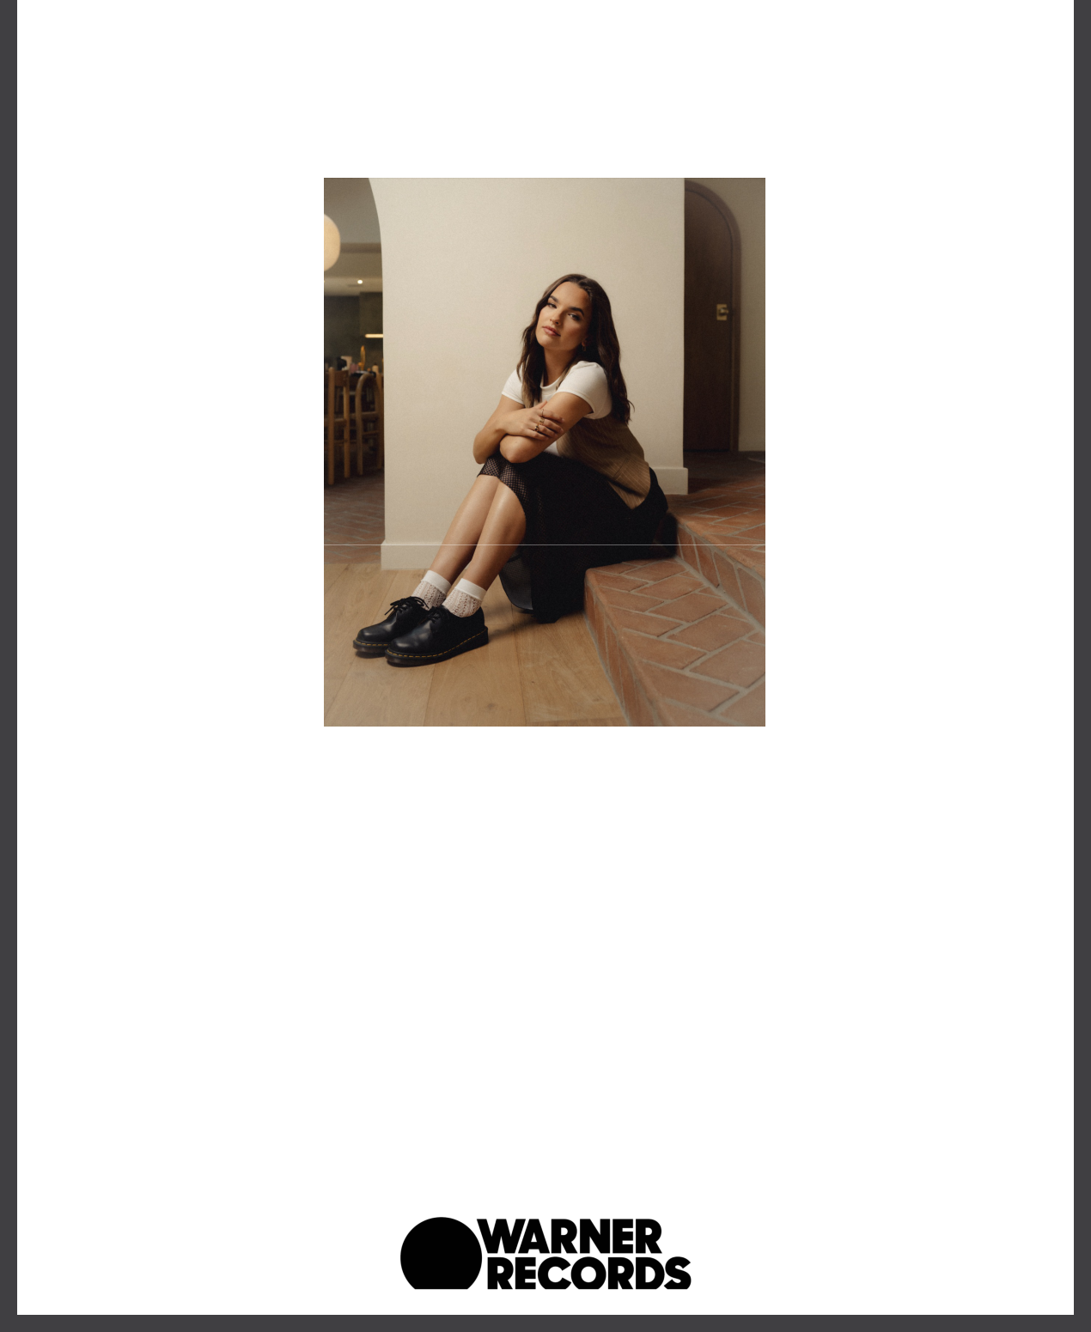fan favorite anthem “It Is What It Is.” From the jump, the track resonated with listeners, piling up 8 million-plus streams in less than a month. At the same time, it set TikTok on fire with its own viral dance. Along the way, she has earned unanimous praise from *Billboard*, *Variety*, *OnesToWatch*, and more. Now, Raine is turning the page on her next chapter, and the story just keeps getting better.

Credit: Jizelle Gutierrez

Download hi-res [HERE](https://drive.google.com/file/d/127oQ0cdZiXSpgJd4qH3feLlC9lbrC9PQ/view?usp=sharing)

###

**FOLLOW JENNA RAINE:**

[**Official**](https://www.jennaraine.com/) | [**TikTok**](https://www.tiktok.com/@itsjennaraine) | [**Instagram**](https://www.instagram.com/itsjennaraine/) | [**Twitter**](https://twitter.com/itsjennaraine) | [**Facebook**](https://www.facebook.com/itsjennaraine) | [**YouTube**](https://www.youtube.com/c/JennaRaine) **|** [**Press Materials**](https://press.warnerrecords.com/jenna-raine)

**For more information on Jenna Raine, please contact:**

Darren Baber | Warner Records

[Darren.Baber@warnerrecords.com](mailto:Darren.Baber@warnerrecords.com)

Patrice Compere | Warner Records

[Patrice.Compere@warnerrecords.com](mailto:Patrice.Compere@warnerrecords.com)

Warner Records | 777 S. Santa Fe | Los Angeles, CA 90021 US

Unsubscribe | [Constant Contact Data Notice](http://www.constantcontact.com/legal/about-constant-contact)

