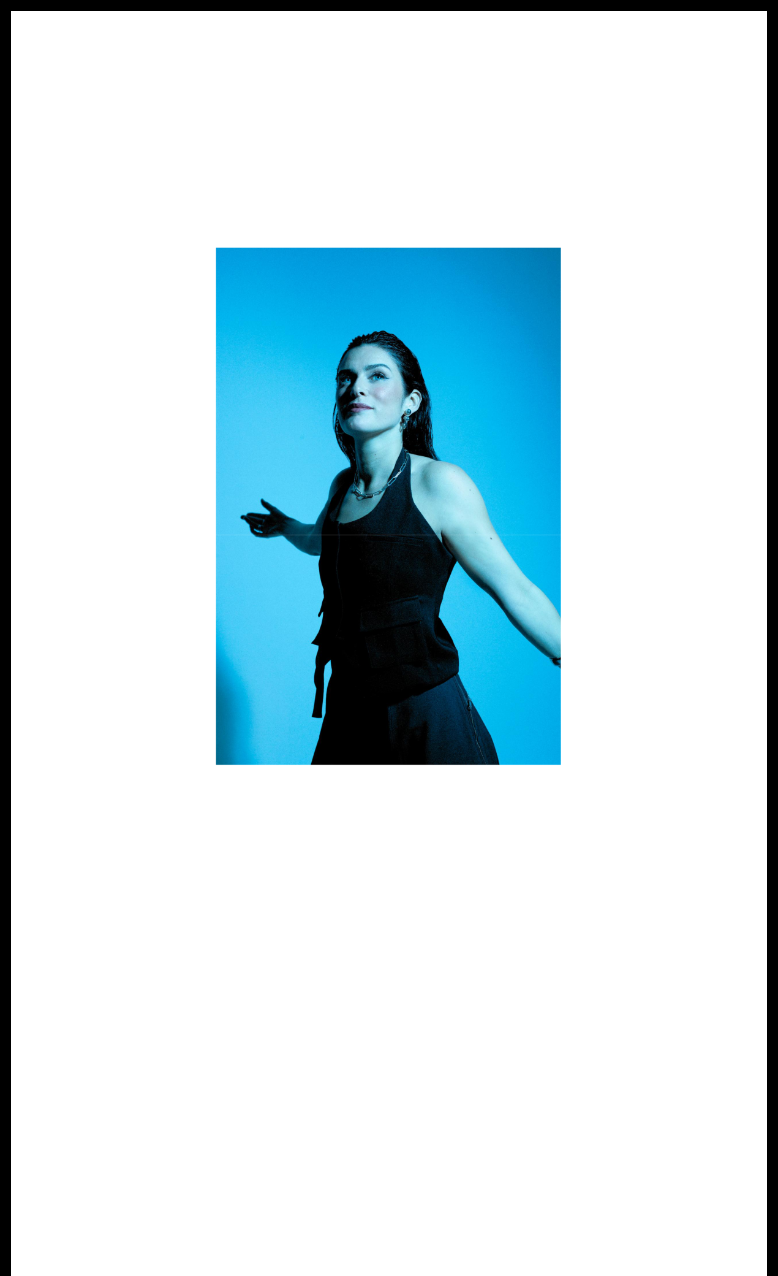

**BUZZING U.K. SINGER & DJ LILY MCKENZIE APPLIES *PRESSURE* ON THE DANCEFLOOR ​WITH DEBUT EP**

**LISTEN** [**HERE**](http://lilymckenzie.lnk.to/PressuretheEP)

**WATCH “WHEN IT COMES TO LOVE” VIDEO** [**HERE**](https://lilymckenzie.lnk.to/WICTLLyricVid)

Download hi-res [here](https://warnerrecords.app.box.com/s/zo18qiw79uomzi93qfw9gcu6f686guqy/file/1592291468684)

**August 9, 2024 (Los Angeles, CA) –** After building anticipation worldwide, U.K. singer, producer, and DJ **Lily McKenzie** unveils her anxiously awaited debut ***Pressure* EP** out now via **Major Recordings/Warner Records**.

Listen [**HERE**](http://lilymckenzie.lnk.to/PressuretheEP).

The five-track body of work affirms her as both a dynamic presence and a buzzing

triple threat without comparison. Among many highlights, lead single **“When It**

**Comes To Love”** takes flight as a bona fide dancefloor anthem. Synths flicker and

beats skitter as the energy overflows during the drop. Her intimate verses give rise to

a hypnotic hook where she asks, *“Tell me when it comes to love, will you be the*

*one*.*”* Then, there’s “**Satellite**.” Keys twinkle across the upbeat bass-powered groove,

and her celestial chorus takes hold, *“Be my satellite, I’ve been trying to find—a signal*

*in the night*.*”* Meanwhile, “**Middle**” spotlights her powerful range. On the track, the

soft piano intro dissolves into a sparse bass hum. Leaning into a soulful cadence,

she wonders, *“Will you meet me in the middle again? Will you catch me when I’m*

*losing my breath?”*

From club-ready bangers to introspective moments of raw emotion, ***Pressure*** showcases multiple sides of her artistry all at once. Check out the full tracklisting

below.

Just last night, she heralded the EP’s arrival with an exclusive release party in London on the rooftop of Tola. The line -up boasted everyone from **Jess Bays** and **Crazy Cousinz** to **DJ Amika Ezer** and more.

Earlier this summer, the single “**Careless**” preceded ***Pressure***. Right out of the gate, [*Global Grind*](https://globalgrind.com/playlist/new-music-july19/item/3) highlighted it on *“This Week’s New Music Roundup*.*”* Plus, she firstteased the EP with the title track “**Pressure**.” The latter has continued to gain traction on streaming platforms in addition to landing on playlists such as Spotify’s *“New Dance Revolution”* and *“The Loft”* and gained notable nods from Capital Dance, BBCRadio1 Future Show, and BBC Radio1 First Play Friday with Sarah Story.

This summer **Lily** ignited the stage at *Glastonbury* not once, but twice. She accompanied **Eats Everything** for a performance and handled DJ duties for UK dance icon **Katy B.** Perhaps most impressively, she did all of this while pregnant, proudly embracing impending motherhood with passion, poise, and power.

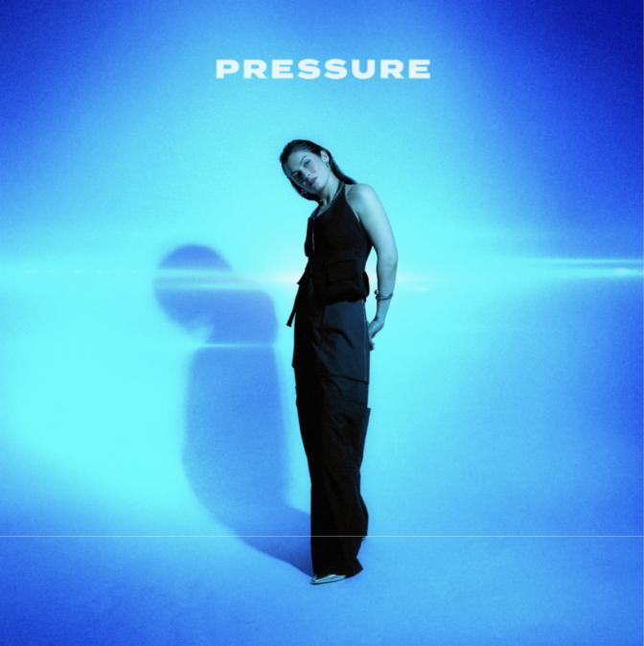

**TRACKLISTING**

1. Pressure
2. Careless
3. Satellite
4. When It Comes To Love
5. Middle

**ABOUT LILY MCKENZIE**

Born and raised in South London, **Lily McKenzie** has emerged as a vibrant force in electronic music. Channeling the spark of UK house and Garage into a sharp sound of her own, the singer, producer, and DJ continues to stir up buzz. Her notable collaborations range from **Todd Edwards** and **Interplanetary**

**Criminal** to **Jess Bays** and **DJ Q** to **Eats Everything** and **Chris Lorenzo**. At the same time, she has reeled in millions of streams and views with **“Better Me”** and **“Lovers & Friends,”** among others. Signing to **Major Recordings,** she’s on the verge of a breakthrough with her ***Pressure*** EP and more to come.

**FOLLOW LILY MCKENZIE:**

[**Spotify**](https://open.spotify.com/artist/6LsSHppZVgx7eks7hAkTPN?si=HCurgHpwRRS-0pbJItLSKw&nd=1&dlsi=5694d79a630d4fe7) **|** [**Instagram**](https://www.instagram.com/lilymckenzie/) **|** [**TikTok**](https://www.tiktok.com/@lilymckenziemusic) **|** [**Apple Music**](https://music.apple.com/gb/artist/lily-mckenzie/373826422)

**For more information, please contact:**

[**Ceri.Roberts@warnerrecords.com**](mailto:Yashar.Zadeh@warnerrecords.com)

Warner Records | 1633 Broadway | New York, NY 10019 US

Unsubscribe | [Constant Contact Data Notice](http://www.constantcontact.com/legal/about-constant-contact)

