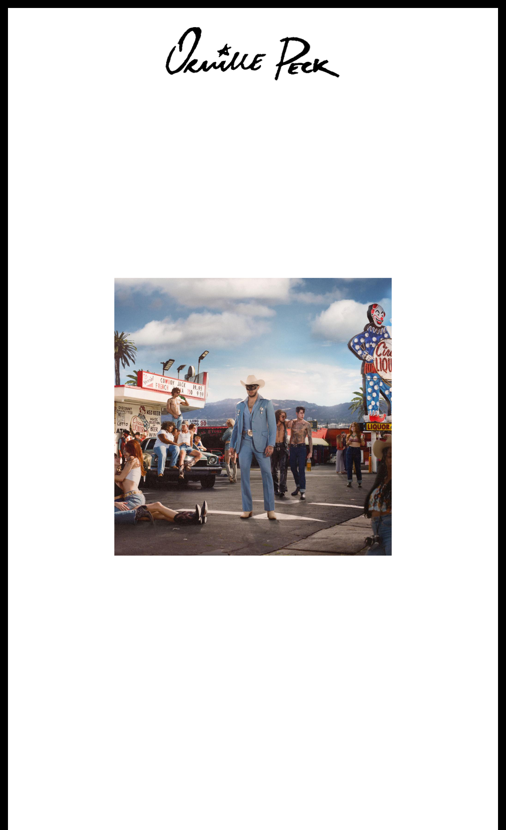

**ORVILLE PECK RELEASES HOTLY ANTICIPATED NEW DUETS ALBUM *STAMPEDE***

**LISTEN** [**HERE**](https://orvillepeck.lnk.to/StampedeAlbum)

**COLLABORATIONS WITH WILLIE NELSON, ELTON JOHN, BECK, KYLIE MINOGUE, DIPLO, TEDDY SWIMS, MARGO PRICE, MICKEY GUYTON, NOAH CYRUS, NATHANIEL RATELIFF & MORE**

***STAMPEDE* TOUR UNDERWAY NOW**

**NEW DATES ADDED**

Download hi-res artwork [HERE](https://drive.google.com/file/d/1AZe_-hKCl5I-WxYiK5pRnMNyr8fgrzJm/view?usp=sharing)

**August 2, 2024 (Los Angeles, CA) —** Today, trailblazing country artist **Orville Peck** releases the eclectic duets album ***Stampede***. Boasting singles like **“**[**Midnight Ride**](https://www.youtube.com/watch?v=lKtOo5vwPVg)**”** with **Kylie** **Minogue** & **Diplo** and **“**[**Death Valley High**](https://www.youtube.com/watch?v=1eodFa9rZZQ)**”** alongside **Beck**, the project pushes the boundaries of country music by creating a unique, genre-blurring blend of styles with each collaborator. Listen [**HERE**](https://orvillepeck.lnk.to/StampedeAlbum).

The album kicks off with **“**[**Cowboys Are Frequently Fond of Each Other**](https://www.youtube.com/watch?v=BirJMnMcfBs) **,”** a cover of queer

anthem featuring vocals from country music icon **Willie Nelson**. Other standouts include the

[soaring ballad **“How Far Will We Take It”** with **Noah Cyrus**, the brooding **“Chemical**](https://www.youtube.com/watch?v=tz2JKgBxs6o)

[**Sunset”** with **Allison Russell**, and album closer **“Rhinestone Cowboy”** alongside **TJ**](https://www.youtube.com/watch?v=tz2JKgBxs6o) **Osborne,**

**Waylon Payne** and **Fancy Hagood**. Additionally, the album features collaborations with **Elton**

**John, Margo Price, Teddy Swims, Mickey Guyton, Midland, Nathaniel Rateliff, Debbii Dawson, Bu Cuaron, and Molly Tuttle** and **Golden Highway.**

**Orville Peck’s 6th annual *Rodeo*** is coming to Nashville later this month, featuring performances from **Medium Build, Mickey Guyton, Reyna Roberts, The Nude Party** and more, in addition to a headline set from **Peck** & **Tanya Tucker**. Hosted by **John Waters**, the rodeo will take place on **August 24** at Ascend Amphitheater, with a kickoff party at Basement East on **August 23** and a closing party at Brooklyn Bowl on **August 25**. Click [**HERE**](https://www.ticketmaster.com/orville-peck-s-rodeo-tickets/artist/3075461) for tickets.

**Peck’s *Stampede* Tour** is underway now across North America, including three newly added dates in Dallas, Houston, and Tulsa this October. Tickets are on sale today, **August 2**, **at 10am** **local time**. See full list of dates below and click [**HERE**](https://www.orvillepeck.com/) for more information.

***Stampede* Tracklist:**

1. Cowboys Are Frequently Secretly Fond Of Each Other [with Willie Nelson]
2. The Hurtin' Kind [with Midland]
3. Saturday Night's Alright (For Fighting) [with Elton John]
4. Back At Your Door [with Debbii Dawson]
5. Chemical Sunset [with Allison Russell]
6. Death Valley High [with Beck]
7. How Far Will We Take It? [with Noah Cyrus]
8. Miénteme [with Bu Cuaron]
9. Papa Was a Rodeo [with Molly Tuttle and Golden Highway]
10. Midnight Ride [with Kylie Minogue and Diplo]
11. Ever You're Gone [with Teddy Swims]
12. You're an Asshole, I Can't Stand You (and I Want a Divorce) [with Margo Price]
13. Where Are We Now? [with Mickey Guyton]
14. Conquer The Heart [with Nathaniel Rateliff]
15. Rhinestone Cowboy [with TJ Osborne, Waylon Payne and Fancy Hagood]

**Upcoming Orville Peck Tour Dates**

8/2 — Saint Charles, IA — Hinterland Music Festival

8/3 — Omaha, NE — The Admiral **~%**

8/5 — Oklahoma City, OK — The Jones Assembly **~%** 8/6 — Santa Fe, NM — Santa Fe Brewing Company **~%** 8/8 — Denver, CO — Fillmore Auditorium **~%**

8/9 — Salt Lake City, UT — Union Event Center **%**

8/23 — Nashville, TN — Orville Peck’s 6th Annual Rodeo Kickoff Party 8/24 — Nashville, TN — Orville Peck’s 6th Annual Rodeo

8/25 — Nashville, TN — Orville Peck’s 6th Annual Rodeo Closing Party 9/24 — Bend, OR — Hayden Homes Amphitheater **@!** 9/25 — Woodinville, WA — Chateau Ste. Michelle **@!**

9/27 — San Francisco, CA — Bill Graham Civic Auditorium **@!**

9/28 — Los Angeles, CA — Hollywood Palladium **@!**

9/29 — Los Angeles, CA — Hollywood Palladium **@!**

10/1 — San Diego, CA — Cal Coast Credit Union - Open Air Theatre **@!**

10/2 — Phoenix, AZ — Mesa Amphitheatre **@!**

10/6 — Austin, TX — Austin City Limits Music Festival

**10/7 — Dallas, TX — House of Blues Dallas @ – JUST ADDED 10/8 — Houston, TX — House of Blues Houston @ – JUST ADDED 10/11 — Tulsa, OK — Tulsa Theater @ – JUST ADDED**

10/13 — Austin, TX — Austin City Limits Music Festival 10/16 — Boston, MA — MGM Music Hall **@&**

10/18 — Philadelphia, PA — MET Opera House **@&**

10/19 — Brooklyn, NY — Brooklyn Paramount **@&**

10/20 — Brooklyn, NY — Brooklyn Paramount **@&**

* **With Jaime Wyatt % With Gold Star @ With Nikki Lane ! With Emily Nenni**

**& With Vincent Neil Emerson**

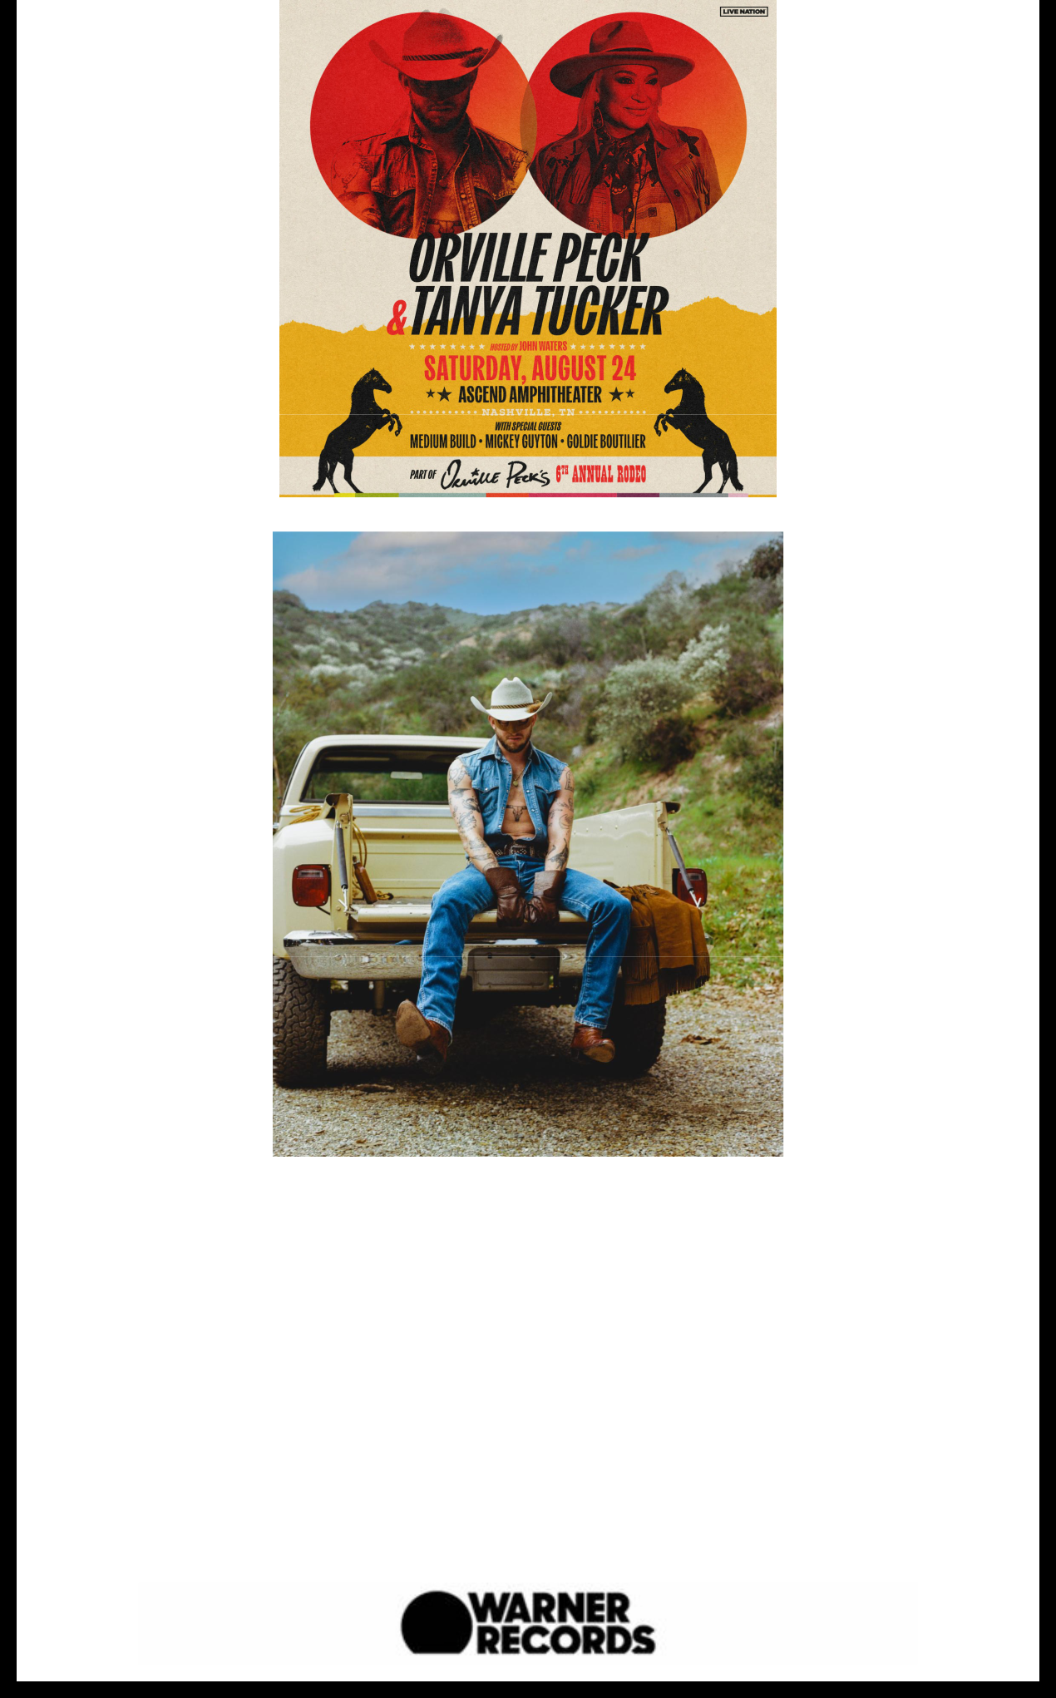

Photo credit: Ben Prince

Hi-res download [HERE](https://drive.google.com/file/d/1i3jqjWyyixSlxTb7zr2Tb012VEduGJAC/view?usp=sharing)

**Connect With Orville Peck:**

[Website](https://www.orvillepeck.com/) | [Instagram](https://www.instagram.com/orvillepeck/) | [Twitter](https://twitter.com/orvillepeck) | [Facebook](https://www.facebook.com/orvillepeck/) | [TikTok](https://www.tiktok.com/@orvillepeck?lang=en)

**For more information, please contact:**

Darren Baber | Warner Records

[Darren.Baber@warnerrecords.com](mailto:Darren.Baber@warnerrecords.com)

**Regional/Tour:** Delanee Wilson | Warner Records

[Delanee.Wilson@warnerrecords.com](mailto:Delanee.Wilson@warnerrecords.com)

Warner Records | 1633 Broadway | New York, NY 10019 US

Unsubscribe | [Constant Contact Data Notice](http://www.constantcontact.com/legal/about-constant-contact)

