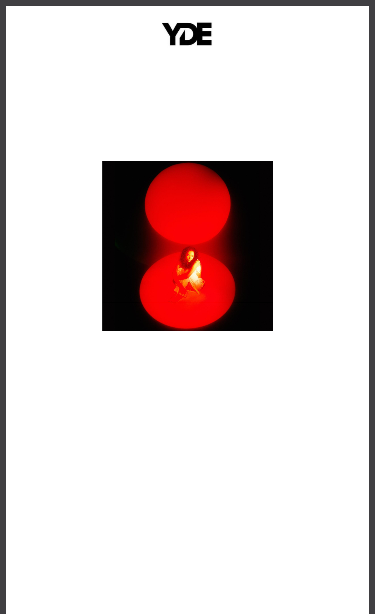

**POP MUSIC TRIPLE THREAT YDE RELEASES SOUL-STIRRING NEW SINGLE “DEFENSE OF LOVE”**

**LISTEN** [**HERE**](https://yde.lnk.to/defenseoflove) **| WATCH THE VISUALIZER** [**HERE**](https://yde.lnk.to/dolvis)

**ANNOUNCES FORTHCOMING EP, *8,* ARRIVING LATER THIS**

**SUMMER**

Download hi-res artwork [HERE](https://drive.google.com/file/d/1riPD4tb_ePGArmTo5RSVwqt8I9TIcRyJ/view?usp=sharing)

*“YDE is a Voice for Her Generation”*

***PAPER***

*“Razor-sharp lyricist with a transformative flair”*

***V Magazine***

**August 9, 2024 (Los Angeles, CA) –** Kicking off another luminous creative era, pop music’s triple threat (singer/songwriter, producer, actress) **YDE** *(pronounced EE-dee)* serves up a brand new single entitled **“Defense of Love.”** Listen to the track—co-written by **Justin**

**Tranter** (Chappell Roan, Justin Bieber, Selena Gomez) and **Mattman & Robin** (Charli XCX, Imagine Dragons, RAYE) and produced by **YDE**—[**HERE**](https://yde.lnk.to/defenseoflove) via **Facet Records/Warner Records**. It heralds her upcoming ***8* EP** arriving later this summer.

*“****‘Defense Of Love’*** *is about letting go and returning to the purity of love. I know the lengths I'm willing to go to defend love. But as I've learned, it’s easy to lose touch with what love truly is. We get clouded by ideas about love, that we forget the true essence of love itself. Co-writing this song with Justin Tranter, Mattman and Robin reminded me that love transcends an ideal, a relationship, a song, a heartbreak. Love is interwoven in our DNA. Love keeps us alive. This song is about choosing love. Whatever that means for you,”* says **YDE**.

Ethereal synths and softly strummed acoustic guitar murmur beneath her dynamic vocals on the track. Mirroring the mixed emotions of a breakup, she flexes her range, stretching from otherworldly verses to heavenly heights on the hook. She comes to a relatable realization on the chantable chorus, “*I did it in defense of love* .”

It follows the fan favorite **“Free Fall.”** Right out of the gate, [*UPROXX*](https://uproxx.com/pop/best-new-pop-j-balvin-dasha-griff/) touted it among *“All The Best New Pop Music From This Week*,*”* going on to applaud how *“****YDE’s*** *breathy vocals convey*



*her desperate feelings toward someone who doesn’t deserve it*.*”*

**YDE’s *SEND HELP* EP** originally arrived in 2022 and has earned widespread critical acclaim. [*NYLON*](https://www.nylon.com/entertainment/yde-send-help-ep-short-film-premiere) applauded *“the project’s inquisitive and emotional*

*world*,*”* and [*Flaunt*](https://archive.flaunt.com/content/yde-send-help) proclaimed, *“With soft and subtle transitions between each track, the artist carefully weaves together a story of love, life, and*

*identity.”* [*Billboard*](https://www.billboard.com/music/music-news/yde-talks-send-help-ep-people-can-change-1235136715/) hailed the single **“People Can Change”** as *“touching*.*”*

Meanwhile, [*OnesToWatch*](https://onestowatch.com/en/blog/yde-send-help-ep-review) attested, *“wow did those skills come to fruition in SEND HELP, a saucy affair that is equal parts riveting, subtle, and complex.”*

The rising artist first made waves with October 2020’s “Stopped Buying Diamonds,” co-written with mentor and Facet Records founder Justin Tranter, a tongue-in-cheek recognition that Gen Z is disastrous in the eyes of older generations.

**ABOUT YDE:**

With razor-sharp lyrics about personal transformation, and her relationship with the future, YDE (EE-dee) writes catchy, alt-skewering pop songs about what it means to be

human. Simultaneously humble and herculean the Australian-born, Filipino singer/songwriter dives even deeper into the human condition on her recent singles, “Old Her” and “People Can Change” as well as her debut EP *SEND HELP* via Facet Records/Warner Records. *“Ultimately, I really hope that people who need to hear my music, hear it,”* YDE says. Born in Australia,Breanna, her real name, moved to the US with her parents as a toddler. YDE went on to land starring roles on Nickelodeon series, *The Haunted Hathaways* at the age of nine, and *School of Rock*, before landing on the Netflix Series, Malibu Rescue. Recently, the multi-faceted artiststarred in the live production of *WILD: A Musical Becoming* alongside Idina Menzel and released her 2024 single “Free Fall.”

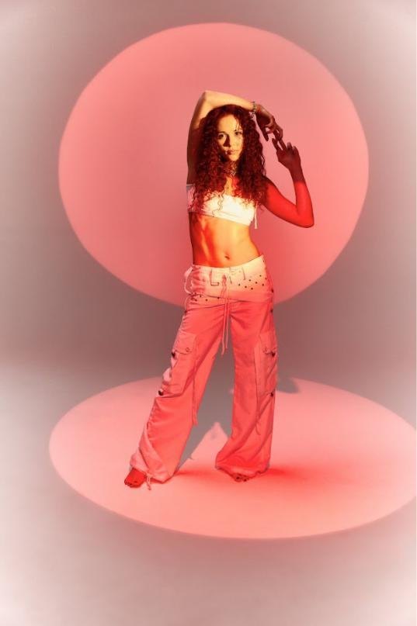

Press Assets [HERE](https://press.warnerrecords.com/yde) - credit: Brian Ziff

**FOLLOW YDE:**

[Instagram](https://www.instagram.com/notyde/) | [YouTube](https://www.youtube.com/channel/UCAMOHR7Lt6ofLsGmA04RKHw) | [TikTok](https://www.tiktok.com/@notyde?lang=en) | [Press Website](https://press.warnerrecords.com/yde/)

**For more information, please contact:**

Darren Baber | Warner Records

[Darren.Baber@warnerrecords.com](mailto:Darren.Baber@warnerrecords.com)

Connor Hunt | Warner Records

[Connor.Hunt@warnerrecords.com](mailto:Connor.Hunt@warnerrecords.com)

Warner Records | 1633 Broadway | New York, NY 10019 US

Unsubscribe | [Constant Contact Data Notice](http://www.constantcontact.com/legal/about-constant-contact)

