**14-YEAR-OLD COUNTRY BREAKOUT ARTIST MADDOX BATSON RELEASES NEW SINGLE “X’s”**

**LISTEN** [**HERE**](https://maddoxbatson.lnk.to/xssong) **| WATCH** [**HERE**](https://maddoxbatson.lnk.to/xsvideo)

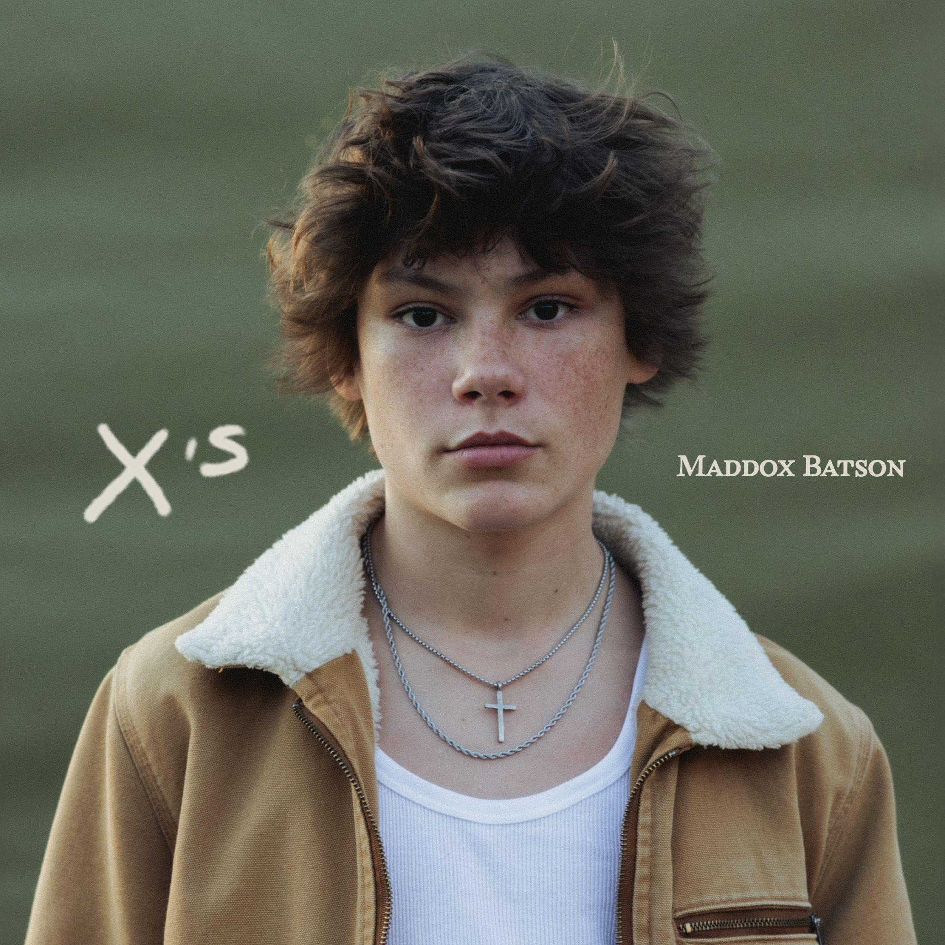

*“one of country music’s newest and youngest stars.”*

**Country Now**

*“Maddox Batson is bringing his infectious charm to a younger audience”*

**Holler Country**

**Los Angeles, CA (September 5, 2024)** – After making waves online, 14-year-old country breakout artist **Maddox Batson** shares a brand new single entitled “**X’s**” out now. It notably marks the young multi-instrumentalist’s (guitar, piano, mandolin) official debut under his newly minted deal with **Warner Records**. Listen to “**X’s**” [**HERE**](https://maddoxbatson.lnk.to/xssong) and watch the music video starring **Harper Zilmer** [**HERE**](https://maddoxbatson.lnk.to/xsvideo).

*“"****X’s****' was inspired by a concert I went to with a couple of my friends. When I walked in, the security immediately wrote with a sharpie a big ole’ X on my right hand because I was under 18. The next day when I was in the studio, one of my co-writers noticed some of the sharpie was still on my right hand - and we came up with the song name. We all loved it and the rest is history, lol," says* ***Maddox****.*

The track layers breezy acoustic guitar over a head-nodding beat punctuated by slide guitar and banjo. During the vivid verses, he paints a nostalgic, yet relatable portrait of young love in full bloom. Simultaneously, a catchy chorus dismisses jealousy, *“Let them talk like they know us, say we’re way too young to fall in love…Like we don’t stand a chance, dancing with these* ***X’s*** *on our hands*.*”*

Recently, **Maddox** landed a massive cut as a songwriter, co-writing Lana Del Rey and Quavo’s latest single “Tough.” As a performer, **Maddox** has already proven to draw in a big audience on the road. At this year’s CMA Fest, Batson became the youngest artist to ever play Nashville’s iconic Whiskey Jam, reaching a capacity crowd. Later this month, the singer will be heading back to his roots in Robertson County for a special “**Maddox Batson** & Friends” headlining show on Sept. 28 at the White House Pumpkin Patch in White House, TN. He’s also joining Gabby Barrett on tour for select dates this Summer and Fall. A full routing can be found below.

In a short time, **Maddox Batson** has skyrocketed to the forefront of country music fueled by a series of popular independent singles. Born just north of Nashville, TN and raised in Birmingham, AL, the 14-year-old singer, songwriter, and multi-instrumentalist developed a fervent passion for music as a kid. Eventually, he cultivated a sharp signature style by infusing classic country storytelling and swagger with southern rock energy, pop palatability, and a distinct groove. Audiences initially fell in love with **Maddox** in 2024 with **“Tears In The River**,**”** which amassed 21 million global streams and landed on *HOLLER*’s *“Top Country Songs*.*”* Riding this wave, **“I Wanna Know”** only accelerated his momentum. Given his surging popularity, he also impressively attracted an audience of over 3.5 million on social media. As buzz reached a boiling point, he signed to **Warner Records** and released his latest single, **“X’s**.**”**

[**Maddox Batson Tour Dates**](https://maddoxbatson.com/)**:**

09/06/24 Evansville, IN Old National Events Plaza*

09/07/24 Lima, OH Veterans Memorial Civic Center*

09/08/24 Wheeling, WV The Capitol Theatre*

09/21/24 Sugar Hill, GA The Bowl At Sugar Hill*

09/28/24 White House, TN White House Pumpkin Patch

10/25/24 Tuscaloosa, AL Druid City Music Hall

*\*Support for Gabby Barrett*

**About Maddox:**

Maddox Batson navigates the world with wisdom and wit far beyond his 14 years. After the Nashville-born, Alabama-based songwriter began gaining notoriety covering songs from Zach Bryan, Red Clay Strays, and more, he started to write his own songs. Thanks to early singles like “Tears In The River” and “I Wanna Know,” Batson quickly showed that he wasn’t only a star at covering country hits, but an excellent writer of his own home-cooked cuts – a practice he saw first-hand as a co-writer on Lana Del Rey and Quavo’s smash hit collaboration, “Tough.”

Now, with the arrival of his latest single, “X’s,” Maddox Batson is ready to show the world you’re never too young to be the face of music all while preparing for live shows across the country and more new music. Life is moving fast for the multi-instrumentalist (piano, guitar & mandolin) and he’s trying his best to remain a kid while becoming next up in country-pop music. “It can be overwhelming, this life, but I’ve got a lot of good people surrounding me,” he explains. “I’m still just a kid, though, and I’m happy about that.”

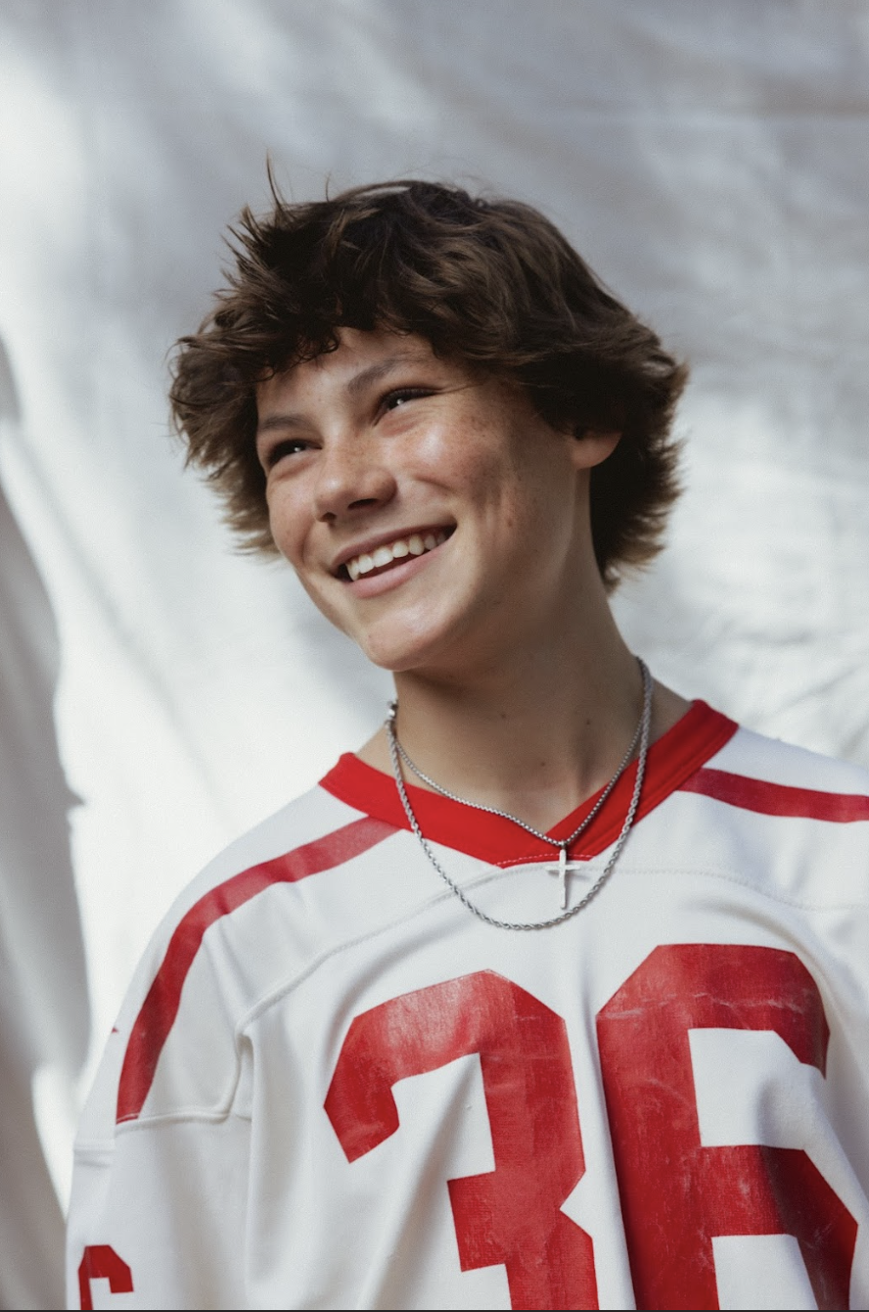

Credit: Cooper Pattison - High Res [HERE](http://press.warnerrecords.com/maddox-batson)

**STAY TUNED WITH MADDOX BATSON**

[TikTok](https://www.tiktok.com/@maddoxbatson?lang=en) | [Instagram](https://www.instagram.com/maddoxbatson/?hl=en) | [YouTube](https://www.youtube.com/channel/UCPOZfdO3JIIIDw7uAzlSNtg) | [Press Website](http://press.warnerrecords.com/maddox-batson)

**For More Information Contact:**

**Warner Records:**

Connor Hunt // [Connor.Hunt@warnerrecords.com](mailto:Connor.Hunt@warnerrecords.com)

**The OH Creative:**

Olivia Hanceri // [olivia@theohcreative.com](mailto:olivia@theohcreative.com)

Kristi Bradshaw // [Kristi@theohcreative.com](mailto:Kristi@theohcreative.com)