**BENSON BOONE’S “BEAUTIFUL THINGS” IS THE**

**#1 MOST STREAMED SONG IN THE WORLD IN 2024**

**NOW RIAA CERTIFIED 5X PLATINUM**

**NOMINATED FOR BEST NEW ARTIST AT THE 2025 GRAMMY AWARDS**

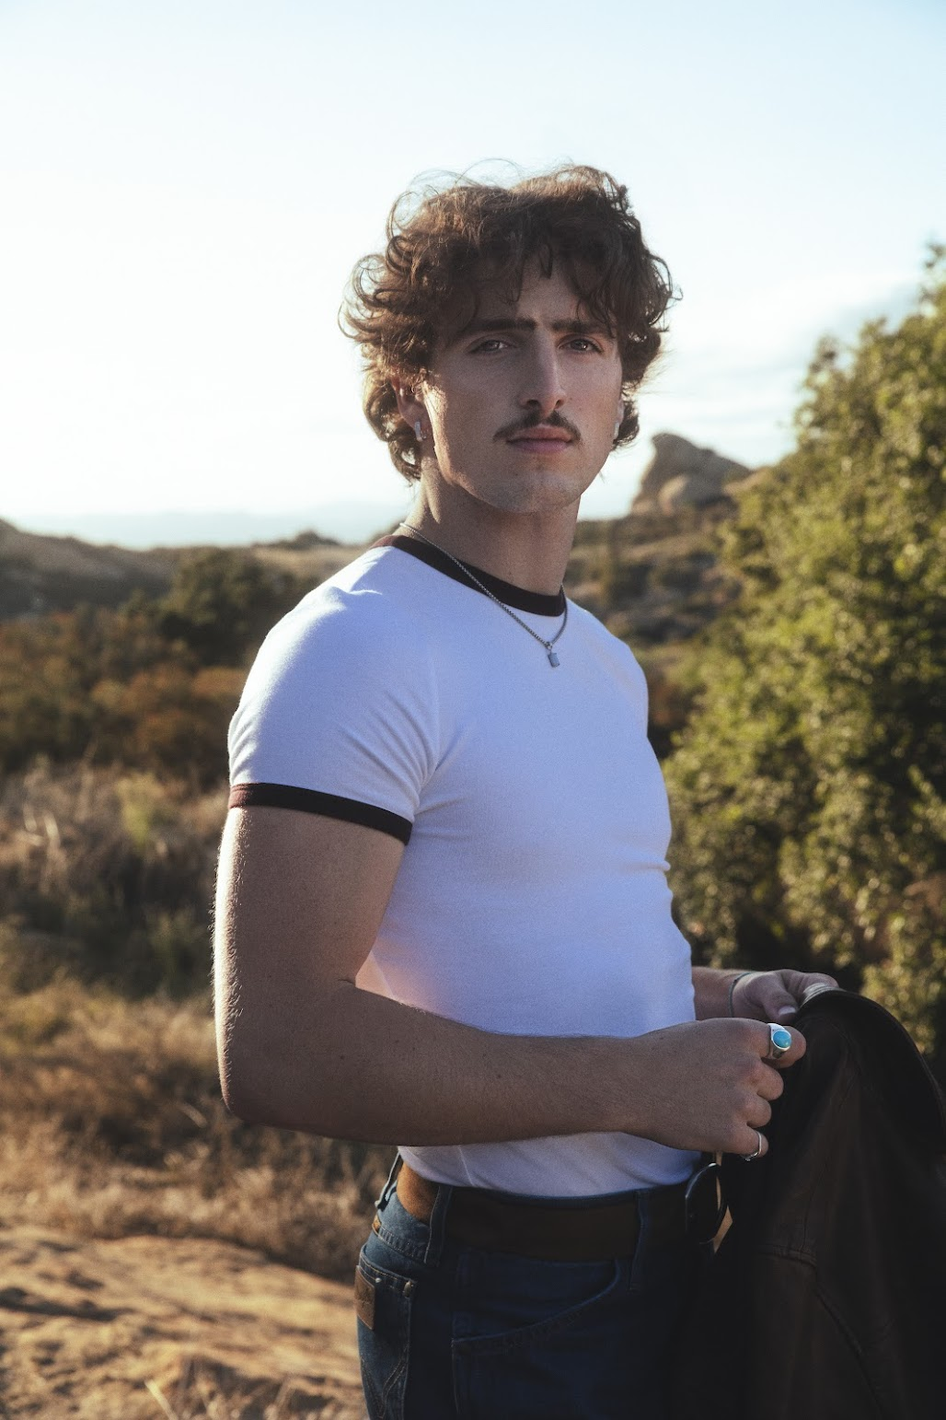

Credit: Jonathan Weiner

Download hi-res image [HERE](https://press.warnerrecords.com/sites/g/files/g2000014901/files/2024-03/BensonBoone_F%26R2024_Warner_DL_SHOT_9_038_Retouch_Color.jpg)

**January 2, 2025 (Los Angeles, CA)** – Grammy-nominated global pop sensation **Benson Boone**’s smash hit **“Beautiful Things”** is officially the #1 most streamed song in the world in 2024. Now RIAA certified **5x Platinum**, the track has garnered over **3 billion streams** since its release earlier this year.

Featured on his acclaimed, Platinum certified debut album ***Fireworks & Rollerblades***, the viral smash logged an impressive 7 weeks at #1 on the *Billboard* Global 200 chart, hit #1 at Top 40 and Hot AC radio, and vaulted to #2 on the *Billboard* Hot 100 chart. It recently earned **Boone** two **Billboard Music Awards** for ***Top Billboard Global 200 Song*** and ***Top Billboard Global (Excl. US) Song***.

***Fireworks & Rollerblades*** also includes the Platinum certified hit **“**[**Slow It Down**](https://www.youtube.com/watch?v=f4Y3b7un4LE)**”** and fan-favorites **“**[**Cry**](https://www.youtube.com/watch?v=i828eLpviiY)**,” “**[**What Do You Want**](https://www.youtube.com/watch?v=znuS5LEWG-M)**,”** and **“**[**Pretty Slowly**](https://bensonboone.lnk.to/prettyslowlyvideo)**.”**

2024 was a record year for **Benson**, earning him a 2025 **Grammy Award** nomination for **Best New Artist**. He performed at the **MTV Video Music Awards**, where he won ***Best Alternative*** and received nominations for ***Best New Artist, Song of Summer*** and ***PUSH Performance of the Year***.His impact has soared across the globe—this year also saw him perform at the **MTV EMAs**, the **NRJ Awards**, and the **Los40 Awards**, taking home trophies at every stop.

In June, he opened for **Taylor Swift**’s ERAS Tour in London at Wembley stadium, following a performance with **Lana Del Rey** at Hangout Festival in May. Earlier this year, **Boone** launched his fully sold-out ***Fireworks & Rollerblades* Tour**, playing shows across the globe.

**BENSON BOONE 2025 TOUR DATES:**

Jan 12 — Seoul, South Korea — Olympic Park Olympic Hall

Jan 14 — Tokyo, Japan — Zepp Haneda

Jan 16 — Melbourne, AUS — Festival Hall

Jan 17 — Melbourne, AUS — Festival Hall

Jan 19 — Sydney, AUS — Hordern Pavilion

Jan 20 — Sydney, AUS — Hordern Pavilion

Jan 22 — Brisbane City, AUS — Riverstage

Jan 23 — Melbourne, AUS — Australian Open

Jan 24 — Auckland, NZ — Spark Arena

Apr 3 — Mexico City, MX — Pepsi Center WTC

Apr 5 — Monterrey, MX — Tecate Pa’l Norte

###

**FOLLOW BENSON BOONE:**

[**TikTok**](https://www.tiktok.com/@bensonboone) | [**Instagram**](https://www.instagram.com/bensonboone/) | [**Twitter**](https://twitter.com/bensonboone) | [**Facebook**](https://www.facebook.com/bensonbooneofficial/) | [**YouTube**](https://www.youtube.com/channel/UCvILah8hAWYhYOmAG3ZjvBA)

**For more information, please contact:**

Darren Baber | Warner Records

[Darren.Baber@warnerrecords.com](mailto:Darren.Baber@warnerrecords.com)

